**Inkosi Langalibalele Local Municipality**



**Mid-Year Budget and Performance Assessment Report 18/19**

**(Section 72 Report)**

Contents

PART 1: IN-YEAR REPORT 3

MAYOR’S REPORT 3

RESOLUTIONS 5

EXECUTIVE SUMMARY 6

INTRODUCTION 6

FINANCIAL PERFORMANCE VERSUS APPROVED BUDGET 6

IN-YEAR BUDGET TABLES 9

PART 2 – SUPPORTING DOCUMENTATION 14

DEBTORS ANALYSIS 14

CREDITORS ANALYSIS 15

INVESTMENT PORTFOLIO ANALYSIS 15

ALLOCATION AND GRANT RECEIPTS AND EXPENDITURE 16

MATERIAL VARIANCE TO THE SERVICE DELIVERY AND BUDGET IMPLEMENTATION PLAN 17

MUNICIPAL MANAGER’S QUALITY CERTIFICATE 27

# PART 1: IN-YEAR REPORT

## MAYOR’S REPORT

In terms of the Municipal Budget and Reporting Regulations, Part 1 in-year report, the Mayor is required to provide a report / comments on:

“(a) ***a summary of whether the municipality’s budget is being implemented in accordance with the Service Delivery and Budget Implementation Plan and any service delivery agreements with municipal entities.”***

The Mayor has considered the Section 71 reports from July until December 2018, and the Quarterly reports in terms of Section 52(d) of the MFMA. The performance of the municipality against its budget is in line with the budget that was approved by Council in May 2018.

**Operating Revenue**

Operational Revenue in Table C4 has a positive variance by the end of December of 29% comparing Actual-to-date versus Budget-to-date. This was made possible by three attributes which are Property Rates (60%), Operational Grants (52%) and Service Charges (148%). Total Operating Revenue for the first 6 months of the year amounts to 322 million which is 74 million more than the budgeted year to date of 258 million

**Operating Expenditure**

The Operating expenditure in Table C4 shows Actual-to-date is R197 mil instead of R249 mil which leads to 20% underspending. This is caused mainly by bulk Purchases, with a variance of 46 million and other expenditure with a variance of 12 million. The variance in the bulk purchases is caused by Eskom invoices that have yet not been paid. Underspending in other expenditure is caused by cost cutting measures in place at the municipality due to cash flow challenges.

**Capital Expenditure**

Capital expenditure for grants is sitting at R26 mil instead of R25mil by mid-year. The municipality received a housing grant that it had not budgeted for, hence the expenditure is above the budgeted amount. The spending on capital grants for the first six months of the year is satisfactory.

**Cash Flow**

As indicated in Table C7, the municipality has had challenges in this regard, however, measures have been put in place to improve the situation.

“(b) ***a summary of any financial problems or risks facing the municipality or any such entity; and***.”

The municipality is facing financial problems and risks of creditors suing the municipality. This situation has prompted the Political leadership together with the management of the municipality with the help of Provincial Treasury and Provincial Cogta to form an Interim Finance Committee (IFC) to put measures in place in avoiding financial deterioration and stabilising fiscal affairs of the municipality. This is done by having weekly meetings which analyse the finances for the month and determine which expenditures/ creditors to be paid.

“(c) ***any other information considered relevant by the Mayor.***”

1. Although Council and management has made good progress on the implementation of mSCOA, challenges are still there since the system processes is new but the vendor is handling all the challenges that the municipality reports on.

“4(a) ***summary of the past year’s annual report.****”*

The municipality is busy compiling the Annual Report. The municipality received an **Adverse** opinion and an action plan is being developed to addresses the audit findings and to improve the audit opinion.

“(b) ***summary of impact of the National Adjustments Budget and Provincial Adjustments Budget.***”

National Treasury is set to release its adjustments to the Annual Division of Revenue Act (DoRA) which would take into account adjustments to allocation for the 2018/19 financial year.

“(c) ***recommendations***

It is therefore recommended based on the information presented above that an Adjustments Budget referred to in Section 28 of the MFMA be prepared and tabled to the Council by February 28, 2019.

## RESOLUTIONS

1. That the Mid-Year Budget and Performance Assessment Report 2018/19 in terms of Section 72 of the MFMA; be **NOTED**.
2. That the Quarterly Report on the implementation of the budget and financial affairs for the municipality referred to in Section 52(d) of the MFMA; be **NOTED**.
3. That the monthly budget statements and supporting documentation be **NOTED**

## EXECUTIVE SUMMARY

### INTRODUCTION

The Municipal Finance Management Act, No.56 of 2003, makes it necessary for all municipalities to prepare Mid-Year Budget and Performance Assessment Report.

Section 72 of the Act state the following:

“*1. The Accounting Officer of a municipality must by 25 January of each year –*

1. *Assess the performance of the municipality during the first half of the financial year, taking into account:*
2. *The monthly budget statements referred to in Section 71 for the first half of the year;*
3. *The municipality’s Service Delivery performance during the first half of the financial year, and the service delivery targets and performance indicators set in the SDBIP;*
4. *The past year’s Annual Report and progress made on resolving problems identified in the Annual Report; and*
5. *The performance of every municipal entity under the sole or shared control of the municipality, taking into account reports in terms of Section 88 of the Act from such entities.*

In compliance with Section 72 of the Act, as stated above, the Mid-Year Budget and Performance Assessment is compiled and reported on accordingly.

### FINANCIAL PERFORMANCE VERSUS APPROVED BUDGET

Table C1 and C4 highlight the financial performance of the municipality for the first half of the financial year. It is clear from the tables that the municipality has reported a surplus of R163.8 mil, this surplus is inclusive of operating and capital grants. However, this should not be taken at face value since Table C4 has items on accrual basis and not on cash.

***Income***

The income reported for the period is R332 mil compared to the budgeted income of R258 mil.The income for the period as detailed in the table below shows the income billed versus the budget income. Property Rates billed are higher than year-to date budget and other revenue such as Service charges have a similar trend.

**Table 1: Income for the six months ended 31 December 2018**



**Graph 1: Income for the six months ended 31 December 2018**

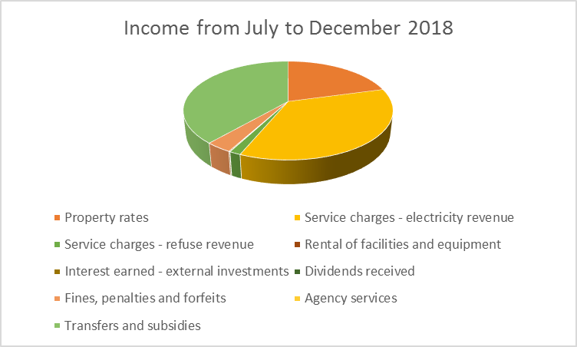

***Expenditure***

The expenditure for the six months period is reported at R199 million, which is 50 million less than the budgeted year to date. The municipality has underspent on most of its expenditure items such as bulk purchases, other materials, contracted services and other expenditure .However there are line items where the municipality has overspent such as employee related costs at 12% over expenditure and Finance charges at 917% over expenditure. Below is a table that details the expenditure.

**Table 2: Expenditure for the six months ended 31 December 2018.**



**Graph 2: Expenditure for the six months ended 31 December 2018**

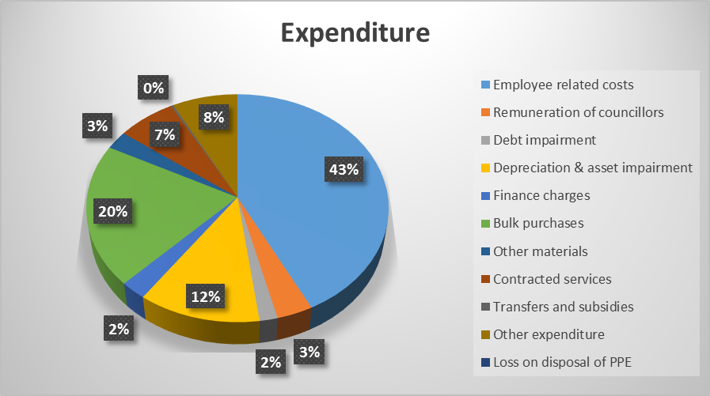

## IN-YEAR BUDGET TABLES





The total revenue for the period is reported at R332 mil and has a 29% positive variance over Year-to-date Budget amount. The bulk of this amount comes from Electricity Sales (60%) and Transfers Subsidies (52%).

The total expenditure is sitting at R199 million with an underspending of 20%. This is mainly due to bulk purchase invoices outstanding. The biggest contributor on expenditure is Employee Related Cost with 43%, followed by Electricity Purchase with 20%. The 917%overspending on finance charges is due to the principal amounts that are debited on the finance charges.



The total expenditure for the period is at R27 mil by end of December 2018 with a positive variance of 1%.

Capital expenditure funded by grants shows overspending of 6% and this is due to a housing grant received by the municipality that was not budgeted for. Capital spending for the first six months of the year was satisfactory.



Table A6 is consistent with international standards of good financial management practice, and improves understandability for councilors and management of the impact of the budget on the statement of financial position (balance sheet).

This format of presenting the statement of financial position is aligned to GRAP1, which is generally aligned to the international version which presents Assets less Liabilities as “accounting” Community Wealth. The order of items within each group illustrates items in order of liquidity; i.e. assets readily converted to cash, or liabilities immediately required to be met from cash, appear first.



The net increase/(decrease) in cash held as at 31 December 2017 is R64.6 mil. This has been increased by grants received during the month of December i.e. Equitable Share R47.5 mil and MIG R11 mil.

The actual Employee Related Cost with Councillors Remuneration is reported at R91.8 mil vs the budget amount of R169 mil. This shows an overspending of 4%.If the year-to-date of the ERC is projected to June 2018 (R96 mil x 2) it equates to R183 mil, this is 14.6 million more than the current budget.

The Cash Coverage for the municipality is still at 0 months and the municipality is planning to improve this.

# PART 2 – SUPPORTING DOCUMENTATION

## DEBTORS ANALYSIS

**Table 3: Summary of Debtors as at 31 December 2018**



**Graph 3: Debtors as at 31 December 2018**

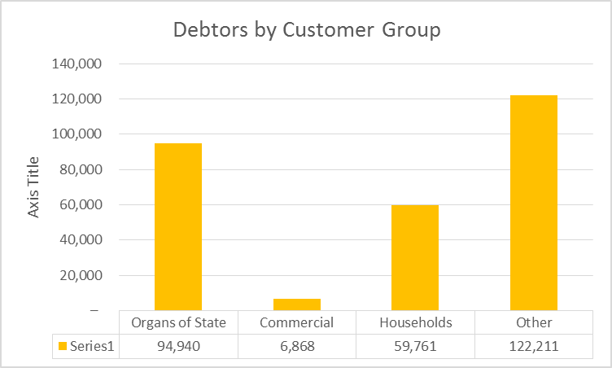

## CREDITORS ANALYSIS

**Table 4: Creditors as at 31 December 2018**



## INVESTMENT PORTFOLIO ANALYSIS

**Table 5: Investments as at 31 December 2018**



## ALLOCATION AND GRANT RECEIPTS AND EXPENDITURE



## MATERIAL VARIANCE TO THE SERVICE DELIVERY AND BUDGET IMPLEMENTATION PLAN





























**MUNICIPAL MANAGER’S QUALITY CERTIFICATE**

I, PS MKHIZE, the Municipal Manager of Inkosi Langalibalele Local Municipality, hereby certify that: -

* The monthly budget statements,
* The quarterly report on the implementation of the budget and financial state of affairs of the municipality, and
* The mid-year budget and performance assessment report

For the **Mid-Year Budget and Performance Assessment,** has been prepared in accordance with the MFMA and its Regulations made under the Act.

**Name: Mr PS Mkhize**

**Municipal Manager of Inkosi Langalibalele Local Municipality**

**Signature: _______________________**

## **Date: ___________________________**