INKOSI LANGALIBALELE MUNICIPALITY



MONTHLY BUDGET STATEMENTS

SEPTEMBER 2018

**MONTHLY FINANCIAL PERFORMANCE –SEPTEMBER 2018**

**1. Purpose**

To inform Council of the financial status of the municipality as at the end 30 September 2018

in accordance with Section 71 of the Municipal Finance Management Act 2003.

**2. Overview of current financial performance**

Table 1 : Operating Revenue and Expenditure as at the end of September 2018.

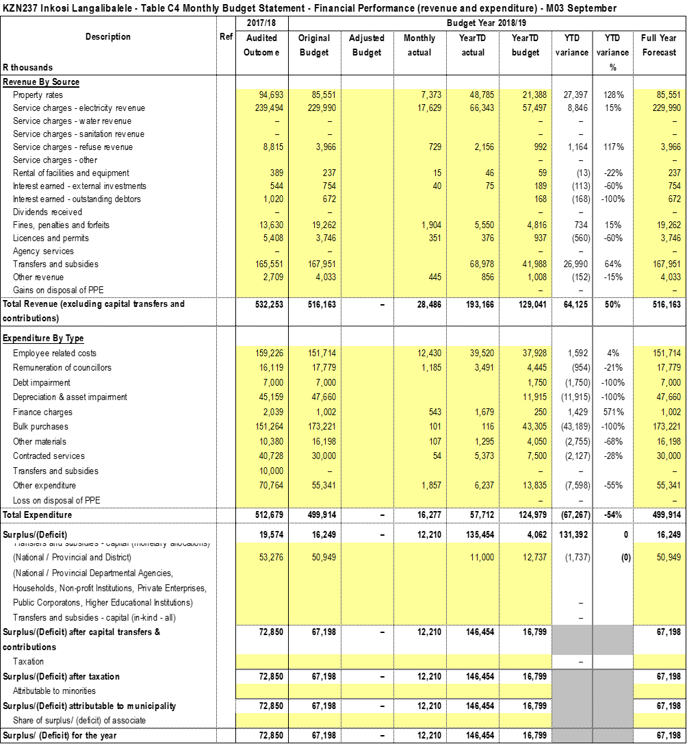

The table above table gives us a picture of the income collected and the expenditure incurred as at the end of September 2018. Total income for the month is 28 million. The highest source of income is service charges-electricity at 17.6 million and service charges-property rates at 7.3 million. Total expenditure this month is 16 million. Employee related costs are the highest at 12.6 million and other expenditure at 1.8 million followed by Remuneration of councillors at 996 thousands. The Municipality had a total operating surplus.

**Figure 1: Income**

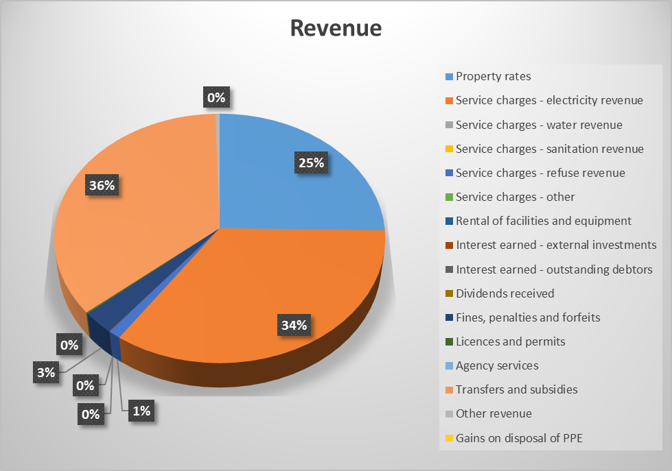

From the pie chart above we can see that we have three biggest sources of income to date being transfers and subsidies at 36%, service charges-electricity at 34% and service charges- property rates at 25% as at the end of September 2018.

.

**Table: Service charges**



From the above table, property rates received is lower compared to billed due to most debtors not paying on time. Billed property rates is very high due to most debtors being billed annually. Electricity and refuse removal are on par.

**Figure 2: Expenditure**

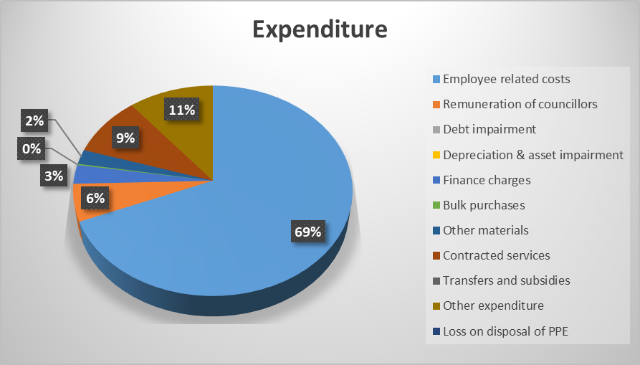

69% Employee related costs are highest as at the end of September 2018, followed by other expenditure at 11%. And contracted services at 9%.

**Section 66 Report**

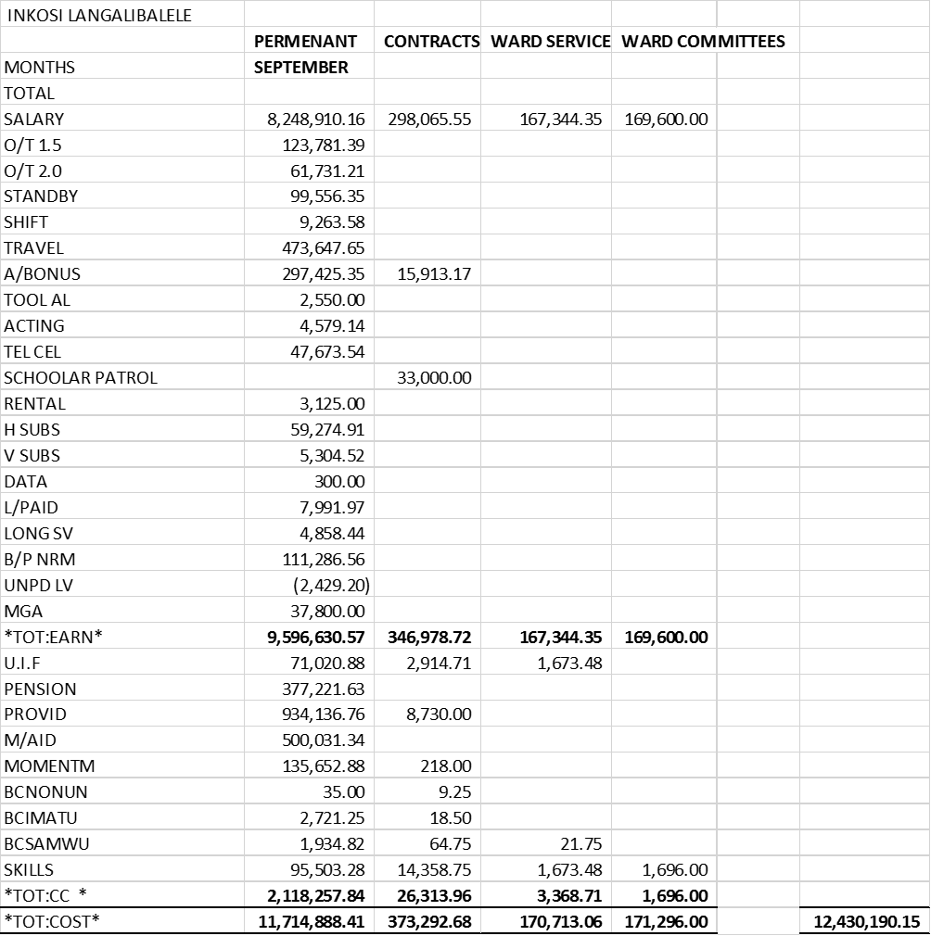

**2.2 INVESTMENTS**

The investments include all the unspent conditional grants and current year receipts that are ring fenced and cash reserves from land sales. Below is a table that details all the investments as at the end of 30 September 2018:

Table 2 : Investments



**2.2.1 Section 11- Withdrawals**



**BANK RECONCILIATION STATEMENT**



**CASH COVERAGE – SEPTEMBER 2018**



**2.3. GRANT FUNDING**

The table below illustrates the expenditure and receipt as at 30 September 2018. As at the end of September R 51 million had been spent on grants.

Figure 1: Grant Funding



**2.5** **CREDITORS AGE ANALYSIS**



The municipality is currently not paying creditors within 30 days. As we can see from the above table. We have creditors outstanding for over 180 days, this is a sign of cash flow weakness. The total Creditors outstanding is 128 million as at end of September.

**2.5.1 Top 20 Paid Creditors**



**2.5.2 Top 20 Unpaid Creditors**



**2.6 DEBTORS AGE ANALYSIS**

Table: Debtors Age Analysis



The aging debtors has decreased to 279 million from previous month being 280 million. Debtors outstanding over 90 has increased to 200 million. This shows that we aren’t performing, the debt collection section has to work harder to try and collect from our debtors.

*Budget Tables*

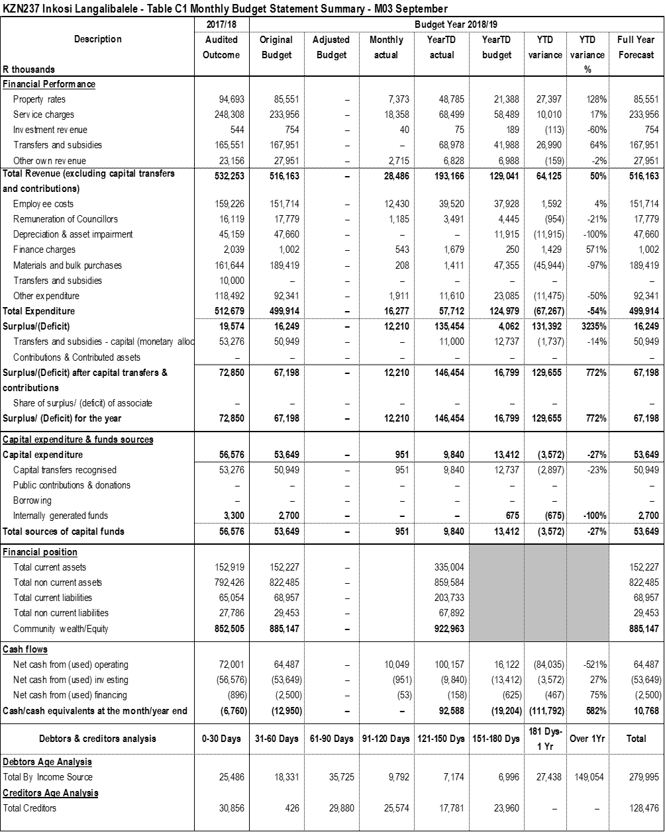















**3. RECOMMENDATION**

That the contents of this report be noted.

Reviewed by: Mr. PS Mkhize

Municipal Manager………………………