UMTSHEZI

MUNICIPALITY

KZN234



MID-YEAR BUDGET & PERFORMANCE ASSESSMENT 2014/15

Table of Contents

PART 1 – IN YEAR REPORT 2

Mayor’s Report 3

Resolutions 7

Executive Summary 7

PART 2 – SUPPORTING DOCUMENTATION 17

Debtors Analysis 19

Creditors’ Analysis 19

Investment portfolio analysis 20

Allocation and grant receipts and expenditure 21

Council allowances and employee benefits 21

Material variances to the service delivery and budget implementation plan 22

Municipal Manager’s quality certificate 34

Table 1: Income for July 2014 to December 2014 3

Table 2: Expenditure from July 2014 to December 2014 5

Table 4: Income for the six months ended 31 December 2014 9

Table 5: Monthly income for the six months ended 31 December 2014 9

Table 6: Expenditure for the period ended 31 December 2014 9

Table 7: Monthly expenditure for the six months ended 31 December 2014 10

Table 8: Capital expenditure for the period ended 31 December 2014 10

Table 16: Summary of Debtors as at 31 December 2014 19

Table 20: Creditors as at 31 December 2014 19

Table 21: Top ten creditors 19

Table 22: Investments 20

Table 23: Grants as at 31 December 2014 21

Table 25: Councillor allowances and employee benefits 21

Figure 1: Income for July 2012 to December 2014 3

Figure 2: Expenditure from July 2012 to December 2014 4

# Introduction

* 1. **Purpose**

To present the 2014/15 mid-year budget and performance assessment for the period covering 1 July 2014 to 31 December 2014 in terms of section 72 of the Municipal Finance Management Act (MFMA).

* 1. **Discussion**

The report will be discussed under the following broad headings:

1. Financial management
2. Mid Term performance review
   1. **Financial Management Review**

This section has been split in 2 parts in terms of reporting method as required by Treasury as follows:

Part 1 – In Year Report

1. Mayor’s Report
2. Executive Summary
3. Resolution
4. In year budget tables

Part 2 – In Year Report

1. Material variance explanation
2. Performance indicators
3. Debtors analysis
4. Creditors analysis
5. Investment portfolio analysis
6. Allocation and grant receipts and expenditure
7. Council and employee benefits
8. Capital Expenditure trend
9. Municipal Managers quality certificate

# PART 1 – IN YEAR REPORT

## Executive Mayor’s Report

The Mid-year budget and performance report is an assessment of the performance of the municipality for the first six months of the financial year. It serves as the mechanism which seeks to review the progress that is made in realizing the targets the municipality had set itself at the beginning of the financial year.

***Highlight of financial performance, Challenges and Risks for the period covering July 2014 to December 2014.***

Total operating revenue to date is R154 Million which is less by 2% from the budgeted target of R158 million. In terms of the percentage of total operating revenue by source actual to total budgeted operating revenue is 48% which the variance can be linked to the slow collection from debtors hence the SCM unit expedite appointment of a Debt Collector contract .Total operating Expenditure which is accumulated from July 2014 is at R 141 million which is 15% less than the budgeted amount of R167million. While this be seen as good news from finance perspective, it is still a challenge for the municipality to further reduce spending as much as possible, but not to the detriment of service delivery, just to stabilise the cash flow position of the municipality.

Below is a chart that depicts the income billed from July 2014 to December 2014:

Figure : Income for July 2014 to December 2014

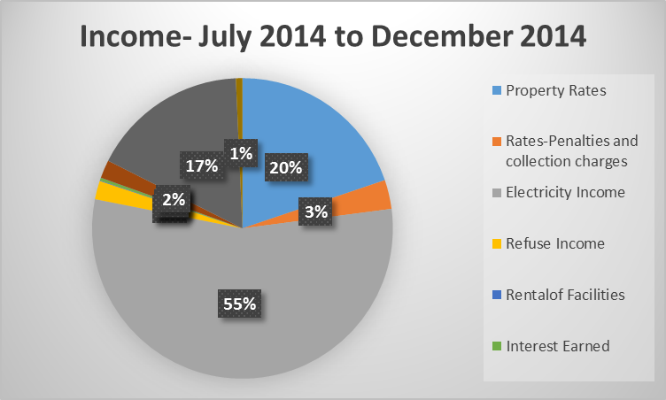

Table : Income for July 2014 to December 2014



**Property rates**

The actual revenue for property rates against the budget is at 57% which is very good. Also penalties on collection of rates is showing a healthy sign at 78%.

**Electricity**

The actual revenue for electricity is at 45.21 % of budget and that is below the half year budget estimate percentage.

Figure : Expenditure from July 2014 to December 2014

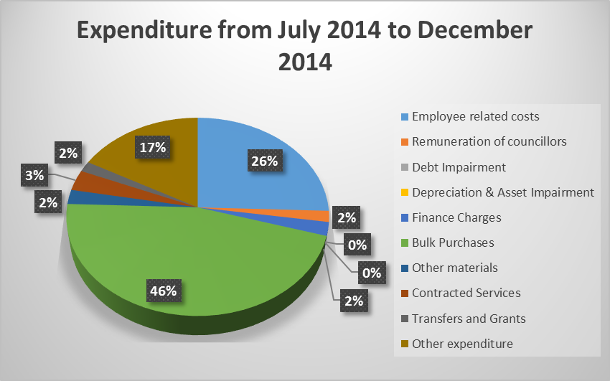

Summary of expenditure for the period July 2014 to December 2014:

Table : Expenditure from July 2014 to December 2014



**Salaries**

The salaries are at 53 per cent of the budget, and that is deemed reasonable and is within the budgetary limits.

**Bulk purchases**

The bulk purchases is at 44 percent of the budget and that is deemed reasonable and is within budgetary limits. The lower percentage is expected as there was lower electricity sale.

**General expenses**

General expenses at 71 percent of the budget is very high, adjustment budget is necessary.

## 

## Financial performance

Table : Operating income and expenditure



***Statement of financial performance***

The statement above of financial performance shows that the municipality is able to pay for its expenses, however it should be noted that general expenses have grown significantly against budget and that makes budget adjustment necessary.

***Summary of municipal performance in terms of PMS, Scorecard and Budget***

A detailed assessment of the performance of the municipality in terms of its service delivery and budget implementation plan is contained in this report. There are a few challenges facing the fulfilment of the capital conditional grants, but these problems have been resolved and progressshould be made from January 2015. In terms of the other performance objectives, many have been met as detailed in the half yearly performance report.

***Summary of past year’s annual report***

In the 2013/14 financial year, the municipality had received an unqualified audit opinion which is an improvement from the qualified audit opinion it held in the previous year. There still remains many challenges regarding service delivery issues and we are currently implementing plans to ensure that all those challenges are addressed

***Summary of impact of the National Adjustments Budget and Provincial Adjustments Budget***

National Treasury is set to release its adjustments to the Division of Revenue Act (DORA) which would take into account adjustments to allocations for the 2014/15 financial year. Our municipality has received R3million from COGTA which will be utilised for the storm water drains project. According to the Division of Revenue Bill, adjustments have been made on Infrastructure Sports Facility Grants, initially the municipality budgeted for R150 000 which is now adjusted to R675 000, Community Library Service Grant has been adjusted from R252 000 to R126 000 and lastly, Museum Grant adjusted from R598 000 to R302 000.

***Recommendations***

Based on the findings in this report, adjustments need to be made in the adjustments budget. I recommend that an adjustment budget be tabled to address these variances as well as the adjusted allocations from national and provincial treasury to ensure that there are sufficient funds available for service delivery. Moreover, adjustments need to be made to our Operating budget on the basis of six months financial performance.

**MAYOR** - **COUNCILLOR B.D DLAMINI**

## Resolutions

**It is resolved:**

1. That the Mid-Year Budget and Performance Assessment referred to in Section 72 of the Municipal Finance Management Act, 56 of 2003 be NOTED.
2. That the monthly budget statement and supporting documentation be NOTED.
3. That the quarterly report on the implementation of the budget and the financial affairs of the municipality as referred to in Section 52(d) of the Municipal Finance Management Act,56 of 2003, be NOTED.

## Executive Summary

**INTRODUCTION**

The Municipal Finance Management Act, No. 56 of 2003, makes it necessary for all municipalities to prepare mid-year budget and performance assessments. S72 of the Act states the following:

1. The Accounting Officer of a Municipality must by 25 January of each year –
2. Assess the performance of the municipality during the first half of the financial year, taking into account-
3. The monthly statements referred to in Section 71 for the first half of the year
4. The municipality’s service delivery performance during the first half of the financial year, and the service delivery targets and performance indicators set in the service delivery and budget implementation plan;
5. The past year’s annual report and progress on resolving problems identified in the annual report; and
6. The performance of every municipal entity under the sole or shared control of the municipality, taking into account reports in terms of section 88 from and such entities.

In compliance with Section 72 of the Act, the Mid-Year Performance Assessment is compiled and reported on accordingly.

**FINANCIAL PERFORMANCE VS APPROVED BUDGET**

Tables C1 and C4 highlight the financial performance of the municipality for the first half of the financial year. It is clear from the tables that the municipality had reported a surplus of R18 million, this surplus is inclusive of operating and capital grants.

***Income***

The income reported for the period was R154 million compared to the budgeted income of R158 million.

The decrease in revenue comes from the slow collection of debtors. The SCM unit has not appointed a contractor for debt collection. Therefore the municipality has not been able to collect all its debts as budgeted. The equitable share was also lower than the budgeted amount, due to the rollover of the grants that was declined by Treasury.

The income for the period as detailed in the table below shows the income billed versus the budgeted income and the audited annual figures for the 2013/14 financial year. Rates billed are higher than year to date budget. The fines budget should be adjusted to reflect a more realistic income to be received from this source of revenue.

Table : Income for the six months ended 31 December 2014



Table : Monthly income for the six months ended 31 December 2014



***Expenditure***

The expenditure for the six month period is reported at R142 million. Below is a table that details the expenditure.

Table : Expenditure for the period ended 31 December 2013



Table : Monthly expenditure for the six months ended 31 December 2014



***Capital Expenditure***

The overspending in the Planning Economic & Community Services department is due to projects which have run for a couple of years that can be identified as the Wembezi Multi-purpose Centre and the Wembezi Taxi rank. Council decided to stop spending on certain projects in order to fund the above mentioned projects. The over spending in the Corporate Services is due to a loan that was received during the six months for security camera. The capital budget will need to be adjusted accordingly to cater for the above mentioned projects.

Table : Capital expenditure for the period ended 31 December 2014

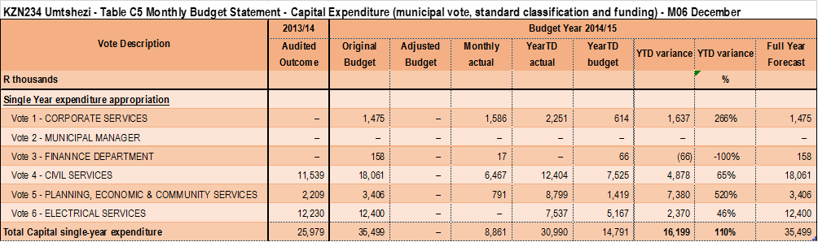

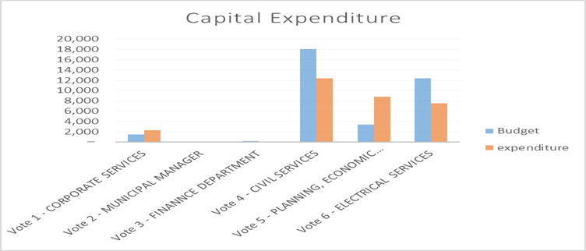

**Bank Reconciliation Statement as at 31 December 2014**



***Conclusion***

Cash balances as at 31 December 2014 were R2,465,922, with balances in investment accounts being R28,021,665. The cash flow situation of the municipality is currently weak when considering month by month. This has reference in the cash flow Actuals (CFA), Since September the monthly cash flow has been negative, which puts strain on the municipal expenditure to be halted and where possible, to delay payments of creditors to the last day payment.

***In Year Budget Statements Tables***











# 

# 

# 2 – SUPPORTING DOCUMENTATION

## Debtors Analysis

The outstanding debtors for the period ended has been reported at R96 million. This figure is due to old Debt from property rates. The Municipality needs to work harder on collecting old debts.

Table : Summary of Debtors as at 31 December 2014



***Arrear Debt***

Much progress has been made in terms of arrear debt collection. However, it is still a big concern that 77 percent of outstanding debtors are sitting on 90 days.

## Creditors’ Analysis

The outstanding creditors have been controlled and monitored. There have been some disputes with some suppliers resulting in payments being delayed due to those issues. Other than those disputed issues, suppliers are being paid within 30 days from receipt of their invoice. Below is a table summarising the ageing of the outstanding creditors.

Table : Creditors as at 31 December 2014



Table : Top ten creditors





## Investment portfolio analysis

Below is a table that details the investments as at 31 December 2014.

Table : Investments



## Allocation and grant receipts and expenditure

Table : Grants as at 31 December 2014



## Council allowances and employee benefits

Table : Councillor allowances and employee benefits



The expenditure on employee related costs is at 53 percent of the budget, which is deemed reasonable and is within the budgetary limits.

## Material variances to the service delivery and budget implementation plan

|  |  |  |  |  |  |  |  |  |  |  |  |  |
| --- | --- | --- | --- | --- | --- | --- | --- | --- | --- | --- | --- | --- |
| **UMTSHEZI LOCAL MUNICIPALITY 2014/2015 FINANCIAL YEAR** | | | | | | | | | |  |  |  |
| **STRATEGIC OBJECTIVE/ OUTPUT** | **STR REF** | **STRATEGIES** | **KPI** | **RESPONSIBLE OFFICIAL** | **2013/2014** | **2014/2015 FY** | **QUARTERLY TARGETS** | | |  | Reasons for Non performanace | Corrective Actions |
| **ANNUAL TARGETS** | **ANNUAL TARGETS** | **Q1 Target** | **Q1 Actual** | **Q2 Target** | **Q2 Actual** |
| To improve institutional and organisational capacity | A1.1 | Review and implement an effective organogram | Date of adopted reviewed organogram | Director: Corporate | **30/06/2014** | **30-Jun-15** | 0 | **n/a** | 0 | **n/a** |  |  |
| Date of adoption | Director : Corporate | **30/06/2014** | **10** | 2 | **6** | 3 | **4** |  |  |
| A.1.2 | Review and implement workplace skills plan | Date of Adoption | Director : Corporate | **30/06/2014** | **7/31/2014** | 7/31/2014 | **27/08/2014** | 0 | **n/a** | The WSP was submitted on time,however, Council only sat on the 28/08/2014, |  |
|  |  | Number of employees trained according to the workplace skills plan | Director : Corporate | **n/a** | **42** | 10 | **22** | 11 | **18** |  |  |
|  |  | Number of employees undertaking induction courses | Director : Corporate | **n/a** | **10** | 3 | **4** | 3 | **4** |  |  |
|  | A1.3 | Develop & Review HR Policies | Number of HR policies developed & reviewed | Director : Corporate | **n/a** | **4** | 0 | **n/a** | 0 | **n/a** |  |  |
|  | A1.4 | Develop & Review IT Policies | No. of IT policies developed & reviewed | Director :Corporate | **n/a** | **4** | 0 | **n/a** | 0 | **n/a** |  |  |
| To ensure functional performance management system implemented | A2.1 | Review and implement Performance Management System | Date of adoption of performance Management system | Municipal Manager | **n/a** | **30-Jun-15** | 0 | **n/a** | 0 | **n/a** |  |  |
| Number of performance management report submitted to council | Municipal Manager | **n/a** | **4** | 1 | **1** | 1 | **1** |  |  |
| Number of individual performance assessments conducted for S56/54 | Municipal Manager | **n/a** | **4** | 1 | **0** | 1 | **0** | The internal audit tender has not been finanlised due to an objection recived from one of the bidders, | To ensure that the tender is finalised timeously |
| To advance access to Basic Services | B1.1 | Facilitate provision of electricity supply to households by Eskom outside town planning schemes | Review households without electricity in terms of new housing schemes | Director Technical | **0** | **1** | 1 | **1** | 0 | **n/a** |  |  |
| Submit a consolidated list of households without electricity identified during izimbizo to Eskom | Director: Technical Services | **0** | **1** | 1 | **1** | 0 | **n/a** |  |  |
| B1.2 | Ensure provision of electricity supply to households within the town planning schemes . | Number of existing units provided with electricity | Director: Technical Services | **12151** | **12151** | 12151 | **12158** | 12151 | **12163** |  |  |
| Number of households receiving free electricity | Director: Technical Services | **3362** | **3362** | 3362 | **5420** | 3362 | **5430** |  |  |
| B1.3 | Providing access to solid Waste Disposal Services | Number of existing units receiving solid waste disposal | Director: Technical Services | **20638** | **20638** | 20638 | **20638** | 20638 | **20638** |  |  |
| Number of households receiving free solid waste disposal | Director :PECS | **3362** | **3362** | 3362 | **5420** | 3362 | **5430** |  |  |
| B1.4 | Facilitate an improved road network | Number of Rural Road Forum meetings attended | Director : PECS | **4** | **4** | 1 | **0** | 1 | **0** | CMC meetings not sitting | The MEC has been notified about the non sittings of the CMC |
| B1.5 | Upgrading of existing road infrastructure | Number of kilometres of existing road upgraded | Director: Technical Services | **2km** | **5km** | 0 | **6,4km** | 2,5km | **4,5km** |  |  |
| B1.6 | Provision and maintenance of community and public facilities | Number of creches built | Director: Technical Services | **1** | **1** | 0 | **n/a** | 0 | **n/a** |  |  |
| Number of community and facilities maintained | Director :PECS | **1** | **5** | 5 | **13** | 5 | **13** |  |  |
| B1.7 | Develop sustainable human settlements | Number of submissions of record of decisions to department of environmental affairs | Director : PECS | **0** | **6** | 6 | **1** | n/a | **n/a** | The targets were planned based on the applications received, The turnaround time is determined by Environmental Affairs, | To enhance communication between the Municipality and Environmental Affairs, All apllications to meet full reqirements on first submission to Environmental Affairs, |
| Number of planning and development act applications approved | Director :PECS | **0** | **6** | 6 | **4** | n/a | **n/a** | Depends on the number of applications received | Town Planners are to ensure that all compliance in terms of finalisation of applications received. |
| B1.8 | Installation of solar streetlights |  | Director :PECS | **0** | **60** | 0 | **106** | 30 | **128** |  |  |
| To promote economic growth and development | C1.1 | Facilitate a Safe and Secure environment | Number of surveillance cameras installed | CORPORATE | **0** | **2** | 0 | **n/a** | 2 | **12** |  |  |
| C1.2 | Develop and capacitate SMMEs | Number of training conducted | Director :PECS | **50** | **2** | 0 | **5** | 1 | **0** | Dept of Economic development did not conduct any trainging for the second quarter | Department of Ecomic Development was contacted to ensure that training is done on a quarterly basis, |
| C1.3 | Create jobs through LED initiatives | Number of jobs created through EPWP | Director :PECS | **0** | **130** | 32 | **50** | 33 | **50** |  |  |
| Number of jobs created through CWP | Director :PECS | **0** | **1000** | 250 | **939** | 250 | **939** |  |  |
| Number of jobs created through Capital Projects | Director :PECS | **137** | **32** | 0 | **50** | 32 | **50** |  |  |
| To advance effective Public Participation | D1.1 | Develop and implement effective public participation strategy | Public participation strategy adopted by council | Director : PECS | **0** | **30-Sep-14** | 14-Sep-30 | **0** | n/a | **n/a** | Funding Challenges experienced | To obtain funding |
| D1.2 | Ensure functional ward committee structures | Number of meetings per ward | Director : PECS | **6** | **36** | 9 | **9** | 9 | **9** |  |  |
| Improve municipal audit opinion and accountability | D2.1 | Audit committee meetings held | Number of Audit Committee reports submitted to council | Municipal Manager | **6** | **4** | 1 | **0** | 1 | **1** | The Chairperson of the Audit Committee was unavailable | Report has been submitted to Council |
| D2.2 | Approved and implemented audit plan | Date approved | Municipal Manager | **0** | **30-Sep-14** | 30-Sep-14 | **0** | n/a | **n/a** | The internal audit tender has not been finanlised due to an objection recived from one of the bidders, | To ensure that the tender is finalised timeously |
| Reports issued in terms of audit plan | Municipal Manager | **4** | **4** | 1 | **0** | 1 | **0** | The internal audit tender has not been finanlised due to an objection recived from one of the bidders, | To ensure that the tender is finalised timeously |
| D.2.3 | Hold Oversight meetings | Number meetings held | Municipal Manager | **4** | **4** | 1 | **2** | 1 | **1** |  |  |
| To improve budget implementation in the municipality | E1.1 | Optimize the expenditure of capital budget | Percentage Capital expenditure budget implementation (actual capital expenditure/budget capital expenditure x100) | Director : Technical | **100%** | **100%** | 25% | **31%** | 25% | **34%** |  |  |
| E1.2 | Optimize the expenditure of operational budget | Percentage operational expenditure budget implementation (actual operational expenditure/budget operational expenditure x100) | CFO | **0** | **100%** | 25% | **23%** | 25% | **59%** |  |  |
| E.1.3 | Optimize revenue of operational budget | Percentage operating revenue budget implementation (actual operating expenditure/budget operating revenue x100) | CFO | **0** | **100%** | 25% | **26%** | 25% | **19%** | Curb Spending | Increase collection rate |
| E1.4 | Optimize actual service charges and property rates revenue | Percentage service charges and property rates revenue budget implementation (Actual service charges and property rates revenue/budget service charges and property rates revenue x100) | CFO | **0** | **100%** | 25% | **26%** | 25% | **24%** | Curb Spending | Increase collection rate |
| E1.5 | Improvement of Annual Financial Statement | Improved audit opinion | CFO | **0** | **Unqualified** | 0 | **n/a** | Unqualified | **Unqualified** |  |  |
| E1.6 | Budget spent on Workplace Skills Plan | % of expenditure of budget allocated to Workplace Skills Plan | CFO | **100%** | **100%** | 25% | **22%** | 25% | **23%** | Discretionary grant was not received, | Proper Control of traininging will be done as departments were not liaising with the HR department and the Skkills Development Facilitator when employees undertaking training. |
| E1.7 | Updating of asset register | Date of adoption of the updated asset register | CFO |  | **31-Oct-14** | n/a | **n/a** | 31-Oct-14 | **31-Oct-14** |  |  |
| To promote efficient and credible strategic and spatial municipal planning | F1.1 | Review SDF | Date of adoption | Director : PECS | **28/05/2014** | **31-Jul-14** | 31-Jul-14 | **28/05/2014** | n/a | **n/a** |  |  |
| To promote sustainable protection and development of the environment | F2.1 | Review integrated environmental management plan | Date of adoption | Director: PECS | **yes** | **31-Oct-14** | n/a | **n/a** | 31-Oct-14 | **0** | Funding Challenges experienced | To obtain funding |
| To improve response to Disasters | F3.1 | Review Disaster management framework | Date of adoption | Director : PECS | **yes** | **31-Oct-14** | n/a | **n/a** | 31-Oct-14 | **0** | Funding Challenges experienced | To obtain funding |
| F3.2 | Respond to disaster in terms of management framework | Number of disaster management forums meetings held | Director : PECS | **0** | **4** | 1 | **5** | 1 | **1** |  |  |
| F3.3 | Number of reports submitted in terms of disaster | Director : PECS | **0** | **12** | 3 | **3** | 3 | **3** |  |  |

## Municipal Manager’s Quality Certificate

I, Ms P.N. Njoko, Municipal Manager of uMtshezi Municipality, hereby certify that –

* The monthly budget statement
* The quarterly report on the implementation of the budget and financial state of affairs of the municipality, and
* The mid-year budget and performance assessment

for the month of December 2014, has been prepared in accordance with the Municipal Finance Management Act and regulations made under the Act.

Name: Ms P.N Njoko

Municipal Manager of Umtshezi Municipality, KZN234

Signature:_____________________________________________

Date:_________________________________________________