UMTSHEZI

MUNICIPALITY

KZN234



MFMA SECTION 28 REPORT – 2014/15

ADJUSTMENTS BUDGET

Contents

**PART 1 – ADJUSTMENT’S BUDGET** 3

**Mayor’s Report** 3

**Resolutions** 4

**Executive Summary** 4

**BACKGROUND** 5

**SUMMARY OF ADJUSTMENTS** 6

CAPITAL EXPENDITURE 9

**CONCLUSION** 10

**PART 2 – SUPPORTING DOCUMENTATION** 18

**Adjustments to expenditure on allocations and grant programmes** 19

**Adjustments to allocations and grants made by the municipality** 19

**Adjustments to capital expenditure** 19

**Municipal manager’s quality certificate** 21

# **PART 1 – ADJUSTMENT’S BUDGET**

# **Mayor’s Report**

Section 28 of the Municipal Finance Management Act, No. 56 of 2003, states that the Mayor must table an adjustments budget in the Municipal Council at any time after the mid-year budget and performance assessment has been tabled in council but no later than the 28th of February as per Treasury guidelines.

The Mid-Year Budget and Performance Assessment for the six months ending December 2014 was tabled in Council on the 22nd of January 2015. Recommendations were made in the report that an adjustments budget be drafted as a result of some of the variances detailed in the assessment. The adjustments budget is detailed in this report and takes into consideration all the matters raised in the Mid-Year Budget Assessment.

Overall, the budgeted operating financial performance of the municipality will decrease by R3,429 million. The overall original deficit, including capital transfers, will decline in the adjustments budget to a deficit of R8,2 million. This is due to the decrease in electrical income, which is caused by the load shedding.

The capital expenditure has also been adjusted. Additional grants have been gazetted in the DORA in December 2014 resulting in additional capital grants that will be forwarded to the Municipality, namely the Neighbourhood Partnership Development Grant. Additional grants from the Province have also been gazetted, namely, the Small Town Rehabilitation grant and the Infrastructure Sports Facilities Grant. There are also increases in council funded assets that amount to a net adjustment of R5,8million. This is detailed in the Executive Summary and attached Detailed Capital Budget. The tables in this document provide details of the adjustments to the capital and operating estimates. I strongly recommend that the Council approves the Adjustments Budget.

**MAYOR**

**COUNCILLOR B.D DLAMINI**

## **Resolutions**

It is recommended:

1. THAT THE 2014/2015 ADJUSTMENTS BUDGET BE APPROVED
2. THAT THE ADJUSTMENTS PERMITTED IN TERMS OF SECTION 28(2) OF THE MFMA BE APPROVED.
3. THAT THE TRANSFER OF FUNDS TO A SEPARATE BANK ACCOUNT BE APPROVED FOR PURPOSES CONTEMPLATED IN SECTION 12 OF THE MFMA

# **Executive Summary**

A Mid-Year Budget Performance Report was tabled in Council on the 22nd of January 2015. This report highlighted the financial and non-financial performance of the Municipality for the first half of the financial year. In this report certain recommendations had been made based on the financial performance of the Municipality. These recommendations and additional trends that had been analysed have been taken into account when drafting this adjustments budget. In addition to this, the economic climate, both internal and external, was considered.

## **BACKGROUND**

An adjustments budget is usually tabled before Council at the prescribed time, namely, 60 days after the adjustments to the Division of Revenue Act (DORA) have been gazetted. The Adjusted DORA was gazetted in December 2014 which effectively means that the adjustments budget should be tabled before the end of February 2015.

The Mid-Year Budget Performance Report highlighted variances in terms of year to date income and expenditures versus year to date budgets. These variances were considered and adjustments made, where necessary, in this adjustments budget.

When drafting the adjustments budget, consideration was always given to Section 18 of the MFMA which states that:

*“An annual budget may only be funded from-*

* 1. *realistically anticipated revenues to be collected;*
  2. *cash-backed accumulated funds from previous years’ surpluses not committed for other purposes; and*
  3. *borrowed funds, but only for the capital budget referred to in section 17(2)*

1. *Revenue projections in the budget must be realistic, taking into account-* 
   * 1. *projected revenue for the current year based on collection levels to date; and*
     2. *actual revenue collected in previous financial years.”*

Great emphasis was placed in ensuring that the budget is realistically funded. A complete analysis of the various financial scenarios and outcomes was done and the best viable solution sought. The supporting document on budget funding highlights the various funding sources identified to ensure that cash reserves are always available to fund expenditure. The eventual outcome was to ensure that the adjustments budget was credible.

A credible budget is described as one that:

* Funds only activities consistent with the revised IDP and vice versa ensuring the IDP is realistically achievable given the financial constraints of the municipality
* Is achievable in terms of agreed service delivery and performance targets
* Contains revenue and expenditure projections that are consistent with current and past performance and supported by documented evidence of future assumptions
* Does not jeopardize the financial viability of the municipality (ensures that the financial position is maintained within generally accepted prudential limits and that obligations can be met in the short, medium and long term); and
* Provides managers with appropriate levels of delegation sufficient to meet their financial management responsibilities.

## **SUMMARY OF ADJUSTMENTS**

OPERATING BUDGET

Total operating income decreased from the original budget of R316million to R302million. This is due to the decrease in Electricity Income which is our main source of income. This decrease is caused by the lower usage of electricity by the firms due to load shedding. The Second contributing factor is the decrease in Refuse Revenue. This is due to the low collection from debtors, as the debt collection tender has not yet been awarded.

The total operating expenditure has increased from R335million to R348million. This was mainly due to the adjustment made to debt impairment of 4million. The debt impairment was under budgeted for as there will be debt of about 12million that will be written off during the year. Finance costs have also increased by 5million. This was also under budgeted for, as the interest on the new loan and the yellow plant leases were not taken into consideration when the original budget was being prepared. The increase in other expenditure in mainly due to the increase in consumption of fuel which is caused by the new plant.

The following expenditure items have been adjusted:

|  |  |  |  |  |  |  |  |  |
| --- | --- | --- | --- | --- | --- | --- | --- | --- |
| 1. |  | Finance Charges | |  |  |  |  |  |
|  |  | The operating lease charges have increased significantly due the new yellow plant lease and the new ABSA loan. The finance charges have been adjusted by 5million | | | | | | |
|  |  |  | | | | | | |
|  |  |  | | | | | | |
| 2. |  | Debt Impairment | |  |  |  |  |  |
|  |  | Debt impairment has increased by 4 million. The write offs have been estimated to amount to 12 million for the current financial year. The original budget was therefore not sufficient. Hence there was a need for an adjustment. | | | | | | |
|  |  |  | | | | | | |
|  |  |  | | | | | | |
|  |  |  | | | |  |  |  |
| 3. |  | Repairs and Maintenance | |  |  |  |  |  |
|  |  | Much needed maintenance was required for Electricity networks. | | | | | | |
|  |  | Maintenance of municipal halls and Municipal vehicles also needs to be done | | | | | | |
|  |  | urgently. As a result of this, this expenditure was increased by R2million. | | | | | | |
| 4. |  | Other expenditure | |  |  |  |  |  |
|  |  | The Yellow Plant and the new fleet that the municipality has purchased in the previous financial year uses a lot of fuel hence the fuel votes had to be adjusted. | | | | | | |
| 5 | Bul | | K Purchases | | | | | | |
|  |  | Bulk purchases have decrease by 8million, this is due to the factories using less electricity because of load shedding. Therefore the demand for electricity has decreased and the purchases will therefore also decrease. | | | | | | |
|  |  |  | | | | | | |
|  |  |  | | | |  |  |  |
| Below we will find tables that summaries the adjusted operating income and expenditure of the municipality. | | | | | | | | |
|  |



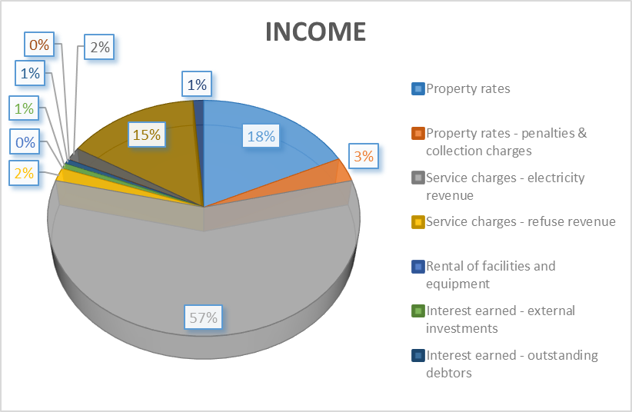

From the tables above we can see that electricity income has decreased but still remains our main source of income which makes up 57% of our total income. Our penalties and collection charges budget has been increased by 3.8 million. Fines have also been decreased due to the low collection during the year.



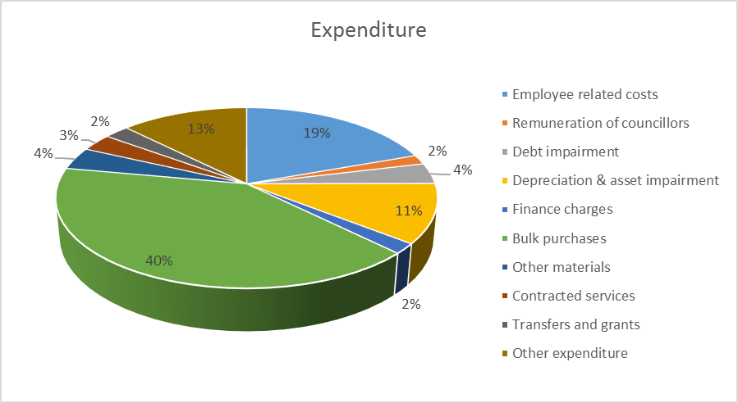

From the above table we can see that there has been an increase in debt impairment, Finance charges, repairs and maintenance , other expenditure and a Decrease in bulk purchases. Bulk purchases have decreased due to a decrease in demand caused by a low usage by factories because of the load shedding. Bulk purchases still remains our highest expenditure item at 40 percent of our total expenditure. Other expenditure is at 12 percent.

# CAPITAL EXPENDITURE

Total capital expenditure was originally estimated to be R35,5 million. This was originally funded as follows:

|  |  |
| --- | --- |
| NDPG | R1,326,000 |
| MIG | R17,289,000 |
| INEP | R10,000,000 |
| COUNCIL | R 6,234,000 |
| Provi of Libr | R 550,000 |
| FMG | R 100,000 |
|  |  |
|  |  |

There have been adjustments made to the allocations or grants for the Municipality that have resulted in a change to the above and resultant capital expenditure of R60,5 million. Grant funding of this expenditure is detailed in the ‘Adjustments to Grant Allocations’, in the supporting documents of this report. Below is a summary of the funding sources to the adjusted capital expenditure:



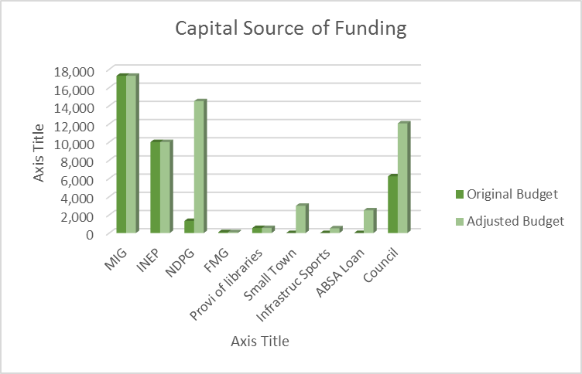

There has been a large increase in council funded capital expenditure. Council funding has increased from 6,2 million to 12 million. The municipality has received R 525,000 from the province which will be used for a sports ground. The municipality also received R3000,000 From the Small Town Rehabilitation grant. The original amount gazzeted for the NDPG WAS 1,3 million, however the municipality received a further amount of R13million from the grant.

## **CONCLUSION**

The adjustments that have been made in the adjustments budget is necessary due to the changes that have taken place in terms of DORA, the results of the mid-year budget and performance review and other items deemed necessary to ensure service delivery

BUDGET TABLES



















# **PART 2 – SUPPORTING DOCUMENTATION**

## **Adjustments to expenditure on allocations and grant programmes**

There was much change to the grant allocations from both National and Provincial Government. Below is a table that summarizes all the adjustments made.



## **Adjustments to allocations and grants made by the municipality**

There were no allocations and grants made by uMtshezi Municipality to any other municipality. There were, however, adjustments made to the municipality’s allocations. The museum grant has been decreased by R296,000 From R598,000 to R302,000. The Community Library Services Grant has decreased by R126,000, From R252,000 to R126,000. The Municipality Received an allocation of R3,000,000 for the Small Town Rehabilitation Grant. The Infrastructure grant was increased by R525,000, from R150,000 to R675,000. Lastly the NDPG grant was increased by R13,174,000, from R1,263,000 to R14,500,000.

## **Adjustments to capital expenditure**

Below is a table that highlights all the adjustments to the capital budget and its funding.



## C:\Users\lebo\Documents\New Folder\budget 2014-15\AdjustmentBudget\20150226083911006.tif