UMTSHEZI

MUNICIPALITY

KZN234



MID-YEAR BUDGET & PERFORMANCE ASSESSMENT 2015/16

Table of Contents

PART 1 – IN YEAR REPORT 2

Mayor’s Report 3

Resolutions 7

Executive Summary 7

PART 2 – SUPPORTING DOCUMENTATION 17

Debtors Analysis 19

Creditors’ Analysis 19

Investment portfolio analysis 20

Allocation and grant receipts and expenditure 21

Council allowances and employee benefits 21

Material variances to the service delivery and budget implementation plan 22

Municipal Manager’s quality certificate 34

Table 1: Income for July 2015 to December 2015 3

Table 2: Expenditure from July 2015 to December 2015 5

Table 4: Income for the six months ended 31 December 2015 9

Table 5: Monthly income for the six months ended 31 December 2015 9

Table 6: Expenditure for the period ended 31 December 2015 9

Table 7: Monthly expenditure for the six months ended 31 December 2015 10

Table 8: Capital expenditure for the period ended 31 December 2015 10

Table 16: Summary of Debtors as at 31 December 2015 19

Table 20: Creditors as at 31 December 2015 19

Table 21: Top ten creditors 19

Table 22: Investments 20

Table 23: Grants as at 31 December 2015 21

Table 25: Councillor allowances and employee benefits 21

Figure 1: Income for July 2015 to December 2015 3

Figure 2: Expenditure from July 2015 to December 2015 4

# Introduction

* 1. **Purpose**

To present the 2015/16 mid-year budget and performance assessment for the period covering 1 July 2015 to 31 December 2015 in terms of section 72 of the Municipal Finance Management Act (MFMA).

* 1. **Discussion**

The report will be discussed under the following broad headings:

1. Financial management
2. Mid Term performance review
   1. **Financial Management Review**

This section has been split in 2 parts in terms of reporting method as required by Treasury as follows:

Part 1 – In Year Report

1. Mayor’s Report
2. Executive Summary
3. Resolution
4. In year budget tables

Part 2 – In Year Report

1. Material variance explanation
2. Performance indicators
3. Debtors analysis
4. Creditors analysis
5. Investment portfolio analysis
6. Allocation and grant receipts and expenditure
7. Council and employee benefits
8. Capital Expenditure trend
9. Municipal Managers quality certificate

# PART 1 – IN YEAR REPORT

## Mayor’s Report

The Mid-year budget and performance report is an assessment of the performance of the municipality for the first six months of the financial year. It serves as the mechanism which seeks to review the progress that is made in realizing the targets the municipality had set itself at the beginning of the financial year.

***Highlight of financial performance, Challenges and Risks for the period covering July 2015 to December 2015.***

Total operating revenue to date is R187 Million which is more by 7% from the budgeted target of R174 million. In terms of the percentage of total operating revenue by source actual to total budgeted operating revenue is 54% which it’s an improvement from the collection section. Total operating Expenditure which is accumulated from July 2015 is at R 161 million which is 18% less than the budgeted amount of R196 million. While this be seen as good news from finance perspective, it is still a challenge for the municipality to further reduce spending as much as possible, but not to the detriment of service delivery, but only to stabilise the cash flow position of the municipality.

Below is a chart that depicts the income billed from July 2015 to December 2015:

Figure : Income for July 2015 to December 2015

Table : Income for July 2015 to December 2015



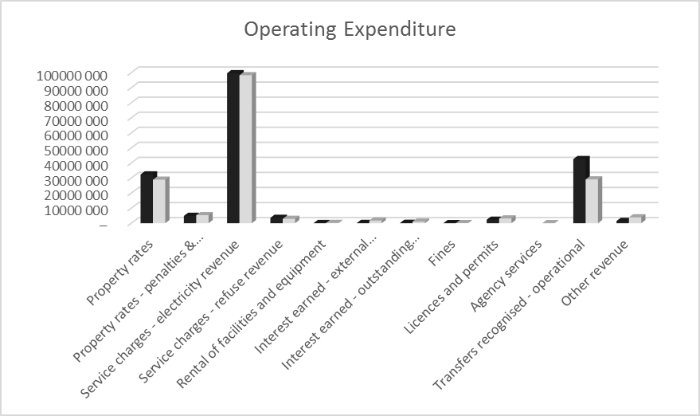

**Property rates**

The actual billed revenue for property rates against the budget is at 56% which is very good. Also penalties on collection of rates is slightly lower than expected simply because of the efforts on improved collection rate. The penalties is at 45%.

**Electricity**

The actual revenue for electricity is at 51 % of budget and that is 1% above the half year budget estimate percentage.

Figure : Expenditure from July 2015 to December 2015

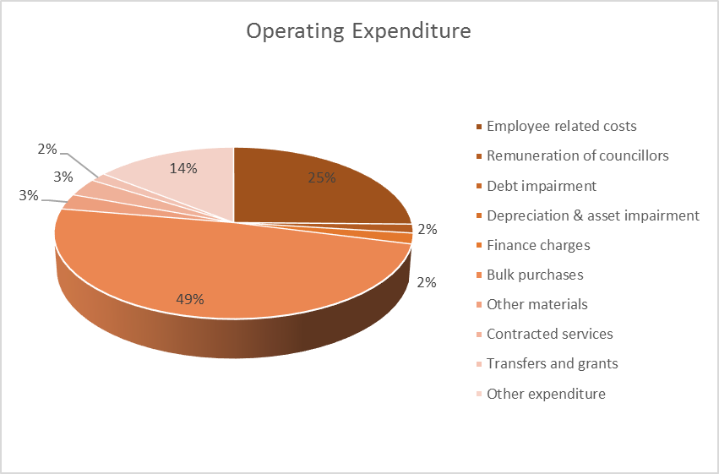

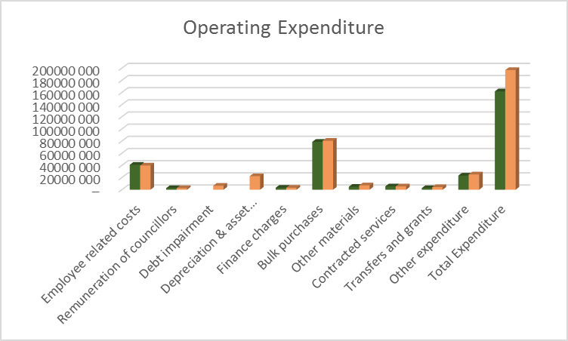

Summary of expenditure for the period July 2015 to December 2015:

Table : Expenditure from July 2015 to December 2015



**Salaries**

The salaries are at 51 per cent of the budget, and that is deemed reasonable and is within the budgetary limits.

**Bulk purchases**

The bulk purchases is at 49 percent of the budget and that is deemed reasonable and is within budgetary limits.

**General expenses**

General expenses at 46 percent of the budget is below the 50% expected for the budgeted amount of R50 millions.

Financial performance

Table : Operating income and expenditure



***Statement of financial performance***

The statement above of financial performance shows that the municipality is able to meet its financial obligation, with more effort to be put on the management of expenditure.

***Summary of municipal performance in terms of PMS, Scorecard and Budget***

A detailed assessment of the performance of the municipality in terms of its service delivery and budget implementation plan is contained in this report. There are a few challenges facing the fulfilment of the capital conditional grants, but these problems have been resolved and progressshould be made from January 2016.

***Summary of past year’s annual report***

In the 2014/15 financial year, the municipality had received a qualified audit opinion which is a regress from the unqualified audit opinion it received in the previous year. There still remains many challenges regarding service delivery issues and we are currently implementing plans to ensure that all those challenges are addressed

***Summary of impact of the National Adjustments Budget and Provincial Adjustments Budget***

National Treasury is set to release its adjustments to the Division of Revenue Act (DORA) which would take into account adjustments to allocations for the 2015/16 financial year. The municipality will be receiving R13 million from the Department of Public Works (Provincial) for the Property Rates.

***Recommendations***

Based on the findings in this report, adjustments need to be made in the adjustments budget. I therefore recommend that an adjustment budget be tabled to address these variances as well as the adjusted allocations from national and provincial treasury to ensure that there are sufficient funds available for service delivery. Moreover, adjustments need to be made to our Operating budget on the basis of six months financial performance.

**MAYOR** - **COUNCILLOR B.D DLAMINI**

## Resolutions

**It is resolved:**

1. That the Mid-Year Budget and Performance Assessment referred to in Section 72 of the Municipal Finance Management Act, 56 of 2003 be **NOTED.**
2. That the monthly budget statement and supporting documentation be **NOTED**.
3. That the quarterly report on the implementation of the budget and the financial affairs of the municipality as referred to in Section 52(d) of the Municipal Finance Management Act,56 of 2003, be **NOTED.**

## Executive Summary

**INTRODUCTION**

The Municipal Finance Management Act, No. 56 of 2003, makes it necessary for all municipalities to prepare mid-year budget and performance assessments. S72 of the Act states the following:

1. The Accounting Officer of a Municipality must by 25 January of each year –
2. Assess the performance of the municipality during the first half of the financial year, taking into account-
3. The monthly statements referred to in Section 71 for the first half of the year
4. The municipality’s service delivery performance during the first half of the financial year, and the service delivery targets and performance indicators set in the service delivery and budget implementation plan;
5. The past year’s annual report and progress on resolving problems identified in the annual report; and
6. The performance of every municipal entity under the sole or shared control of the municipality, taking into account reports in terms of section 88 from and such entities.

In compliance with Section 72 of the Act, the Mid-Year Performance Assessment is compiled and reported on accordingly.

**FINANCIAL PERFORMANCE VS APPROVED BUDGET**

Tables C1 and C4 highlight the financial performance of the municipality for the first half of the financial year. It is clear from the tables that the municipality had reported a surplus of R35 million, this surplus is inclusive of operating and capital grants. The surplus could change after the provision of Debt Impairment and Depreciation been taken into account.

***Income***

The income reported for the period was R187 million compared to the budgeted income of R174 million.

The income for the period as detailed in the table below shows the income billed versus the budgeted income. Rates billed are higher than year to date budget. The fines budget should be adjusted to reflect a more realistic income to be received from this source of revenue.

Table : Income for the six months ended 31 December 2015



Table : Monthly income for the six months ended 31 December 2015



***Expenditure***

The expenditure for the six month period is reported at R161 million. Below is a table that details the expenditure.

Table : Expenditure for the period ended 31 December 2015



Table : Monthly expenditure for the six months ended 31 December 2015



***Capital Expenditure***

The overspending in the Planning Economic & Community Services department is due to projects which have run for a couple of years that can be identified as the Hollace road. Council decided to stop spending on certain projects in order to fund the above mentioned projects. The underspending in the Electricity department is due to the delays in contract award for the electrification project. The capital budget will need to be adjusted accordingly to cater for the above mentioned projects.

Table : Capital expenditure for the period ended 31 December 2015



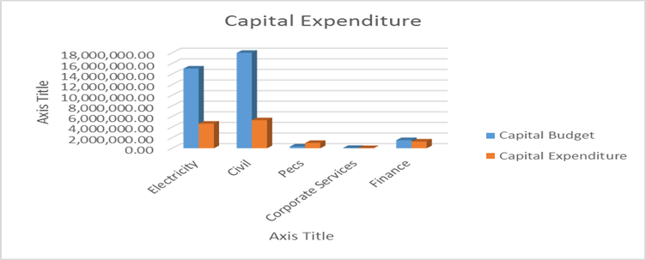

**Bank Reconciliation Statement as at 31 December 2015**

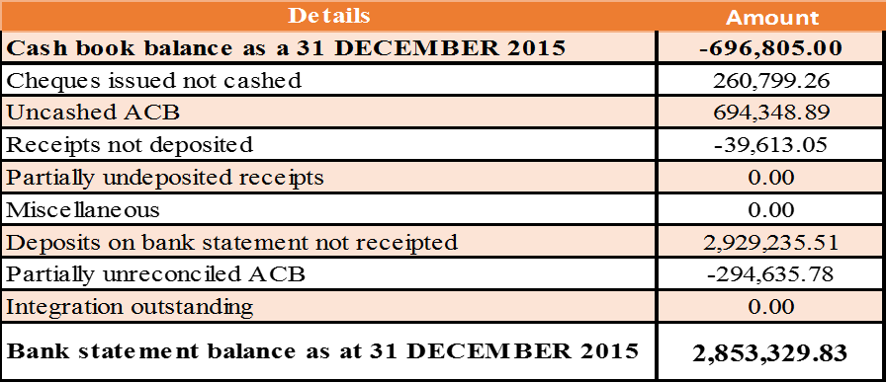

***Conclusion***

Cash bank balances as at 31 December 2015 were R2,853,329, with balances in investment accounts being R17,260,460. The cash flow situation of the municipality is currently weak when considering month by month.

***In Year Budget Statements Tables***













# 

# 2 – SUPPORTING DOCUMENTATION

## Debtors Analysis

The outstanding debtors for the period ended has been reported at R88 million. This figure is due to old Debt from property rates. The Municipality needs to work harder on collecting old debts.

Table : Summary of Debtors as at 31 December 2015

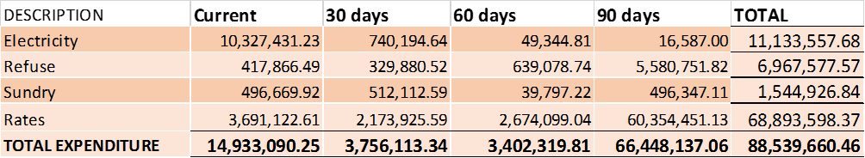

***Arrear Debt***

The total outstanding debt by the end of December 2015 is at R88 million. The amount has increased by R9.9 million compared to the end of last financial year with the outstanding amount of R 70 million. More attention must be dedicated into Rates collection as it contributes 78% of the total debt.

## Creditors’ Analysis

The outstanding creditors have been controlled and monitored. There have been some disputes with some suppliers resulting in payments being delayed due to those issues. Other than those disputed issues, suppliers are being paid within 30 days from receipt of their invoice. Below is a table summarising the ageing of the outstanding creditors.

Table : Creditors as at 31 December 2015

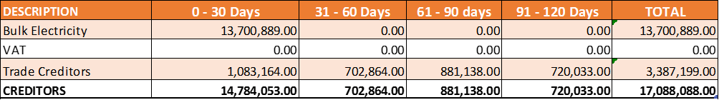

Table : Top ten paid creditors

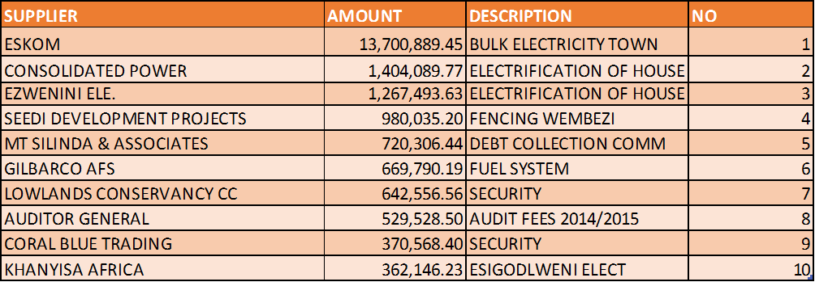

**Top ten outstanding creditors**

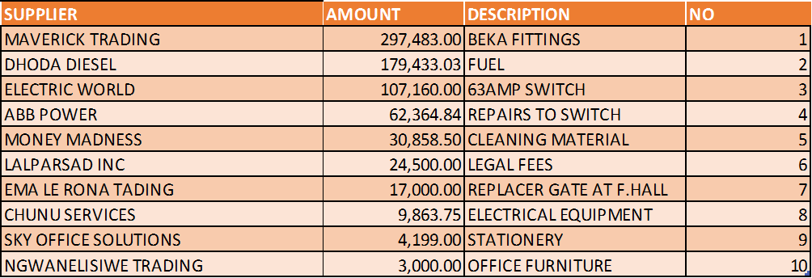

## Investment portfolio analysis

Below is a table that details the investments as at 31 December 2015.

Table : Investments

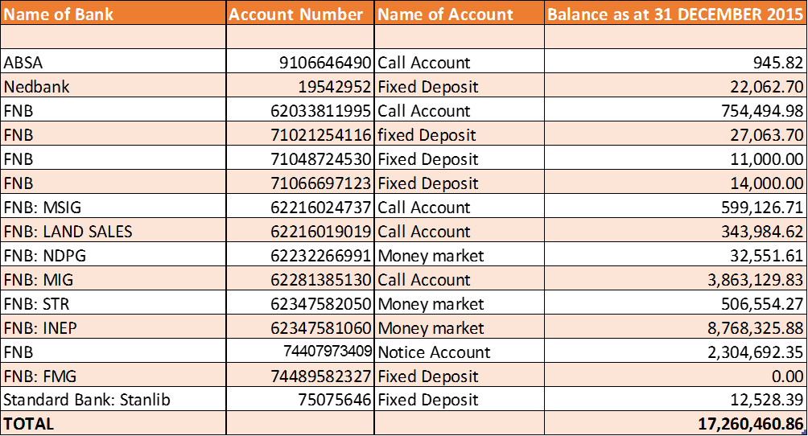

## Allocation and grant receipts and expenditure

Table : Grants as at 31 December 2015

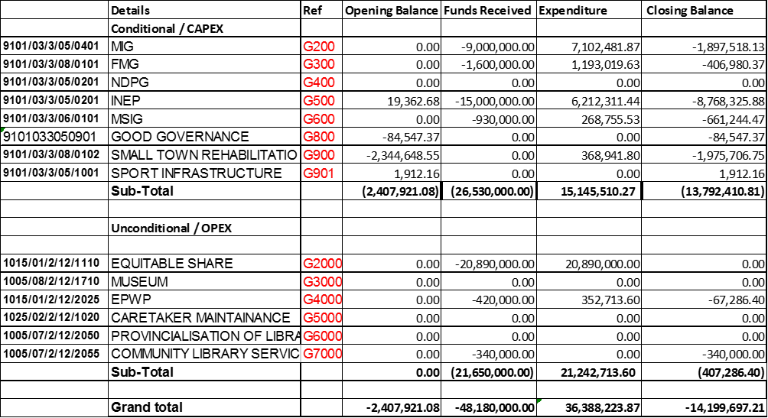

## Council allowances and employee benefits

Table : Councillor allowance and employee benefits



The expenditure on employee related costs is at 51 percent of the budget, which is deemed reasonable and is within the budgetary limits.

## Material variances to the service delivery and budget implementation plan







## 

## Municipal Manager’s Quality Certificate

I, **Mr E.H Dladla**, Municipal Manager of uMtshezi Municipality, hereby certify that –

* The monthly budget statement
* The quarterly report on the implementation of the budget and financial state of affairs of the municipality, and
* The mid-year budget and performance assessment

for the **Mid-Year Budget and Performance Assessment**, has been prepared in accordance with the Municipal Finance Management Act and regulations made under the Act.

Name**: Mr EH Dladla**

Acting Municipal Manager of uMtshezi Municipality, KZN234

Signature:_____________________________________________

Date:_________________________________________________