UMTSHEZI

MUNICIPALITY

KZN234



MFMA SECTION 52(d) REPORT – 2015/16

QUARTER 3

**Quarterly Financial Performance: 1st January 2016 – 31th March 2016**

**Executive summary**

To inform Committee of the financial status of the municipality for the Quarter 3 for the 2015/16 financial year in accordance with section 52(d) of the Municipal Finance Management Act 56 of 2003 which states “the mayor of a municipality must, within 30 days of the end of each quarter, submit a report to the council on the implementation of the budget and the financial state of affairs of the municipality”.

The Municipal Budget and Reporting Regulations also put emphasise on the quarterly reporting with Regulation 31(1) which state that “the mayor’s quarterly report on the implementation of the budget and the financial affairs of the municipality as required by section 52(d) of the MFMA must be –

1. In the format specified in Schedule C and include all the required tables, charts and explanatory information, taking into account any guidelines issued by the Minister in terms of section 168(1) of the MFMA; and
2. Consistent with the monthly budget statements for September, December, March and June as applicable; and
3. Submitted to the National Treasury and relevant provincial treasury within five days of tabling of the report in the council.

**Overview of the current financial performance**



Table C1 is a financial performance summary and provides a concise overview of the Umtshezi municipality’s performance from all major financial perspectives (operating, capital expenditure, financial position and cash flow).

**Financial Performance (Revenue and Expenditure)**



Table C4 explanatory notes:

Total operating revenue to date is R266 million which is more by 3% from the budgeted target of R259 million. In terms of the percentage of total operating revenue by source actual to total budgeted operating revenue is 77%. Total operating expenditure which is accumulated from July 2015 is at R223 million which is 26% lesser than the budgeted amount of R300 million. While this be seen as good news from finance perspective, it is still a challenge for the municipality to further reduce spending as much as possible, but not to the detriment of service delivery, only to stabilise the cash flow position of the municipality.

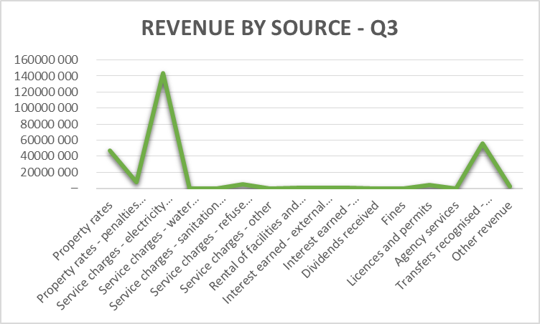

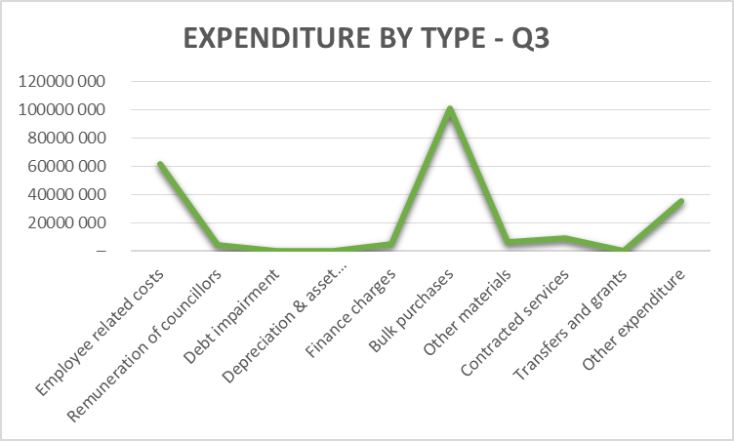

**Financial Performance (Revenue and Expenditure by vote)**



Table C3 provides financial information in terms of municipal votes. The only department that has collected satisfactory is PECS department which exceeded its target by 23%, while others struggle with the challenge that has been stated under table C4 explanatory note in regard of debt collection.

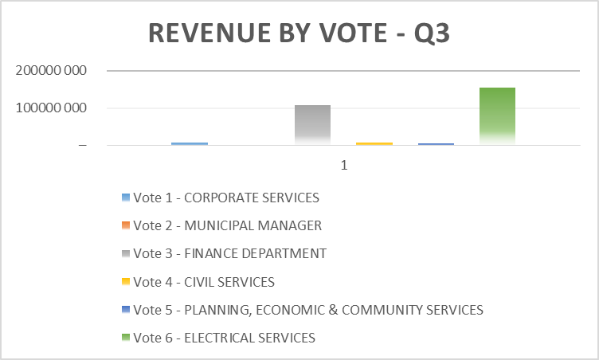

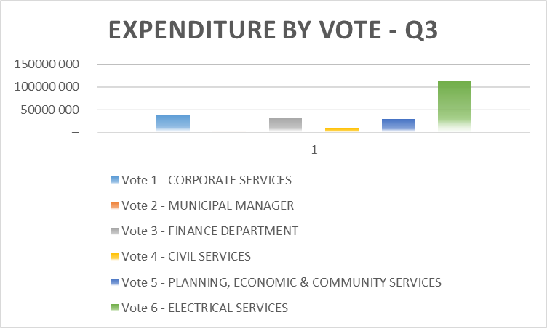

**Financial Performance (Standard Classification)**



Table C2 provides financial information in terms of standard classification that is aligned with Government Financial Statistics by National Treasury. It is clear that Trading services contributes the most in terms of revenue as well as expenditure, which will necessitate extra effort from the management in supporting the relevant sections under Trading services.

**Cash Flow Statement**



Umtshezi municipality’s cash flow position has improved when considered month-by-month. The improvement has been the result of prioritisation of expenditure as per instruction by the Acting Municipal Manager.

**Statement of Financial Position**



Table C6 provides information about the Financial position of the municipality which is good taking into account the assets compared to the liabilities of the municipality. Any movement on the Financial Performance Actual or the Capital Expenditure will inevitably impact on the Financial Position Actual.

**Capital Expenditure (Municipal Vote, Standard Classification & Funding)**



Table C5 shows information for Capital Expenditure. Expenditure trend on overall capital projects is not satisfactory, however, critical projects such as MIG and INEP are doing fairly well, which satisfy the conditions of the grants.

**Debtors’ Analysis**



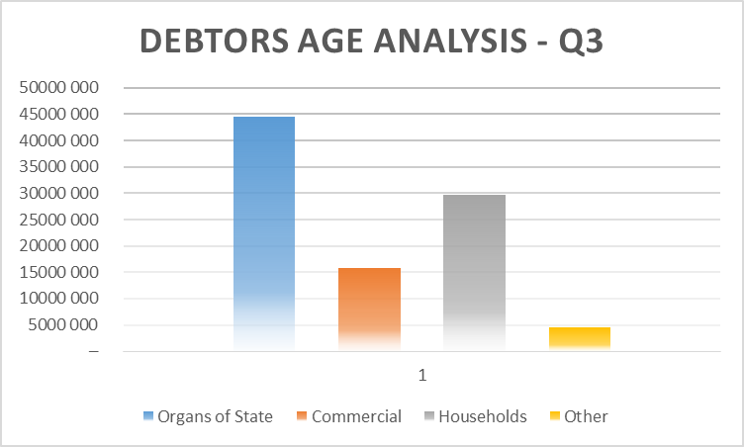

The total outstanding debt by end of March 2016 is at R94.5 million. This amount has increased by R6 million compared to end of the first quarter with outstanding amount of R88 million. More attention must be dedicated into Rates collection as it contributes 77% of the total.

**Creditors’ Analysis**

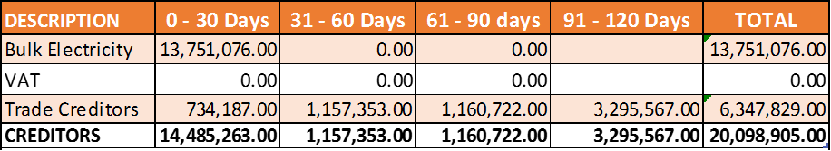

Umtshezi municipal creditors amounted to R20 million by the end of March 2016. It has increase from end of December 2015 by R3 million, however, with the total amount of R5.6 million sitting over 30 days, it shows that the municipality do not comply with section 65(2)(e) of MFMA which states that “all money owing by the municipality be paid within 30 days of receiving the relevant invoice or statement, unless prescribed otherwise for certain categories of expenditure”.

**Top 10 Outstanding Creditors**

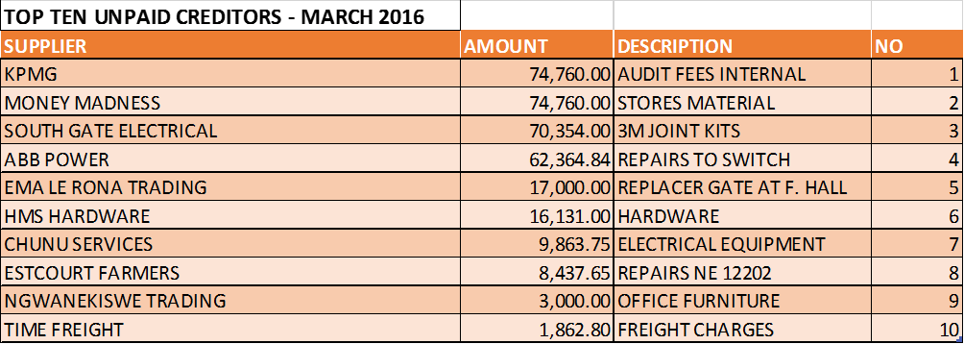

**Investment Portfolio Analysis**

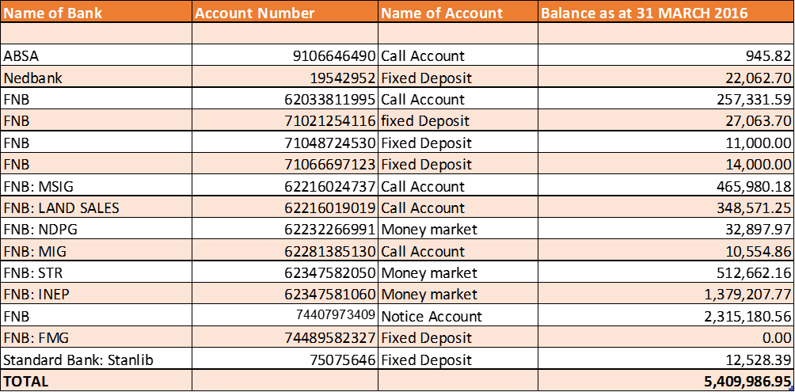

Umtshezi municipality has been consistent with the requirements of the Municipal Investment Regulations, 2005 in its dealings with investments exhibited in the above table.

**Allocation and grant receipts and expenditure**

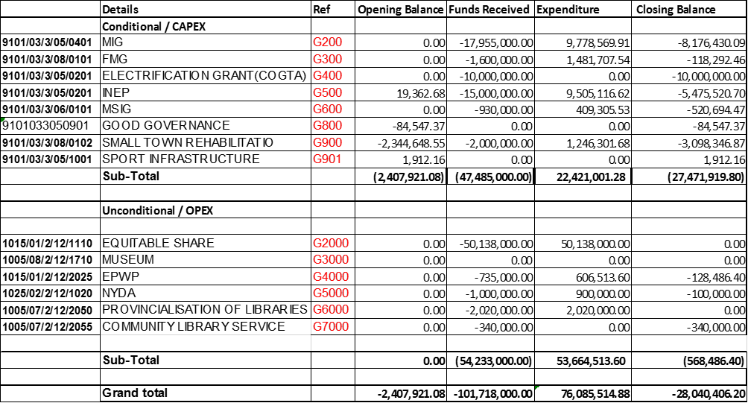

**Municipal Manager’s Quality Certificate**

I, **EH DLADLA**, the acting municipal manager of Umtshezi Municipality hereby certify that-

* The monthly budget statement
* Quarterly report on the implementation of the budget and financial state affairs of the municipality
* Mid-year budget and performance assessment

For the **Quarter 3**, has been prepared in accordance with the Municipal Finance Management Act and Regulations made under that Act.

Print name: **EH DLADLA**

Municipal Manager of **Umtshezi Municipality, KZN234**

Signature: …………………………………………………

Date: ………………………………………………………