UMTSHEZI

MUNICIPALITY

KZN234



FINAL SDBIP

2015/16

1. **MAYORS FOREWORD**

Section 1 of the Municipal Finance Management Act (No.56 of 2003) defines the SDBIP as:

***“ a detailed plan approved by the mayor of a municipality in terms of section 53 (1)(c)(ii) for implementing the municipality’s delivery of services and the execution of its annual budget and which must include (as part of the top layer)***

***the following:***

***(a) projections for each month of-***

1. ***revenue to be collected, by source; and***
2. ***operational and capital expenditure, by vote;***

***(b) service delivery targets and performance indicators for each quarter”.***

In developing a good performance management tool for the municipality, the IDP is drafted, the budget is drafted and the service delivery and budget implementation plan (SDBIP) is developed in order to put into effect the budget. The SDBIP is a monitoring and implementation tool that is the vital link between the Mayor, Council and Administration as it facilitates the process for holding management accountable for its performance. The SDBIP quantifies the strategic objectives as highlighted in the budget to measurable outcomes. It is then, that as a monitoring tool, the Mayor and Council are able to monitor the performance of Senior Managers and the Community is able to monitor the municipality.

Adherence to this SDBIP will ensure that the objectives set out in the budget are achieved and hence the objectives and goals identified in the IDP will be realised, thus ensuring service delivery and that the municipality meets the needs of the community.

1. **INTRODUCTION BY THE MUNICIPAL MANAGER**

The SDBIP is a contract between the Administration, Council and Community where the goals and objectives as set out by the council are quantified and can be implemented by the administration of the municipality. Municipal Managers are encouraged to develop the SDBIP concept further so that it is meaningful and useful to managers.

Whilst the budget sets yearly service delivery and budget targets (revenue and expenditure per vote), it is imperative that in-year mechanisms are able to measure performance and progress on a continuous basis. Hence, the end-of-year targets must be based on quarterly and monthly targets, and the municipal manager must ensure that the budget is built around quarterly and monthly information. Being a start-of-year planning and target tool, the SDBIP gives meaning to both in-year reporting in terms of section 71 (monthly reporting), section 72 (mid-year report) and end-of-year annual reports.

The SDBIP is essentially the management and implementation tool which sets in-year information, such as quarterly service delivery and monthly budget targets, and links each service delivery output to the budget of the municipality, thus providing credible management information and a detailed plan for how the municipality will provide such services and the inputs and financial resources to be used. The SDBIP indicates the responsibilities and outputs for each of the senior managers in the top management team, the inputs to be used, and the time lines for each output. The SDBIP will therefore determine the performance agreements of the municipal manager and senior managers, including the outputs and deadlines for which they will be held

responsible. The SDBIP should also provide all expenditure information (for capital projects and services) per municipal ward, so that each output can be broken down per ward, where this is possible, to support ward councillors in service delivery information.

The SDBIP aims to ensure that managers are problem-solvers, who routinely look out for unanticipated problems and resolve them as soon as possible and enables the **Council** to **monitor** the performance of the municipality against quarterly targets on service delivery.

Being a management and implementation plan (and not a policy proposal), the SDBIP is not required to be approved by the council. It is however tabled before council and made public for information and for the purpose of monitoring. The SDBIP should be seen as a dynamic document that may (at lower layers of the plan) be continually **revised** by the **municipal manager** and **other top managers**, as actual performance **after each month or** **quarter** is taken into account. However, the top-layer of the SDBIP and its targets cannot be revised without notifying the council, and if there is to bechanges in service delivery targets and performance indicators, this must be with the approval of the council, following approval of an adjustments budget (section 54(1) (c) of MFMA). This Council approval is necessary to ensure that the Mayor or Municipal Manager do not revise service delivery targets downwards in the event where there is poor performance.

**SDBIP “contract “diagram as depicted in the Circular No. 13 by National Treasury, MFMA**



**COUNCIL ADMINISTRATION**

**SDBIP**

IDP

Budget

Monthly Reports

Mid-year performance

Assessment

Annual Report

**Service delivery targets**

**(by top manager and by ward)** Employee contract

And annual

**Performance indicator** performance for the

**Revenue and expenditure by vote** agreements for the Municipal Manager

**&**

Senior Managers

1. **TIMING AND METHODOLOGY FOR PREPARATION OF THE SDBIP**

Section 69 (3) (a) of the MFMA requires the accounting officer to submit a draft SDBIP to the mayor no later than 14 days after the approval of the budget and drafts to the performance agreement as required in terms of the section 57 (1) (b) of the Municipal Systems Act. The Mayor in accordance with section 53 (1) (c) (ii) of the MFMA.

These are the legal requirements and deadline limits to assist a municipality to comply with the law-however, best practice suggests that this be don earlier by municipalities, starting with senior managers to draw up their second layer departmental SDBIPs in the early stages of the planning and budget preparation process in line with the strategic direction set in the IDP. The mayor and municipal manager should lead this process.

The municipality should ideally publish its draft SDBIP with its draft budget, or soon after as supporting documentation to assist its budget hearings process normally held at the end of March or in April. As noted above, the SDBIP should be submitted to the mayor by 1 May at the latest. If the draft SDBIP is to be provided for the budget hearings, the municipality may want to bring this date forward, or provide departmental SDBIPs as supporting information to the relevant committee around the end of March. In this case, the mayor will need to approve such departmental or draft SDBIP by mid-March.

It should be noted that it is up to the municipality to determine extra detail, and whether they wish to bring forward their deadlines for submission and approval. A municipality could also opt to have a high level SDBIP complete with ward break-downs for tabling and publication, but may also in addition make available lower layer departmental SDBIPs and other information as requested by Council.

With careful planning of the budget process it may be possible for the **Mayor** to approve the SDBIP **in less than 7 days** after the council approves the budget. **Legally,** to take account of possible revisions to the budget, the Act allows for this to occur **not later than 28 days** **after budget approval**.

The SDBIP is a key management, implementation and monitoring tool, which provides operational content to the end-of-year service delivery targets, set in the budget and IDP. It determines the performance agreements for the municipal manager and all top managers, whose performance can then be monitored through Section 71 and 72 reports, and evaluated through the annual report process.

1. **SDBIP CYCLE**

The SDBIP process comprises the following stages, which forms part of a cycle:

**Planning:**

During this phase the SDBIP process Plan is developed, to be tabled with the IDP Process Plan. SDBIP related processes e.g. workshop schedules distribution of circulars and training workshops, are also reviewed during this phase.

**Strategising:**

During this phase the IDP is reviewed and subsequent SDBIP programmes and projects for the next 5 years based on local, provincial and national issues, previous year’s performance and current economic and demographic trends etc.

**Tabling:**

The SDBIP is tabled with the draft IDP and budget before Council. Consultation with the community and stakeholders of the IDP on the SDBIP is done through budget hearings and formal local, provincial and national inputs or responses are also considered in developing the final document.

**Adoption:**

The Mayor approves the SDBIP no later than 28 days after the adoption of the Municipality’s budget.

**Publishing:**

The adopted SDBIP is made public and is published on the Council’s website.

1. **THE SDBIP PROCESS**

The process for preparing and approving the SDBIP, as depicted in the MFMA

Circular No.13, is diagrammatically summarised as follows:

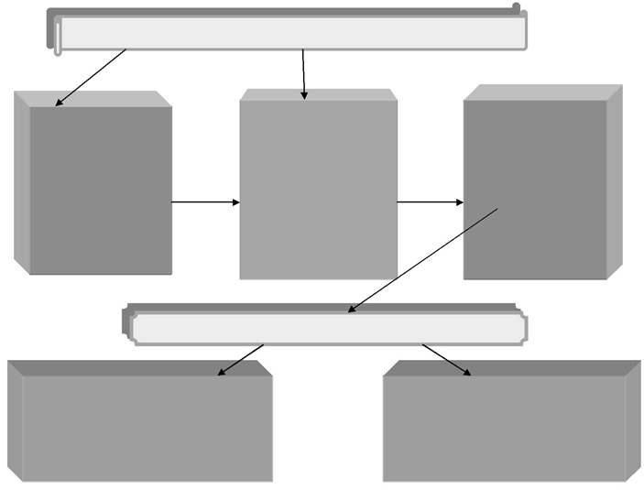

**Approved Budget**

**Approve Annual Performance Agreements for Municipal Manager and Senior Managers**

**Approved SDBIP with monthly projections for revenue and expenditure and quarterly projections for service delivery targets and performance indicators**

**Draft Dept SDBIP with proposed monthly and quarterly projections for the 1st year and annual projections for the two outer years rolled up into the draft SDBIP.**

●●●

**STRATEGIC DIRECTION AND PRIORITIES BY COUNCIL**

**Draft Budget with proposed annual measurable performance indicators and projections for the outer years**, etc.

●●●

**Municipal Budget Policy Statement with indicative allocations for revenue and expenditure including initial tariff modeling,** etc.

●●●

1. **LEGISLATIVE MANDATES**

|  |  |  |  |
| --- | --- | --- | --- |
|  | **NATIONAL PRIORITIES** |  | **PROVINCIAL PRIORITIES** |
|  |  |  |  |
| **1** | **Creation of decent work and economic growth** | **1** | **Create an image of new administration** |
| **2** | **Social and Economic Infrastructure** | **2** | **Caring and Humane Government** |
| **3** | **Rural Development linked to Land Reform** | **3** | **Good Governance** |
| **4** | **Skills and Human Resource base** | **4** | **Inclusive Government** |
| **5** | **Improving the Nation’s Health Profile** | **5** | **Present a practical, measurable programme of action for government with time frame** |
| **6** | **Fight against Crime and Corruption** | **6** | **Use Agriculture as the main platform for integration** |
| **7** | **Cohesive and Sustainable Communities** | **7** | **Household food** |
| **8** | **International Co-operation** |  |  |
| **9** | **Sustainable Resource Management** |  |  |
| **10** | **Democratic Development** |  |  |
|  |  |  |  |

1. **LEGISLATIVE PERFORMANCE REPORTING FRAMEWORK**

|  |  |  |
| --- | --- | --- |
| **FREQUENCY AND NATURE OF REPORT** | **MANDATE** | **RECIPIENTS** |
|  |  |  |
| Monthly reporting on actual revenue targets and spending against budget no later than 10 working days after the end of each month | Section 71 of the MFMA | National Treasury |
| Quarterly progress report | Section 41 (1) (e) of the Systems Act,  Section 166 (2) (a)  (v) and (vii) of the Municipal Management Finance Act  (MFMA) and Regulation 7 of Municipal Planning and  Performance Management Regulations. | 1. Municipal Manager 2. Mayor 3. EXCO 4. Audit Committee 5. National Treasury |
| Mid‐year performance assessment | Section 72 of the MFMA.  Section 13 (2) (a) of Municipal Planning and Performance  Management Regulations 2001. | 1. Municipal Manager 2. Mayor 3. EXCO 4. Council 5. Audit Committee 6. National Treasury 7. Provincial Government |
| Annual report (to be tabled before Council by 31 January (draft and approved / published by 31 March each year) | Sections 121 and 127 of the MFMA, as read with Section 46 of the  Systems Act and Section 6 of the Systems Amendment Act. | 1. Mayor 2. EXCO 3. MPAC 4. Council 5. Audit Committee 6. Auditor‐General 7. National Treasury 8. Provincial Government 9. Local Community |
|  |  |  |

1. **THE SDBIP AS A MONITORING AND REPORTING TOOL**
   1. Montly Report

Section 71 of the MFMA stipulates that reporting on actual revenue targets and spending against the budget should occur on a monthly basis. This reporting must be conducted by the **Accounting Officer** of a municipality no later than 10 working days, after the end of each month.

Reporting must include the following:

1. revenue, per source;
2. actual borrowings;
3. actual expenditure, per vote;
4. actual capital expenditure, per vote;
5. the amount of any allocations received

If necessary, explanation of the following must be included in the monthly reports:

* 1. any material variances from the municipality’s projected revenue by source, and from the municipality’s expenditure projections per vote
  2. any material variances from the service delivery and budget implementation plan and;
  3. any remedial or corrective steps taken or to be taken to ensure that the projected revenue and expenditure remain within the municipalities approved budget.
  4. **Quarterly Reporting**

Section 52 (d) of the MFMA compels the **Mayor** to submit a report to the council on the implementation of the budget and the financial state of affairs of the municipality within 30 days of the end of each quarter. The quarterly performance projections captured in the SDBIP form the basis for the mayor’s quarterly report.

* 1. **Mid**‐**year Reporting**

Section 72 (1) (a) of the MFMA outlines the requirements for mid‐year reporting. The **Accounting Officer** is required by the 25th January of each year to assess the performance of the municipality during the first half of the year taking into account:

1. The monthly statements referred to in section 71 of the first half of the year
2. The municipalities service delivery performance during the first half of the financial year, and the service delivery targets and performance indicators set in the Service Delivery and Budget Implementation Plan;
3. The past year’s annual report, and progress on resolving problems identified in the annual report; and,
4. The performance of every municipal entity under the sole or shared control of the municipality, taking into account reports in terms of section 88 from any such entities.

Based on the outcomes of the mid‐year budget and performance assessment report, an adjustments budget may be tabled if actual revenue or expenditure amounts are materially different from the projections contained in the budget or the SDBIP.

The SDBIP is also a living document and may be modified based on the mid‐year performance review. Thus the SDBIP remains a kind of contract that holds The uMtshezi Municipality accountable to the community.

1. **PRINCIPLES UNDERPINNING OUR SDBIP**

The uMtshezi Municipality commits to the following key principles in its implementation of the SDBIP. That the process:

* Must be used as a management tool and incorporated into existing ways of managing performance in the municipality.
* Measurement must be based on clearly defined targets and agreed timeframes.
* Must align strategic organisational development goals and budget prioritisation linked to community needs and resource constraints.
* Must provide for measurement of progress against IDP commitments;
* Only focus on budgeted projects
* Must ensure measurement of performance against National KPIs
* Must promote use as an early warning system
* Must focus on outcomes (development impact achievements)
* Must provide clarity to all employees on their role in the achievement of municipal and departmental targets.

1. **STRATEGIC OUTCOMES**

**Office of the Municipal Manager**

1. Strategic Planning and Organisational Performance Management
2. Inter-governmental Relations (IGR), Communications and Corporate Image
3. Council Support and Public Participation
4. Internal Audit and Risk Management
5. Legal Services
6. Youth Sports Arts Culture and Recreation
7. Special Programme (disabled, elderly, widows and women, HIV-AIDS and vulnerable children)
8. Local Economic Development and Poverty Alleviation

**Financial Services**

1. Expenditure
2. Revenue Management
3. Supply Chain Management
4. Asset Management
5. Budget, Reporting and Compliance

**Infrastructure, Planning and Development**

1. PMU and Civil Engineering;
2. Electrical Engineering
3. Building Control
4. Spatial Planning and Development Services

**Community Development Services**

18. Community Social Services (Facilities and Amenities, Solid Waste Removal, Landfill Sites, Parks, Cemeteries and Pound Management)

**Corporate Services**

1. Administration Services (Management of Municipal Properties, Secretariat, Admin, ICT, Fleet and Stores Management)
2. Human Resources (Human Resources and Development, Human Resources Administration)
3. Customer Care Services
4. **THE VISION, MISSION AND CORE VALUES OF THE MUNICIPALITY AS FOLLOWS:**

**VISION:**

**By 2016, uMtshezi Municipality will be the champion of a sustainable growth with an aim of building better communities**

**MISSION:**

**The Umtshezi Municipality in partnership with other stakeholders are committed to:**

*  Providing an enabling economic and social development environment
*  Provide a robust plan for the vulnerable, including youth, physically challenged,

gender and aged persons

*  Work co-operatively to unlock resources from other spheres of government and

the private sector

*  Continuously provide services in an equitable manner taking Batho Pele

Principles into cognizance

*  Establish and maintain community networks that promote healthy engagements

between the municipality and our stakeholders

*  Strive to facilitate the provision of basic services
*  Develop Umtshezi in a sustainable manner that does not compromise current and

future generations.

1. **CONSOLIDATED OVERVIEW OF THE 2015/16 DRAFT MTREF**

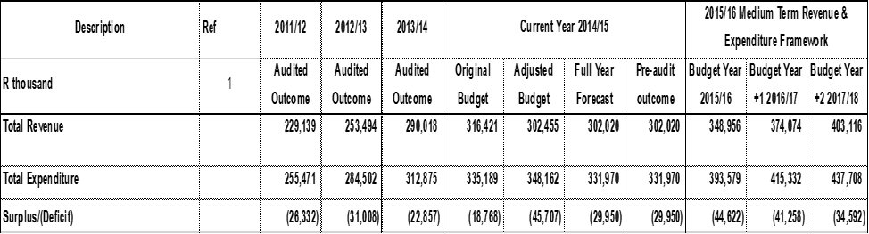

Total operating revenue has grown by 14.12 per cent or R42.6 million for the 2015/16 financial year when compared to the 2014/15 Adjustments Budget. For the two outer years, operational revenue will increase by 7.18 and 7.79 per cent respectively, equating to a total revenue growth of R24.7 million over the MTREF when compared to the 2014/15 financial year.

Total operating expenditure for the 2015/16 financial year has been appropriated at R385.9 million and translates into a budgeted deficit of R41.3 million. When compared to the 2014/15 Adjustments Budget, operational expenditure has grown by 16.27 per cent in the 2015/16 budget and by 5.55 and 5.38 per cent for each of the respective outer years of the MTREF. The operating deficit for the two outer years steadily decrease to R37.9 million and then at R31.1 million.

1. **BUDGETED MONTHLY REVENUE AND EXPENDITURE BY SOURCE**



1. **REVENUE AND EXPENDITURE BY MUNICIPAL VOTE**



1. **SERVICE DELIVERY TARGETS AND PERFORMANCE INDICATORS**





1. **CAPITAL WORK PLAN**

