**INKOSI LANGALIBALELE LOCAL MUNICIPALITY**

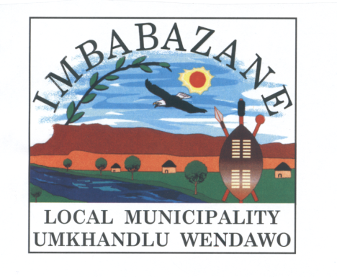

**MID YEAR BUDGET AND**

**PERFORMANCE ASSESSMENT**

**2016/17**

1. **Introduction**

Inkosi Langalibalele local municipality is hereby reporting on for the institutional performance relating to 2016/17 financial year.

This is required by the local government: Municipal Systems Act as amended and local Government: Municipal Financial Management Act. In terms of section 72 of the MFMA the Accounting Officer of a municipality must by 25 January of every year must assess the performance of the municipality during the first half of the financial year. Whereafter, the Mayor must table the report before 30 January each year.

1. **Purpose**

The purpose of the report is to account to the public on the 2016/17 mid-year institutional performance of Inkosi Langalibalele local municipality.

This report contains information which is based on the service delivery and budget implementation plan formulated for the financial year 2016/17 and concentrates on both the financial and service delivery performance assessment. The report was compiled using first and second quarter information.

1. **Challenges and Progress**

Section 72(1) a(iii) request the accounting officer to assess the performance of a municipality during the first half of the financial year, taking into account, the past year’s annual report and progress on resolving problems identified in the annual report. Reflected here under, are the challenges identified on the 2015/16 annual report of Imbabazane and Umtshezi. The challenges will be tabled per department and also will include progress in resolving such challenges.

* 1. **Community Services**

Local economic development, tourism, and development planning performance information are not reflected on the annual report and hence there are no challenge reflected on those areas.

|  |  |  |
| --- | --- | --- |
| **No.** | **Challenge** | **Progress** |
| 1 | Insufficient youth development programs which included HIV/AIDS, Sport and Economic development initiatives. | * Conduct career exhibition, training of unemployed youth on business development * Establishment of Local Aids Council * Conduct festive Tournament, Indlamu, Gospel and Isicathamiya |
| 2. | 23 ward committees were elected, not trained and sworn into office. | * All ward committees were elected, sworn in and inducted. |

* 1. **Corporate Services**

|  |  |  |
| --- | --- | --- |
| **No.** | **Challenges** | **Progress** |
| 1. | Delays on filling the post of HOD | * Post have been advertised. |
| 2. | Budgeted positions were not filled due to delay of finalization of placement process and issues pertaining to fixed term contracts | * Placement process is in the objection phase, the issue of fixed term contracts the panelists have been appointed and awaiting the outcome. |
| 3. | Occupational Health & Safety committee was not functional. | * The Occupational Health and Safety plan is being developed, the position of Occupational Health and Safety Officer is catered in the new organogram * Recruitment process is underway. |
| 4. | Bylaws and Policies not promulgated yet | * Workshops have been done to staff and dates are scheduled to workshop councillors. |
| 5. | Failure to implement performance contracts due to non-appointment of the Municipal Manager | * The Municipal Managers position has been advertised |
| 6. | Due to the amalgamation there is a lack of office space | * Management is looking at the satellite offices to relocate staff |
| 7. | Update of leave register | * Files are being transferred to central place and data capturing is underway |
| 8. | Council resolutions not implemented | * Resolution register to be developed and maintained |
| 9. | Linkage of filing plan between records and department | * Appointment of incumbents to departments that will be work in collaboration with records |

* 1. **Public Works and Basic Services (Civil)**

|  |  |  |
| --- | --- | --- |
| .**No.** | **Challenges** | **Progress** |
| 1. | The whole municipality is characterized by serious infrastructure backlog. These are serious backlogs when it comes to roads network within the municipality especially access roads | * Five year plan to address municipal infrastructure backlog has been included in the municipal IDP. * This five year plan seeks to reduce our infrastructure backlog. * Further funding initiatives need to be explored as to assist and reducing the infrastructure backlog. * Aging MISA to develop support plan by the 31 January 2017 |
| 2. | Housing projects get delayed due to land availability/ legal matters/ environmental issues/ beneficial approval | * No progress has been achieved, however there are developments. |
| 3. | Roads were maintained without a proper or the whole set of plant being available. | * Complete set of plant machinery is available to provide maintenance however is not sufficient given the size and scope of work to be done. |

* 1. **Public Works and Basic Services (Electricity)**

|  |  |  |
| --- | --- | --- |
| **No** | **Challenges** | **Progress** |
| 1. | Insufficient materials | Requisitions are being submitted to SCM continuously but some of the material are not ordered |
| 2. | Lack of skills upgrade to technical staff | * Required trainings are put forward to Human Resources through WSP |
| 3. | Insufficient Vehicles | * The requirements for the department are put forward during yearly budget |

**3.5 Budget and Treasury Office**

|  |  |  |
| --- | --- | --- |
| **No.** | **Challenges** | **Progress** |
| 1. | The Section is still not fully compliant to all legislative prescripts due to shortage of staff | * Temporal allocation of duties to staff pending placement |
| 2. | Safe keeping and Storage of financial documents | * Proposed position of filing clerk * Installation of additional filing cabinets |
| 3. | Installation of Financial System | * Service Provider on site to integrate to new system |
| 4. | Asset Register | * Merging with new financial system |
| 5. | Asset Management: Especially fleet.  Vehicles are leased | * Implement fleet management policy, and access to tracking system reporting to each department. * Reviewal of lease agreements. * Reviewal of budget to accommodate new leases and procurement of vehicles. |
| 6. | Stores Management | * Implementation of stores management module into the system |
| 7 | Increase in debtors book | * Reviewal of the debt collector’s contract |
| 8 | Inability to pay creditors on time due to cash flow problems | * Implementation of the cost cutting measures |
| 9 | MSCOA implementation | * Appointment of the Mscoa technical committee and implementation team |

**3.6 Development Planning Services**

|  |  |  |
| --- | --- | --- |
| **No** | **Challenges** | **Progress** |
| 1. | Implementation of SPLUMA | * Establishment of MPT and Planning Bylaws |
| 2. | Insufficient tools of trade | * Request increase within our budget |
| 3. | Insufficient Staff | * Request to fill in vacant posts and appointment of interns |

1. **Organisational Scorecard Mid-Year Information.**

**The report is based on analyzed and evaluated information through a process whereby information of the KPA’s, objectives, KPI’s and programmes/ projects reflected in the IDP objectives of the municipality. The institutional is based on the IDP scorecard.**

| **Indicator number** | **Key Performance Indicator** | **Unit Measure** | **Annual Target** | **Quarter 1** | | **Quarter 2** | | **Blockage** | **Corrective Measure** |
| --- | --- | --- | --- | --- | --- | --- | --- | --- | --- |
| **Target** | **Actual** | **Target** | **Actual** |
| CSS01/2017 | Facilitation and conduction of training and capacity building programmes | Number | 50 officials and 46 councillors to undergo training and capacity building programmes by 30 June 2017 | 12 Officials 46 Councillors | Target Not Achieved | 12 Officials 46 Councillors | Target Not Achieved |  |  |
| CSS02/2017 | Number of people from employment equity target groups employed in the three highest levels of management in compliance with the approved employment equity plan | Number | 2 employees from employment equity target groups to be employed in the 3 highest levels of Management (Section 54, 56) in compliance with the approved employment equity plan throughout the 2016/2017 financial year | N/A | N/A | N/A | N/A |  |  |
| CSS03/2017 | Percentage of municipality’s budget actually spent on implementing its workplace skills plan (LGSETA) | Percentage | 100% of municipality’s budget actually spent on implementing its workplace skills plan (LGSETA) | 25% | 0% | 50% | 0% |  |  |
| CSS04/2017 | To review organogram | Date | To Review Organogram and adopted by the Council by 30 June 2017 | N/A | N/A | N/A | N/A |  |  |
| CSS05/2017 | To improve organisational and institutional capacity | Number | Number of Council meetings convened | 1 Council meetings convened | Target Achieved (17/08/2016)  (06/09/2016)  (29/09/2016) | 1 Council meetings convened | Target Achieved  (06/10/2016)  (27/10/2016)  (01/12/2016)  (15/12/2016)  (22/12/2016) |  |  |
| CSS06/2017 | Number | Number of EXCO meetings convened | 3 EXCO meetings convened | Target Not Achieved  (06/09/2016)  (27/09/2016) | 3 EXCO meetings convened | Target Achieved  (18/10/2016)  (22/11/2016)  (13/12/2016) |  |  |
| MM01/2017 | Signing of Performance Agreements by Section 54/56 Managers by 30 November 2016 | Date | Signing of Performance Agreements by Section 54/56 Managers by 30 November 2016 | N/A | N/A | Signing of Performance Agreements by Section 54/56 Managers by 30 November 2016 | Target Achieved |  |  |
| MM02/2017 | Number of Performance Reports Compiled by 31 June 2017 | Number | 4 Performance Reports to be compiled by 31 June 2017 | 1st Performance Report compiled by 30 September 2016 | Target Not Achieved | 2nd Performance Report compiled by 31 December 2016 | Target Not Achieved |  |  |
| MM03/2017 | Number of Risk Committee meetings convened by the end of 30 June 2017 | Number | 4 Risk Committee meetings | 1st Risk Committee meeting | Target Not Achieved | 2nd Risk Committee meeting | Target Not Achieved |  |  |
| MM04/2017 | Quarterly updates Risk Registers submitted to Office of the Municipal Manager | Number | 4 Updated Risk Report by 30 June 2017 | 1st Updated Risk Report by 30 Sep 2016 | Target Not Achieved | 2nd Updated Risk Report by 31 Dec 2016 | Target Not Achieved |  |  |
| PWBS01/2017 | Construction of Masimini Gravel Road | Km's | 8Kms constructed | Construction in Progress and Practical Completion | Target Achieved | N/A | N/A |  |  |
| PWBS02/2017 | Construction Of Dube-Village Gravel Road | Km's | 8kms | Appointment of the Service provider and other SCM processes | Target Achieved | Start of the project and construction in progress | Target Achieved |  |  |
| PWBS03/2017 | Construction of Mahlutshini Gravel Road | Km's | 5kms constructed | Tender Advert | Target Achieved | Construction in Progress | Target Achieved Practical Completion |  |  |
| PWBS04/2017 | Construction Mankonjane Gravel Road | Km's | 6kms constructed | Tender Advert | Target Achieved | Construction in Progress | Target Achieved Construction in progress |  |  |
| PWBS05/2017 | Construction Thwathwa link Gravel Road | Km's | 4kms constructed | Tender Advert | Target Not Achieved | Construction in Progress | Target Not Achieved | Financial constrains | The project will start in the last quarter in the current financial year |
| PWBS06/2017 | Construction of Newlands-Lochsloy Pedestrian Bridge | Number | Complete 1 Pedestrian Bridge | Tender Advert | Target Not Achieved | Construction in Progress | Target Not Achieved | The project is still submitted to MIG for registration | The Project will be implemented in the next financial year |
| PWBS07/2017 | Construction of Tatane Vehicle Bridge | Number | Complete 1 Pedestrian Bridge | Tender Advert | Target Not Achieved | Construction in Progress | Target Not Achieved | The project is still submitted to MIG for registration | The Project will be implemented in the next financial year |
| PWBS08/2017 | Construction of Ephangweni Community Hall | Number | Complete 1 Ephangweni Community Hall | Construction in Progress and Practical Completion | Target Achieved | N/A | N/A |  |  |
| PWBS09/2017 | Bhungane/Rosedale Community Hall | Number | Completion of 1 Bhungane/Rosedale Community Hall | Construction in Progress | Target Achieved | Construction in Progress | Target Achieved |  |  |
| PWBS10/2017 | Construction of Madazane Community Hall/Creche | Number | Completion of 1 Madazane Community Hall/Creche | Tender advert | Target Achieved | Construction in progress | Target Achieved |  |  |
| PWBS11/2017 | Construction of Mimosadale Bus and Taxi route | Number | Completion of Mimosadale Bus and Taxi route | Construction in progress | Target Achieved | Construction in progress | Target Achieved |  |  |
| PWBS12/2017 | Number of 63Kms maintained (MIG Roads) | Km's | Maintain 63km’s of MIG Roads | 15.8 Kms | Target Achieved  65,3kms | 15.8 Kms | Target Achieved  31 Kms |  |  |
| PWBS13/2017 | Number of Units completed | Number | 200 Units to be completed by 30 June 2017 | 50 Units completed | Target Not Achieved | 100 Units completed | Target Not Achieved | Still Awaiting for the Department to complete the Environment Impact Assessment Process |  |
| PWBS12/2017 | Review households without electricity in terms of new housing schemes by the end of 30 June 2017 | Date | Review households without electricity in terms of new housing schemes by the end of 30 June 2017 | N/A | N/A | N/A | N/A |  |  |
| PWBS13/2017 | Number of households with access to basic electricity in the Eskom area by 30 June 2017 | Number | 3511of households with access to basic electricity in the Eskom area | 3511 of households with access to basic electricity in the Eskom area | Target Achieved | 3511 of households with access to basic electricity in the Eskom area | Target Achieved |  |  |
| CS01/2017 | Facilitation of Job Creation opportunities through the LED initiatives by 30 June 2017 | Number | 150 jobs opportunities created through the LED initiatives by 30 June 2017 | N/A | N/A | N/A | N/A |  |  |
| CS02/2017 | Number of SMME’s and Co-ops through LED initiatives | Number | 20 SMMEs and Co-ops supported through LED initiatives by 30 June 2017 | 20 SMMEs and Co-ops supported through LED initiatives by 30 June 2017 | Target Achieved | 20 SMMEs and Co-ops supported through LED initiatives by 30 June 2017 | Target Achieved |  |  |
| CS03/2017 | Number of Tourism awareness campaign | Number | Hosting of Tourism Awareness Campaign by 31 Dec 2016 | Hosting of Tourism Awareness Campaign by 31 Dec 2016 | Target Achieved | N/A | N/A |  |  |
| CS04/2017 | 4 Local Tourism Forum to be held by 30 June 2017 | Number | 4 Local Tourism Forum to be held by 31 June 2014 | 1st Local Tourism Forum by 30 Sep 2016 | Target Not Achieved | 2nd Local Tourism Forum 31 Dec 2016 | Target Not Achieved | The Forum was still established for the new municipality | Will sit in the next financial year |
| CS05/2017 | Poverty Alleviation Projects and agricultural projects by 31 June 2017 | Date | Poverty Alleviation Projects and agricultural projects by 31 June 2017 | land identification, preparation and appointment of service provider | Target Achieved | pre-emergency spray, planting and post emergency spray | Target  Achieved |  |  |
| CS06/2017 | Facilitation of Community gardens | Date | To Plough 150 hectors of land by 31 June 2017 | Identification of community gardens and distribution of seeds and monitoring |  | purchasing and distribution of seeds |  |  |  |
| CS07/2017 | Number of Activities Conducted | Number | 3 OSS Activities conducted | N/A | N/A | N/A | N/A |  |  |
| CS08/2017 | Number of LTT conducted | Number | 3 LTT Meetings held | N/A | N/A | N/A | N/A |  |  |
| CS09/2017 | To participate in KwaNaloga Games by 31 Dec 2016 | Date | Promoting all sports codes by participating in KwaNaloga Games by 31 Dec 2016 | N/A | N/A | Promoting all sports codes by participating in KwaNaloga Games 31 Dec 2016 | Target Not Achieved | Financial constrains | The Project to be done in the next financial year |
| CS10/2017 | Hosting Mayoral Cup by 31 Dec 2016 | Date | Hosting Mayoral Cup by 31 Dec 2016 | N/A | N/A | Hosting Mayoral Cup 31 Dec 2016 | Target not Achieved | Financial constrains | The Project to be done in the next financial year |
| CS11/2017 | Number of Youth Development Programs by 31 June 2017 | Number | 1 Youth Development programmes conducted by 31 June 2017 | N/A | N/A | N/A | N/A |  |  |
| CS12/2017 | Hosting of 16 days of activism 31 Dec 2016 | Date | Hosting of 16 days of Activism by  31Dec 2016 | N/A | N/A | Hosting of 16 days of Activism by 31 Dec 2016 | Target Not Achieved | Financial constrains | The Project to be done in the next financial year |
| CS13/2017 | Number of Functional Luncheon Clubs | Number | 23 Functional Luncheon Clubs supported | 23 Functional Luncheon Clubs supported | Target Achieved | 23 Functional Luncheon Clubs supported | Target Achieved |  |  |
| CS14/2017 | Golden Games | Date | Participation in District Golden Games | Recruitment and selection of players | Target Achieved | Participation in District Golden Games | Target Achieved |  |  |
| CS15/2017 | Hosting of the Disability Day by 31 Dec 2016 | Date | Hosting of Disability Day by 31 Dec 2016 | N/A | N/A | Hosting of Disability Day | Target Achieved |  |  |
| CS16/2017 | Commemoration of World AIDS Day | Date | World Aids Day commemoration | N/A | N/A | World Aids Day commemoration | Target Achieved |  |  |
| CS17/2017 | Number of Local AIDS Council Meetings and  Trainings | Date | 4 LAC meetings and trainings conducted | 1st LAC meeting conducted | Target Not Achieved | 2nd LAC meeting conducted | Target Not Achieved | Financial constrains | The Project to be done in the next financial year |
| CS18/2017 | Number of Campaigns conducted | Number | One crime awareness campaign | N/A | N/A | One crime awareness campaign | Target Not Achieved | Financial constrains | The Project to be done in the next financial year |
| CS19/2017 | Number of Poverty alleviation projects assisted in Communities (NGO) | Number | 23 Projects assisted in all Municipal Wards | 23 Projects assisted in all Municipal Wards | Target Achieved | 23 Projects assisted in all Municipal Wards | Target Achieved |  |  |
| CS20/2017 | Conducting of Library outreach programmes | Number | Conducting of Library outreach programmes | N/A | N/A | N/A | N/A |  |  |
| CS21/2017 | Provision of access to 13 recreation parks to the public thought the financial year 2016/2017 | Number | 13 Recreational Parks availed to the public (Lambart Park; Princes Park; Dramond Park; Caravan Park; Elizabeth Avenue Park; Sir Frederick Park; Heritage Park; 1st Avenue Park; Town Garden Park; Wembezi Park 1 and 2; Bert Webster Park; kwaNobamba Park; Cameria Park)) throughout the financial year 2016/2017 | Provision of access to 13 recreation parks to the public thought the financial year 2016/2017 | Target Achieved | Provision of access to 13 recreation parks to the public thought the financial year 2016/2017 | Target Achieved |  |  |
| CS22/2017 | Provision to access for burial plots in 7 Municipal Cemeteries to the public throughout the financial year | Number | Burial plot in 7 municipal cemeteries (Masonite; Nylon; Weenen; Cornfields; Wembezi; Phangweni; Riversdale) will be available to public throughout the year 2016/2017 | Provision to access for burial plots in 7 Municipal Cemeteries to the public throughout the financial year | Target Achieved | Provision to access for burial plots in 7 Municipal Cemeteries to the public throughout the financial year | Target Achieved |  |  |
| CS23/2017 | Provision of Municipal swimming pools accessible to the public during the spring and summer seasons | Number | 2 Swimming pools availed to the public during spring and summer seasons (Fordeville; Town pool) throughout the year 2016/2017 | N/A | N/A | 2 Swimming pools availed to the public during spring and summer seasons (Fordeville; Town pool) throughout the year 2016/2017 | N/A |  |  |
| CS24/2017 | Provision of access to 30 Community halls to the public throughout the financial year 2016/2017 | Number | 30 Community halls ( town hall, Fordeville, Colita, Mshayazafe, Mabhalonini,Monthall, Wembezi, C-Section, Zwelisha, Confieds, Weenen Town, Ezitendeni, Nhlawe, Shayamoya, Ducth, Goodhome,KwaDlamini, Hlathikhulu,Nstonge | 30 Community Halls available | Target Achieved | 30 Community Halls available | Target Achieved |  |  |
| CS25/2017 | Provision of access to community Thusong facilities to the public throughout the financial year- 2016/2017 | Number | 1 Community Thusong facilities (Ntabamhlophe) availed to the public throughout the year- 2016/2017 | 1 Thusong facility | Target Achieved | 1 Thusong facility | Target Achieved |  |  |
| CS26/2017 | Conducting of road blocks | Number | 12 road blocks to be conducted | 3 | Target Achieved | 3 | Target Achieved |  |  |
| CS27/2017 | Processing of all vehicles' applications received | Percentage | 100% processing of all vehicles' applications received by 30 June 2017 | 100% | Target Achieved  100% | 100% | Target Achieved  100% |  |  |
| CS28/2017 | Issuing of leaners' licences and Driving licences to all successful applicants tested | Percentage | 100% issuing of learners' licences and driving licences to all successful applicants tested by 30 June 2017 | 100% | Target Achieved  100% | 100% | Target Achieved  100% |  |  |
| DP01/2017 | Council Adopted IDP by the 30 June 2017 | Date | Credible IDP adopted by Council with 10 critical services identified and included and aligned to outcome 9 by 20 June 2017 | Adoption of the IDP Budget Process Plan | Target Achieved | Development of the Situational Analysis and Desktop Analysis | Target Achieved |  |  |
| DP02/2017 | 100% attendance to disaster incidents reported | Percentage | 100% attendance to disaster incidents reported | 100% attendance to disaster incidents reported | Target Achieved | 100% attendance to disaster incidents reported | Target Achieved |  |  |
| DP03/2017 | Implementation of Wall to Wall scheme | Date | The scheme should be finished by the end of 31 June 2017. | N/A | N/A | N/A | N/A |  |  |
| DP04/2017 | Review of the Weenen Town Planning Scheme and rural policy and also Reviewal of Estcourt outdated scheme | Date | Scheme and Town Planning be reviewed by the 31 June 2017 | N/A | N/A | N/A | N/A |  |  |
| DP05/2017 | Environmental Assessment for the proposed Extension of Cove Crescent Housing Development | Date | Environmental Assessment for the proposed Extension of Cove Crescent Housing Development | N/A | N/A | N/A | N/A |  |  |
| BT01/2017 | Number of Section 71 & 66 Reports Prepared and submitted to Provincial Treasury | Number | 12 Section 71 & 66 Reports Prepared and submitted to Council by 30 June 2017 | 3 Section 71 & 66 Reports Prepared and submitted to Provincial Treasury by 30 Sep 2016 | Target Achieved | 3 Section 71 & 66 Reports Prepared and submitted to Treasury by 31Dec 2016 | Target Achieved |  |  |
| BT02/2017 | Number of Quarterly Section 52(d) Report Prepared and submitted to Council | Number | 4 Quarterly Section 52 Reports Prepared and submitted to Council By 30 June 2017 | 1st Quarterly Section 52 Report Prepared and submitted to Council By 30 Sep 2016 | Target Achieved | 2nd Quarterly Section 52 Report Prepared and submitted to Council By 31 Dec 2016 | Target Achieved |  |  |
| BT03/2017 | Ratio: Total operating revenue received minus operating grants divided by debt service payments (ie. Interests plus redemption) | Ratio | 1:3 | 1:3 | 1:3 | 1:3 | 1:3 |  |  |
| BT04/2017 | Ratio: Available cash plus investments divided by monthly fixed operating expenditure | Ratio | 1:2 | 1:2 | 1:2 | 1:2 | 1,66:2 |  |  |
| BT05/2017 | Ratio: Outstanding service debtors divided by annual revenue actually received for services | Ratio | 1:1 | 1:1 | 1:1 | 1:1 | 0,18:1 |  |  |
| BT06/2017 | Number of Acquisition /Procument Report compiled | Number | 4 Acquisition /Procument Report compiled | 1st Acquisition /Procument Report compiled | Target Achieved | 2nd Acquisition /Procument Report compiled | Target Achieved |  |  |
| BT07/2017 | Compilation and submission of a credible combined Asset Register by 30 June 2017 | Date | 1 Credible combined Asset Register to be compiled by 30 June 2017 | N/A | N/A | N/A | N/A |  |  |
| BT08/2017 | The percentage of a municipality's capital budget actually spent on capital projects identified for a particular financial year in terms of the municipality's integrated development plan by 30 June 2017 | Percentage | 100% the percentage of a municipality's capital budget actually spent on capital projects identified for a particular financial year in terms of the municipality's integrated development plan by 30 June 2017 | 25% | Target Achieved 33% | 50% | Target Not Achieved  42 % |  |  |
| BT09/2017 | The percentage of households earning less than R2840 per month with access to free basic services | Percentage | 100% of households earning less than R2840 per month with access to free basic services | 100% | Target Achieved 100% | 100% | Target Achieved 100% |  |  |
| BT10/2017 | Total number of households earning less than R2840 per month with access to free basic services | Number | 3511 households earning less than R2840 per month with access to free basic services | 3511 | Target Achieved | 3511 | Target Achieved |  |  |
| BT11/2017 | Review of MSCOA Project Plan by 30 June 2017 | Date | Review of MSCOA Project Plan by 30 June 2017 | N/A | N/A | N/A | N/A |  |  |

**Mayor’s Report**

1. **Financial performance assessment**

The Mid Year Performance Review is an assessment of the first six months of the financial year. It includes a financial review as well as a performance review in terms of the organizational scorecard for the 2016/17 financial year.

The analysis on this document indicate that the municipality’s budget is being implemented in accordance with the service delivery and budget implementation plan and any service delivery agreement.

* 1. **Operating Revenue**

Total operating revenue to date is R284 Million which is more by 19% from the budgeted target of R239 million. In terms of the percentage of total operating revenue by source actual to total budgeted operating revenue is 59% which it’s an improvement from the collection section.

Below is a chart that depicts the income billed from July 2016 to December 2016.

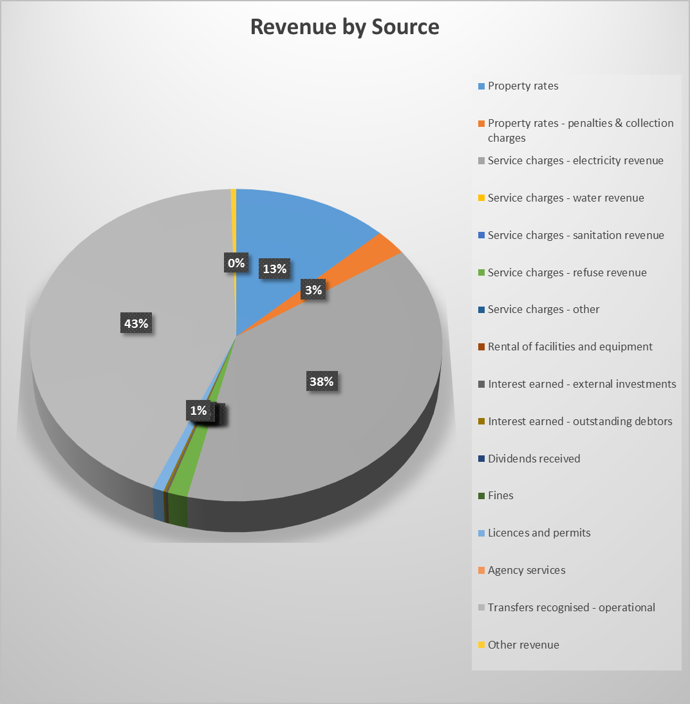

**Table for Income from July 2016 to December 2016**



**Table C4 Monthly Budget Statement**



* + 1. **Key variances identified and explained**
* Rental of facilities: this revenue source is under performing by 79%. However, it is out of municipal control for the community to hire or not to hire halls, etc.
* Revenue from Interest Earned: External Investment: under-performing by 57% since the municipality do not have large investments made during the financial year.
* Revenue from Fines: also under-performing by 93%. The management must review the functioning of Traffic Protection unit to identify and resolve any challenge that the unit might be faced with.
* Debt Impairment expenditure: this expenditure items it’s performed usually at the end of the financial year.
* Depreciation and asset impairment: also this item is usually performed by financial year end.
* Expenditure on Other Materials: is under-performing by 24%.
* Expenditure on Contracted Services (Security): this item shows over-spending by 59%, where most of the expenditure was incurred during the protest by municipal employees.
* Employee Related Cost: under-performing by 31% because the contracts of contractual workers were not renewed.

* + 1. **Debtors age analysis**

The outstanding Debtors amount to R 121 093 815.

The debt owed by government departments amount to R59 million

The debt owed by businesses amount to R16 million

The debt owed by households amount to R34 million



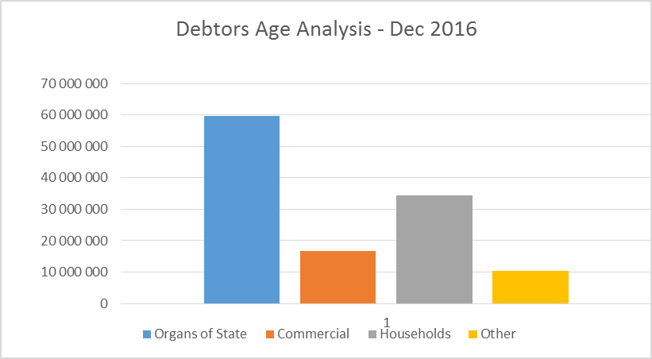

* 1. **Operating Expenditure**

The Total Expenditure to date amounts to R187 million which is 25% less than the Year To Date Budget of R250 million. This has been the effect of MFMA Circular 82 issued by the National Treasury on Cost Containment Measures.

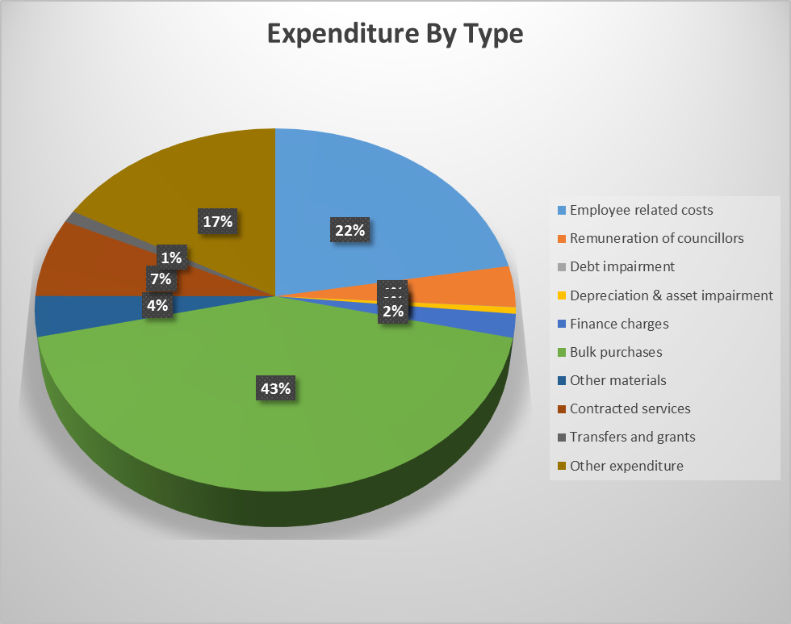

**Table of Expenditure from July 2016 to December 2016**



* + 1. **Creditors Age-analysis**

Creditors are currently paid within 30 days of receipt of Invoice. Creditors reflected within 90 days and 120 days have been settled in January 2016. The challenge is on Trade Creditors and Other which do not comply with section 65 of the MFMA.



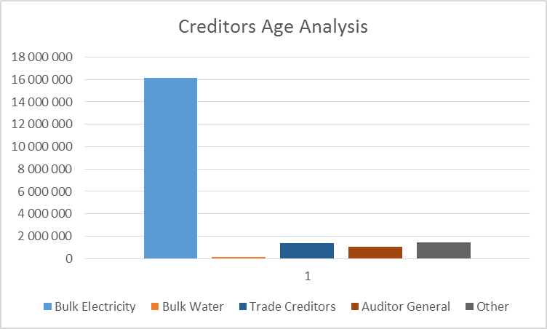

* + 1. **Capital Expenditure**

Capital Projects are primarily funded from the MIG (Municipal Infrastructure Grant) and INEP Grant.

Capital expenditure is under-performing by 7%. However, MIG under Technical Services is 9% more when compared to Year To Date Budget of R19 million by the end of December 2016.

The table below indicates the expenditure per department for the six months period up to December 2016.



**Funding of Capital Expenditure**



1. **GENERAL RECOMMENDATIONS BY THE MUNICIPAL MANAGER**
   1. That, in compliance with Section 72 of the MFMA, the financial results regarding the operating and capital budgets for the first half of the 2015/2016 financial year, and supporting documents as required by National Treasury, is submitted to Council; and
   2. In order to comply, this report be submitted to the National Treasury and the relevant Provincial Treasury ***within five days*** of tabling of the report in the council, in both a Council approved document and in electronic format; and
   3. It is recommended that an adjustment budget be prepared to recommend revised projections for revenue and expenditure where necessary.
2. **Resolutions**
   1. Monthly budget statement and any supporting documents to be **NOTED**.
   2. Quarterly Report on the implementation of the budget and the financial affairs for the municipality referred to in section 52(d) of the Act be **NOTED**.
   3. The Mid-year Budget and Performance Assessment referred to in section 72 of the Act be **NOTED**.

**In-year Budget Statements – C Schedules**







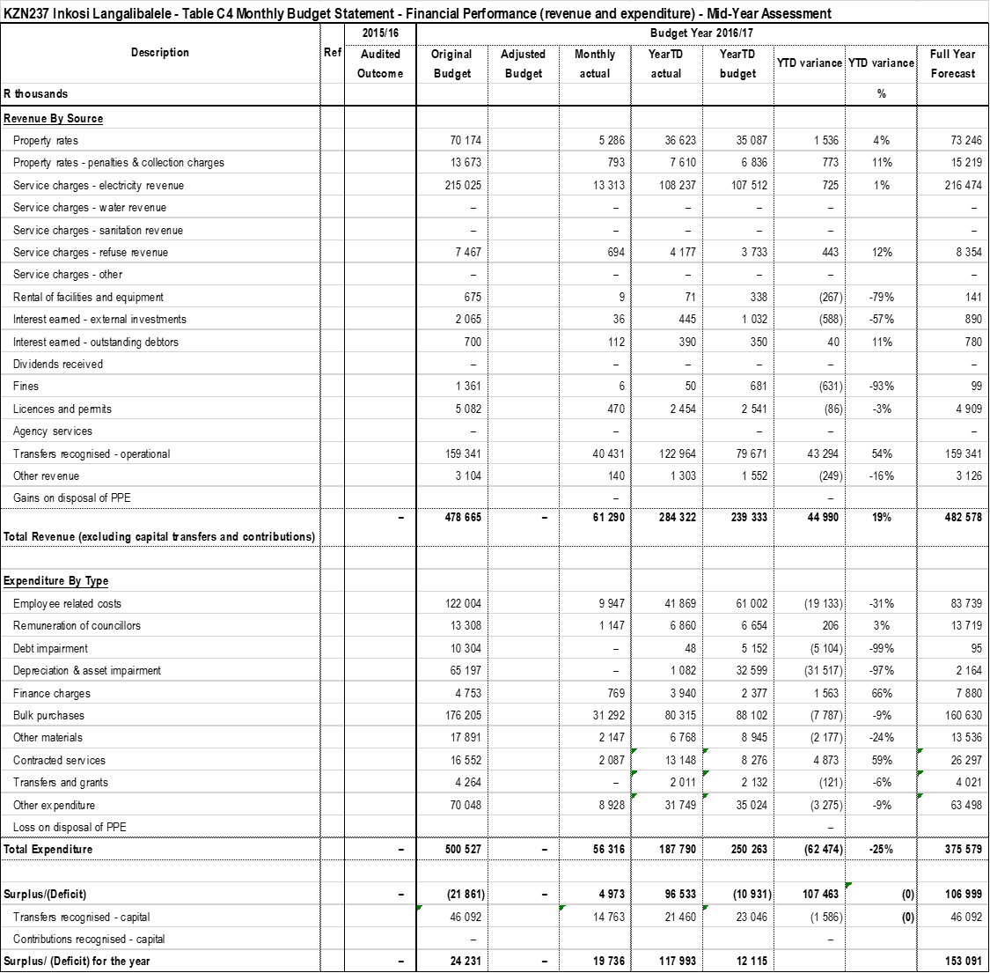







**Supporting Mid-Year Budget Schedules**

**Investment Portfolio Analysis**

The investments include all unspent conditional grants and current year receipts that are ring-fenced and cash reserve from land sales.

Below is the table that details all investments as at 31 December 2016.

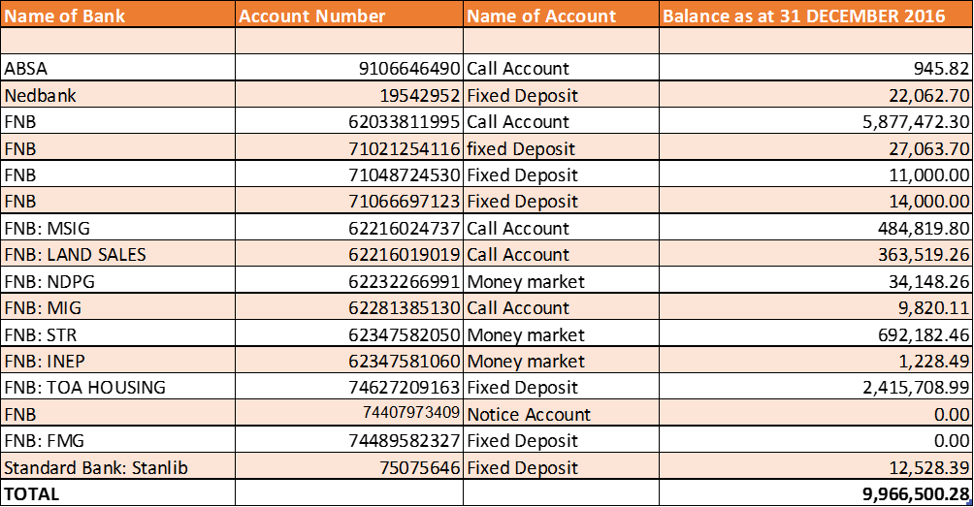

Another investment from FNB by the then Imbabazane Local Municipality is R1 027 784.46 as at 31 December 2016.

**Allocations and Grants received and expenditure**

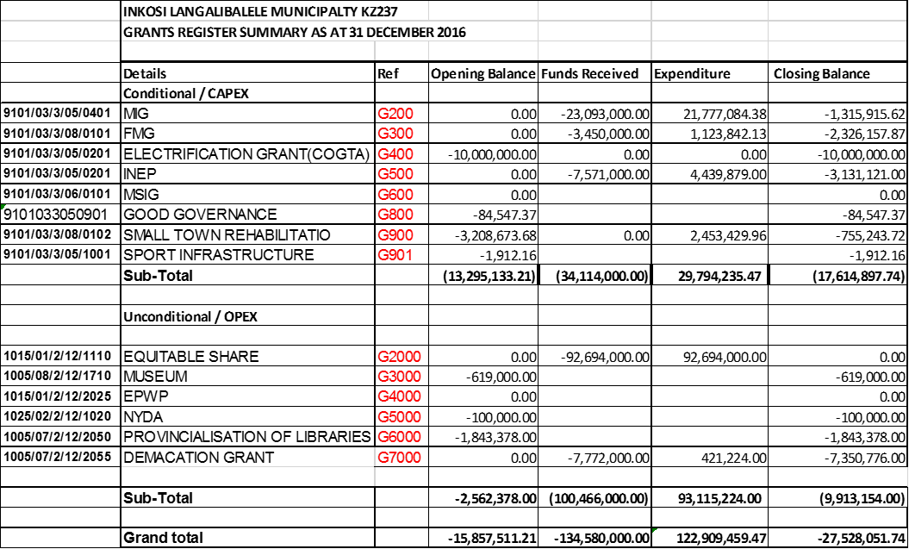







**Municipal Manager’s Quality Certification**

I, **ZM Ndlela,** the Acting Municipal Manager of Inkosi Langalibalele Local Municipality, hereby certify that:

* The monthly budget statements
* Quarterly report on the implementation of the budget and financial state affairs of the municipality
* Mid-year budget and performance assessment

For the month of December 2016 has been prepared in accordance with the Municipal Finance Management Act and regulations made under that Act.

Print name: __________________________________________

Acting Municipal Manager of Inkosi Langalibalele Local Municipality (KZN237)

Signature: __________________________________________

Date: _________________________________________