**Inkosi Langalibalele Local Municipality**



**Mid-Year Budget and Performance Assessment Report 17/18**

**(Section 72 Report)**

Contents

PART 1: IN-YEAR REPORT 3

MAYOR’S REPORT 3

RESOLUTIONS 5

EXECUTIVE SUMMARY 6

INTRODUCTION 6

FINANCIAL PERFORMANCE VERSUS APPROVED BUDGET 6

IN-YEAR BUDGET TABLES 9

PART 2 – SUPPORTING DOCUMENTATION 14

DEBTORS ANALYSIS 14

CREDITORS ANALYSIS 15

INVESTMENT PORTFOLIO ANALYSIS 15

ALLOCATION AND GRANT RECEIPTS AND EXPENDITURE 16

MATERIAL VARIANCE TO THE SERVICE DELIVERY AND BUDGET IMPLEMENTATION PLAN 17

MUNICIPAL MANAGER’S QUALITY CERTIFICATE 27

# PART 1: IN-YEAR REPORT

## MAYOR’S REPORT

In terms of the Municipal Budget and Reporting Regulations, Part 1 in-year report, the Mayor is required to provide a report / comments on:

“(a) ***a summary of whether the municipality’s budget is being implemented in accordance with the Service Delivery and Budget Implementation Plan and any service delivery agreements with municipal entities.”***

The Mayor has considered the Section 71 reports from July until December 2017, and the Quarterly reports in terms of Section 52(d) of the MFMA. The performance of the municipality against its budget is in line with the budget that was approved by Council in May 2017.

**Operating Revenue**

Operational Revenue in Table C4 has a positive variance by the end of December of 15% comparing Actual-to-date versus Budget-to-date. This was made possible by three attributes which are Property Rates (28%), Operational Grants (39%) and Other revenue (49%). Under Operational grants, it must be noted that the tranche for December was R38 mil instead of R41 mil. This was due to unapproved rollover applications of grants that were unspent by end of June 2017.

**Operating Expenditure**

The Operating expenditure in Table C4 shows Actual-to-date is R197 mil instead of R245 mil which leads to 19% underspending. This is caused by the Debt Impairment, Depreciation and Transfers & subsidies which do not show any expenditure to date. The aforesaid items are usually transacted against at the year-end, with the help of specialists.

**Capital Expenditure**

Capital expenditure for grants is sitting at R19.6 mil instead of R26.6 mil by mid-year. This was caused by delays on INEP grant where the projects were advertised during the month of December 2017. The management must expedite the spending of all conditional grants to avoid unspent balance by year end and to delivery crucial services to our communities.

**Cash Flow**

As indicated in Table C7, the municipality has had challenges in this regard, however, measures have been put in place to improve the situation.

“(b) ***a summary of any financial problems or risks facing the municipality or any such entity; and***.”

The municipality is facing financial problems and risks of creditors suing the municipality. This situation has prompted the Political leadership together with the management of the municipality with the help of Provincial Treasury and Provincial Cogta to form an Interim Finance Committee (IFC) to put measures in place in avoiding financial deterioration and stabilising fiscal affairs of the municipality. This is done by having weekly meetings which analyse the finances for the month and determine which expenditures/ creditors to be paid.

“(c) ***any other information considered relevant by the Mayor.***”

1. Although Council and management has made good progress on the implementation of mSCOA, challenges are still there since the system processes is new but the vendor is handling all the challenges that the municipality reports on.
2. Collection of outstanding debtors which has led to the review of a contract between the municipality and debt collector.
3. Slow capital expenditure remains a challenge as it affects basic service to the community.

“4(a) ***summary of the past year’s annual report.****”*

The municipality is busy with the Annual Report since the Auditor General has not completed auditing AFS for 2016/17 financial year.

“(b) ***summary of impact of the National Adjustments Budget and Provincial Adjustments Budget.***”

National Treasury is set to release its adjustments to the Annual Division of Revenue Act (DoRA) which would take into account adjustments to allocation for the 2017/18 financial year.

“(c) ***recommendations***

It is therefore recommended based on the information presented above that an Adjustments Budget referred to in Section 28 of the MFMA be prepared and tabled to the Council by February 28, 2018.

## RESOLUTIONS

1. That the Mid-Year Budget and Performance Assessment Report 2017/18 in terms of Section 72 of the MFMA; be **NOTED**.
2. That the Quarterly Report on the implementation of the budget and financial affairs for the municipality referred to in Section 52(d) of the MFMA; be **NOTED**.
3. That the monthly budget statements and supporting documentation be **NOTED**.

## EXECUTIVE SUMMARY

### INTRODUCTION

The Municipal Finance Management Act, No.56 of 2003, makes it necessary for all municipalities to prepare Mid-Year Budget and Performance Assessment Report.

Section 72 of the Act state the following:

“*1. The Accounting Officer of a municipality must by 25 January of each year –*

1. *Assess the performance of the municipality during the first half of the financial year, taking into account:*
2. *The monthly budget statements referred to in Section 71 for the first half of the year;*
3. *The municipality’s Service Delivery performance during the first half of the financial year, and the service delivery targets and performance indicators set in the SDBIP;*
4. *The past year’s Annual Report and progress made on resolving problems identified in the Annual Report; and*
5. *The performance of every municipal entity under the sole or shared control of the municipality, taking into account reports in terms of Section 88 of the Act from such entities.*

In compliance with Section 72 of the Act, as stated above, the Mid-Year Budget and Performance Assessment is compiled and reported on accordingly.

### FINANCIAL PERFORMANCE VERSUS APPROVED BUDGET

Table C1 and C4 highlight the financial performance of the municipality for the first half of the financial year. It is clear from the tables that the municipality has reported a surplus of R145.3 mil, this surplus is inclusive of operating and capital grants. However, this should not be taken at face value since Table C4 has items on accrual basis and not on cash.

***Income***

The income reported for the period is R303.5 mil compared to the budgeted income of R264.2 mil.

The income for the period as detailed in the table below shows the income billed versus the budget income. Property Rates billed are higher than year-to date budget and other revenue have a similar trend.

**Table 1: Income for the six months ended 31 December 2017**



**Graph 1: Income for the six months ended 31 December 2017**

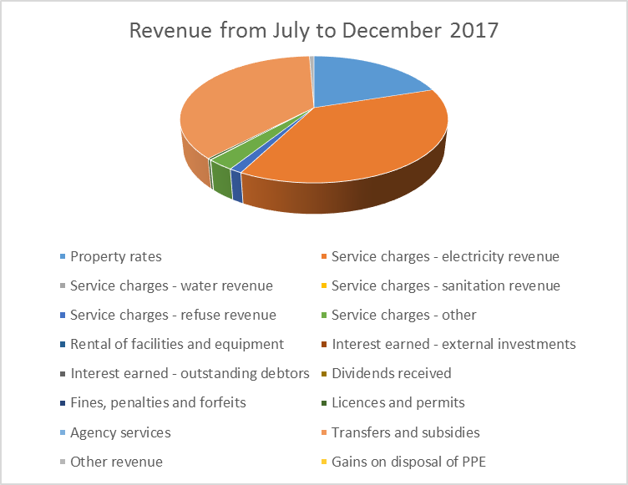

***Expenditure***

The expenditure for the six months period is reported at R197.4 mil. Below is a table that details the expenditure.

**Table 2: Expenditure for the six months ended 31 December 2017.**



**Graph 2: Expenditure for the six months ended 31 December 2017**

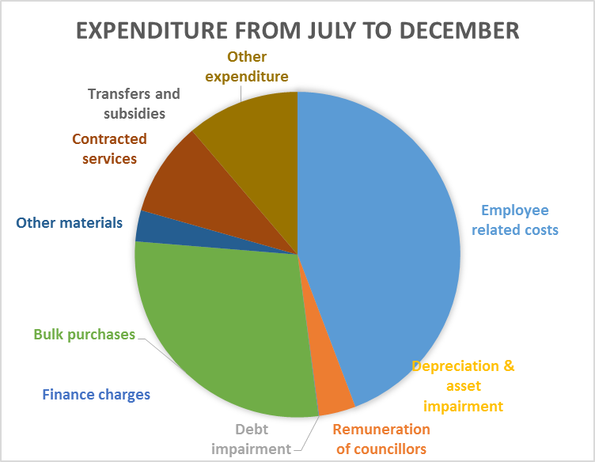

## IN-YEAR BUDGET TABLES





The total revenue for the period is reported at R303.5 mil and has a 15% positive variance over Year-to-date Budget amount. The bulk of this amount comes from Electricity Sales (38%) and Transfers Subsidies (37%).

The total expenditure is sitting at R197.4 mil with an underspending of 19%. This is due to expenditure such as Depreciation and Debt Impairments being not taken into account since these are done thoroughly at the end of the financial year. The biggest contributor on expenditure is Employee Related Cost with 44%, followed by Electricity Purchase with 28%.



The total expenditure for the period is at R17.8 mil by end of December 2017 with a negative variance of 34%.

Capital expenditure funded by grants show underspending of 36% and this has caused by slow spending on INEP grants, however, the department promised to expedite the spending once the awards are done. Also the overspending under Social Department for the Landfill site should be noted and will be considered in the Adjustments Budget.



Table A6 is consistent with international standards of good financial management practice, and improves understandability for councilors and management of the impact of the budget on the statement of financial position (balance sheet).

This format of presenting the statement of financial position is aligned to GRAP1, which is generally aligned to the international version which presents Assets less Liabilities as “accounting” Community Wealth. The order of items within each group illustrates items in order of liquidity; i.e. assets readily converted to cash, or liabilities immediately required to be met from cash, appear first.



The net increase/(decrease) in cash held as at 31 December 2017 is R72.7 mil. This has been increased by grants received during the month of December i.e. Equitable Share R38 mil, MIG R15 mil, INEP R6 mil and Library and Museum grant R3 mil.

The actual Employee Related Cost with Councillors Remuneration is reported at R96 mil vs the budget amount of R145 mil. This shows an overspending of 16% which is an indication that the original budget will not be sufficient. If the year-to-date of the ERC is projected to June 2018 (R96 mil x 2) it equates to R192 mil, and the % to total operating expenditure would be 39%.

The Cash Coverage for the municipality is still at 0 months and the municipality is planning to improve this.

# PART 2 – SUPPORTING DOCUMENTATION

## DEBTORS ANALYSIS

**Table 3: Summary of Debtors as at 31 December 2017**



**Graph 3: Debtors as at 31 December 2017**

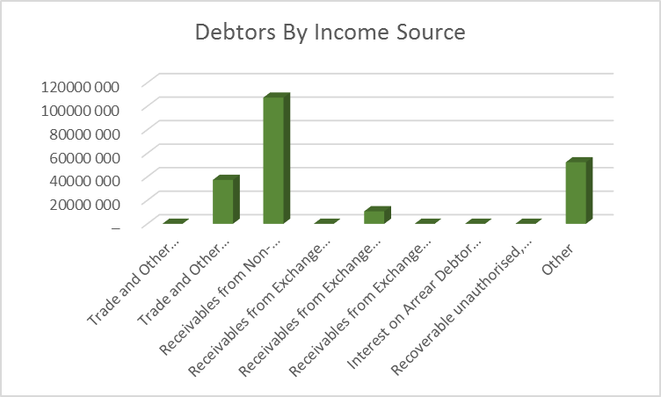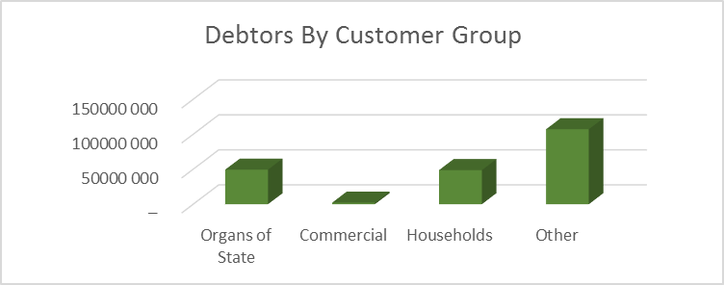

## CREDITORS ANALYSIS

**Table 4: Creditors as at 31 December 2017**



## INVESTMENT PORTFOLIO ANALYSIS

**Table 5: Investments as at 31 December 2017**



## ALLOCATION AND GRANT RECEIPTS AND EXPENDITURE



## MATERIAL VARIANCE TO THE SERVICE DELIVERY AND BUDGET IMPLEMENTATION PLAN





















## 