**QUARTERLY FINANCIAL PERFORMANCE –SEPTEMBER 2017**

**1. Purpose**

To inform Council of the financial status of the municipality as at the end 30 September 2017 in accordance with Section 52 of the Municipal Finance Management Act 2003.

**2. Overview of current financial performance**

Table 1 : Operating Revenue and Expenditure as at the end of September 2017.



The table above table gives us a picture of the income collected and the expenditure incurred as at the end of September 2017. Total income for the month is 29 million. The highest source of income is service charge - electricity at 19 million followed by property rates – revenue at 5.1 million and other service charges at 1.6 million. Total expenditure this month is 34 million. Employee related costs the highest at 13 million, followed by Bulk Purchases at 9 million followed by other expenditure at 4.8 million for the month of September, and contracted services at 3.1 million. The Municipality had a total operating deficit of 5 million.

**Figure 1: Income**

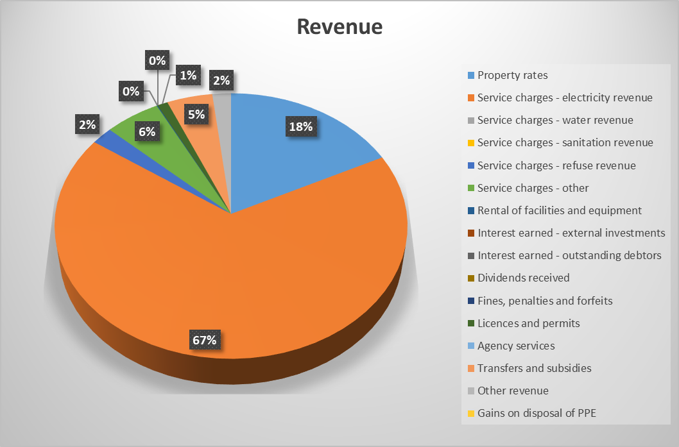

From the pie chart above we can see that we have three biggest sources of income to date being electricity at 67%, property rates at 18% and service charges other at 6% as at the end of September 2017.

Table: Service charges



From the above table, property rates billed and received is higher compared to budget due to most organs of state being billed annually. Electricity and refuse removal is on par.

**Figure 2: Expenditure**

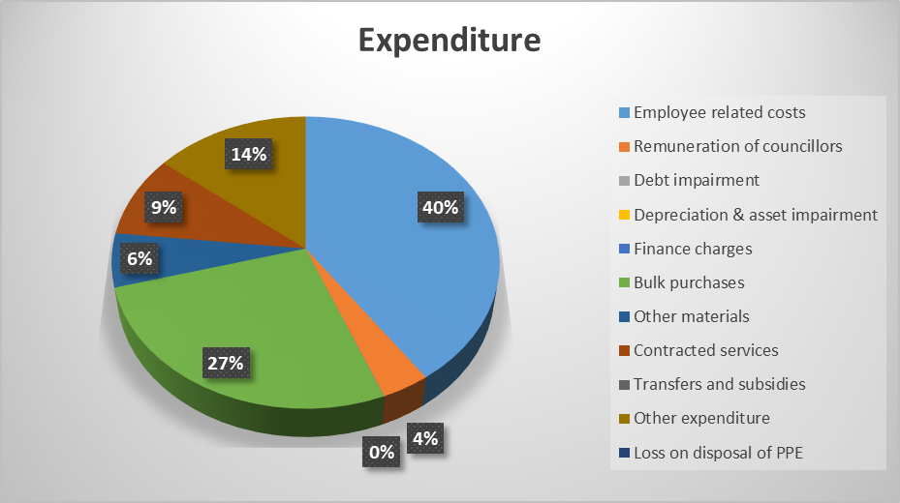

40% Employee related costs are highest as at the end of September 2017, followed by Bulk purchases at 27%. And other expenditure at 14%.

**2.2 INVESTMENTS**

The investments include all the unspent conditional grants and current year receipts that are ring fenced and cash reserves from land sales. Below is a table that details all the investments as at the end of 30 September 2017:

Table 2 : Investments



**2.3. GRANT FUNDING**

The table below illustrates the expenditure and receipt as at 30 September 2017. As at the end of September 5.6 million has been spent. Conditional grants received amount to 18.9 million and unconditional grants to the amount of R 59 772 000.

Figure 1: Grant Funding



**2.4 CREDITORS**

Table 3: Top 20 Paid Creditors



**2.5** **CREDITORS AGE ANALYSIS**



The municipality is currently not paying creditors within 30 days. As we can see from the above table. We have creditors outstanding for over 121 days, this is a sign of cash flow weakness. The total Creditors outstanding is to 38 million as at end of September.

**2.6 DEBTORS AGE ANALYSIS**

Table: Debtors Age Analysis



The aging debtors has decreased to 200 million from previous month being 218 million. Debtors outstanding over 90 has decreased to 131 million. This shows that we aren’t performing, the debt collection section has to work harder to try and collect from our debtors.

*Budget Tables*











**3. RECOMMENDATION**

That the contents of this report be noted.

Reviewed by:

Acting Municipal Manager………………………