INKOSI LANGALIBALELE

MUNICIPALITY

KZN 237



ADJUSTMENTS BUDGET

2018/19

Contents

**PART 1 – ADJUSTMENT’S BUDGET** 3

**Mayor’s Report** 3

**Resolutions** 4

**Executive Summary** 4

**BACKGROUND** 4

**SUMMARY OF ADJUSTMENTS** 5

CAPITAL EXPENDITURE 9

**CONCLUSION** 9

**PART 2 – SUPPORTING DOCUMENTATION** 21

**Adjustments to expenditure on allocations and grant programmes** 24

**Adjustments to allocations and grants made by the municipality** 24

**Adjustments to capital expenditure** 25

**Municipal manager’s quality certificate** 31

# **PART 1 – ADJUSTMENT’S BUDGET**

# **Mayor’s Report**

Section 28 of the Municipal Finance Management Act, No. 56 of 2003, states that the Mayor must table an Adjustments Budget in the Municipal Council at any time after the mid-year budget and performance assessment has been tabled in council but no later than the 28th of February as per Treasury guidelines.

The Mid-Year Budget and Performance Assessment for the six months ending December 2018 was tabled in Council on the 24th of January 2019. Recommendations were made in the report that an Adjustments Budget be drafted as a result of some of the variances detailed in the assessment. The adjustments budget is detailed in this report and takes into consideration all the matters raised in the Mid-Year Budget and Performance Assessment.

The budgeted operating financial performance of the municipality will decrease the surplus to R1.1 million from R16 million. The overall original surplus, including capital transfers, will decrease in the adjustments budget to R56 million from R67 million.

In summary, the Adjustments Budget figures are as follows:

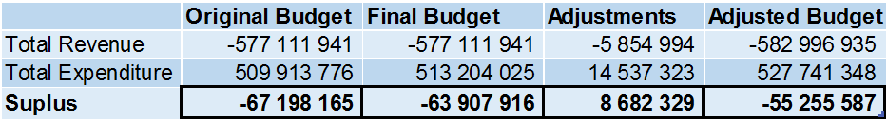

**HER WORHIP, THE MAYOR**

**COUNCILLOR J.M. MBHELE**

## **Resolutions**

It is recommended:

1. THAT THE 2018/19 ADJUSTMENTS BUDGET BE APPROVED.

# **Executive Summary**

A Mid-Year Budget Performance Report was tabled in Council on the 24th of January 2019. This report highlighted the financial and non-financial performance of the Municipality for the first half of the financial year. In this report certain recommendations had been made based on the financial performance of the Municipality. These recommendations and additional trends that had been analysed have been taken into account when drafting this adjustments budget. In addition to this, the economic climate, both internal and external, was considered.

## **BACKGROUND**

An adjustments budget is usually tabled before Council on the prescribed time, namely, 60 days after the adjustments to the Division of Revenue Act (DORA) have been gazetted. The Adjusted DORA was gazetted in December 2018 which effectively means that the adjustments budget should be tabled before the 28th of February 2019.

The Mid-Year Budget Performance Report highlighted variances in terms of year to date income and expenditures versus year to date budgets. These variances were considered and adjustments made, where necessary, in this adjustments budget.

When drafting the adjustments budget, consideration was always given to Section 18 of the MFMA which states that:

*“An annual budget may only be funded from-*

* 1. *realistically anticipated revenues to be collected;*
  2. *cash-backed accumulated funds from previous years’ surpluses not committed for other purposes; and*
  3. *borrowed funds, but only for the capital budget referred to in section 17(2)*

1. *Revenue projections in the budget must be realistic, taking into account-* 
   * 1. *projected revenue for the current year based on collection levels to date; and*
     2. *actual revenue collected in previous financial years.”*

Great emphasis was placed in ensuring that the budget is realistically funded. A complete analysis of the various financial scenarios and outcomes was done and the best viable solution sought. The supporting document on budget funding highlights the various funding sources identified to ensure that cash reserves are always available to fund expenditure. The eventual outcome was to ensure that the adjustments budget was credible.

A credible budget is described as one that:

* Funds only activities consistent with the revised IDP and vice versa ensuring the IDP is realistically achievable given the financial constraints of the municipality
* Is achievable in terms of agreed service delivery and performance targets
* Contains revenue and expenditure projections that are consistent with current and past performance and supported by documented evidence of future assumptions
* Does not jeopardize the financial viability of the municipality (ensures that the financial position is maintained within generally accepted prudential limits and that obligations can be met in the short, medium and long term); and
* Provides managers with appropriate levels of delegation sufficient to meet their financial management responsibilities.

## **SUMMARY OF ADJUSTMENTS**

OPERATING BUDGET

Total operating income increased from the original budget of R516.1 million to R528 million. This is due to the operating grants received and other adjustments on revenue.

The total operating expenditure has increased from R499.9 million to R527 million. This was mainly due to Employee related cost with an increase of 19 million, which was caused by parity of salaries that took place during the financial year. Contracted services were also adjusted by 8.7 million, security services was reduced by R5 mil in the adjustments budget. Other expenditure was decreased by 11 million and other materials by 3.4 million.



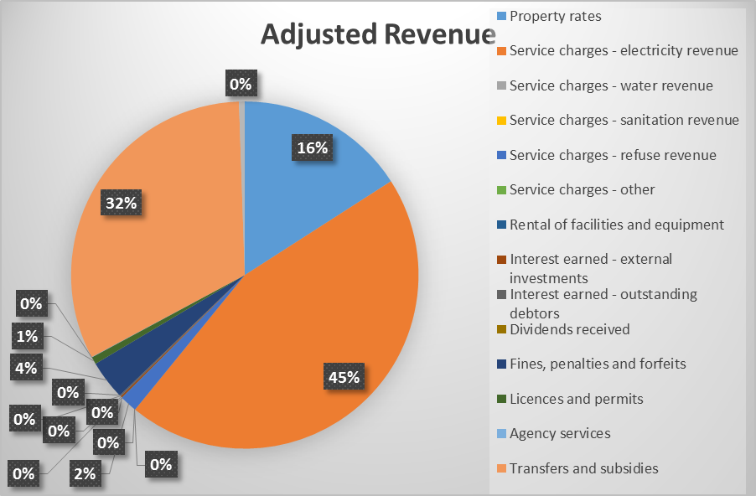

**The following expenditure items have been adjusted:**

1. **Finance Charges**

Have been increased by R7.6 mil, as operating leases for vehicles have ended and the municipality has not entered into new contracts.

1. **Other Materials**

Repairs and Maintenance has been reduced by R3.4 million as a result of the cash flows problems that the municipality is experiencing

1. **Contracted Services**

Security services has been reduced by R5 mil, however, for mSCOA setting, other items are classified as Contracted Service hence there is an increase of 8.7 mil which comes from item Other Materials.

1. **Other Expenditure**

The decreased of R11 mil has been effected due to cost containment measures and mostly affected items were special programmes.

1. **Employee Related Costs**

Employee related costs were increased by R19 million due to under budgeting during the original budget.



# CAPITAL EXPENDITURE

The capital adjustments were on Massification Project Grant, Housing Grant and Internally Funded as illustrated on the table below.

Below is a summary of the funding sources to the adjusted capital expenditure:



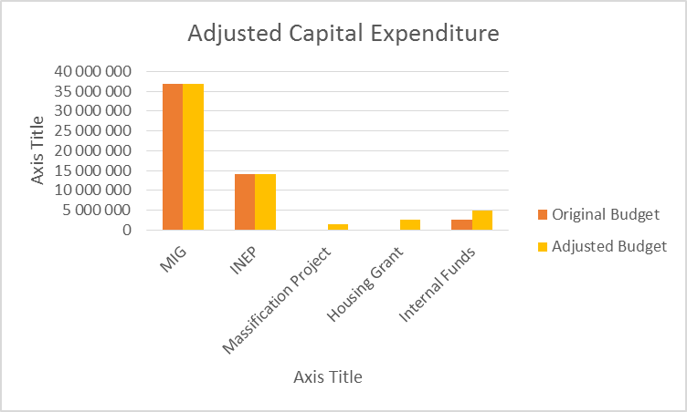

## **CONCLUSION**

The adjustments that have been made in the adjustments budget is necessary due to the changes that have taken place in terms of Provincial Gazette, the results of the mid-year budget and performance review and other items deemed necessary to ensure service delivery.

BUDGET TABLES



1. Table B1 is a budget summary and provides a concise overview of the Municipality’s budget from all of the major financial perspectives (operating, capital expenditure, financial position, cash flow, and MFMA funding compliance).
2. The table provides an overview of the amounts approved by Council for operating performance, resources deployed to capital expenditure, financial position, cash and funding compliance, as well as the municipality’s commitment to eliminating basic service delivery backlogs.
3. Financial management reforms emphasizes the importance of the municipal budget being funded. This requires the simultaneous assessment of the Financial Performance, Financial Position and Cash Flow Budgets, along with the Capital Budget. The Budget Summary provides the key information in this regard:
   1. The operating surplus/deficit (after Total Expenditure) is negative over the MTREF
   2. Capital expenditure is balanced by capital funding sources, of which
      1. Transfers recognised is reflected on the Financial Performance Budget;
      2. Internally generated funds is financed from a combination of the current operating surplus and accumulated cash-backed surpluses from previous years. The amount is incorporated in the Net cash from investing on the Cash Flow Budget. Although the Cash flow has a positive balance, the municipality’s cash flow position is steal weak. Hence the municipality has decided to keep its internally generated capital funding low.
4. The Municipality plans to work hard on collecting its old debt. The revenue section has put a plan in action in this regard, as the municipality is putting great emphasis on regaining its financial stability.
5. Even though the Council is placing great emphasis on securing the financial sustainability of the municipality, this is not being done at the expense of services to the poor. The section of Free Services shows that the amount spent on Free Basic Services and the revenue cost of free services provided by the municipality continues to increase. In addition, the municipality continues to make progress in addressing service delivery backlogs.



1. Table B2 is a view of the budgeted financial performance in relation to revenue and expenditure per standard classification. The modified GFS standard classification divides the municipal services into 06 functional areas. Municipal revenue, operating expenditure and capital expenditure are then classified in terms if each of these functional areas which enables the National Treasury to compile ‘whole of government’ reports.
2. Note the Total Revenue on this table includes capital revenues (Transfers recognised – capital) and so does not balance to the operating revenue shown on Table B4.
3. Note that as a general principle the revenues for the Trading Services should exceed their expenditures. The table highlights that this is the case for Electricity, but not the Waste management function. As already noted above, the municipality will be undertaking a detailed study of this function to explore ways of improving efficiencies and provide a basis for re-evaluating the function’s tariff structure.
4. Other functions that show a deficit between revenue and expenditure are being financed from rates revenues and other revenue sources reflected under the other departments.



1. Table B3 is a view of the budgeted financial performance in relation to the revenue and expenditure per municipal vote. This table facilitates the view of the budgeted operating performance in relation to the organisational structure of the Municipality. This means it is possible to present the operating surplus or deficit of a vote. The following table is an analysis of the surplus or deficit for the electricity and water trading services.



1. Total revenue is R516 million and increased to R528 million in the Adjustments Budget. This represents an increase of less than 2% from the original budget of 2018/19.
2. Transfers recognised – The Municiplaity will be receiving a further 2 million on the for MSIG R1 055 000, Building Plans System R500 000, LED Strategy R400 000 and Sport Facilities R50 000.



1. Table B5 is a breakdown of the capital programme in relation to capital expenditure by municipal vote (multi-year and single-year appropriations); capital expenditure by standard classification; and the funding sources necessary to fund the capital budget, including information on capital transfers from national and provincial departments.
2. The MFMA provides that a municipality may approve multi-year or single-year capital budget appropriations. In relation to single-year appropriations, for 2018/19 R59 million has been allocated.
3. The capital programmes is funded from national and provincial grants and transfers and internally generated funds from current year surpluses. For 2018/19, capital transfers totals R55 million. For Internally Funded items: R4.8 millions.



1. Table B6 is consistent with international standards of good financial management practice, and improves understandability for councilors and management of the impact of the budget on the statement of financial position (balance sheet).
2. This format of presenting the statement of financial position is aligned to GRAP1, which is generally aligned to the international version which presents Assets less Liabilities as “accounting” Community Wealth. The order of items within each group illustrates items in order of liquidity; i.e. assets readily converted to cash, or liabilities immediately required to be met from cash, appear first.
3. The municipal equivalent of equity is Community Wealth/Equity. The justification is that ownership and the net assets of the municipality belong to the community.
4. Any movement on the Budgeted Financial Performance or the Capital Budget will inevitably impact on the Budgeted Financial Position. As an example, the collection rate assumption will impact on the cash position of the municipality and subsequently inform the level of cash and cash equivalents at year end. Similarly, the collection rate assumption should inform the budget appropriation for debt impairment which in turn would impact on the provision for bad debt. These budget and planning assumptions form a critical link in determining the applicability and relevance of the budget as well as the determination of ratios and financial indicators. In addition the funding compliance assessment is informed directly by forecasting the statement of financial position.
5. The adjustment on Cash of R12 million was to reconcile the closing balance with that of Cash Flow in table B7.



1. Grants Operating was adjusted due to new allocation of R2 005 000.
2. Increase on Finance Charges by R 7.6 mil is because of the expenditure trend for the past months.
3. The adjustment on Suppliers and Employees increased by R17 million, caused mainly by bulk purchases and employee related costs.

# **PART 2 – SUPPORTING DOCUMENTATION**

## **Adjustments to budget assumptions**

**General inflation outlook and its impact on the municipal activities**

There are five key factors that have been taken into consideration in the compilation of the Adjusted 2018/19 MTREF:

* National Government macro economic targets;
* The general inflationary outlook and the impact on municipality’s residents and businesses;
* The impact of municipal cost drivers;
* The increase in prices for bulk electricity; and

**Interest rates for borrowing and investment of funds**

The MFMA specifies that borrowing can only be utilised to fund capital or refinancing of borrowing in certain conditions. The municipality engages in a number of financing arrangements to minimise its interest rate costs and risk. Amortisation schedule were obtained from the financial institutions and used to calculate the finance charges the municipality will incur in the 2018/19.

**Collection rate for revenue services**

With the help from Ernst & Young, we have calculated the municipality’s collection rate on Rates, Electricity and Refuse. Both the Debtors and Revenue collection rate were calculated. For cash flow purposes, the Revenue collection rate was used because we felt its more accurate reflection of the income that is collected. The Revenue collection rates were as follows:

* Electricity: 92%
* Refuse: 40%
* Property Rates: 45%

Please note that the revised collection rate was not given to Budget Unit during the Adjustments budget.

**Salary increases**

* The increase in the cost of remuneration. Employee related costs has been increased by 7% as per Circular 80, however, we have seen that in the previous financial and current financial year actual employee related costs exceeds the budgeted amount. We therefore, decided to forecast on actual expenditure trend of this line item.

**Impact of national, provincial and local policies**

Integration of service delivery between national, provincial and local government is critical to ensure focussed service delivery and in this regard various measures were implemented to align IDPs, provincial and national strategies around priority spatial interventions. In this regard, the following national priorities form the basis of all integration initiatives:

* Creating jobs;
* Enhancing education and skill development;
* Improving Health services;
* Rural development and agriculture; and
* Fighting crime and corruption.

To achieve these priorities integration mechanisms are in place to ensure integrated planning and execution of various development programs. The focus will be to strengthen the link between policy priorities and expenditure thereby ensuring the achievement of the national, provincial and local objectives.

**Ability of the municipality to spend and deliver on the programmes.**

It is estimated that a spending rate of at least 100 per cent is achieved on operating expenditure and 100 per cent on the capital programme for the 2018/19 MTREF of which performance has been factored into the cash flow budget.

## **Adjustments to budget funding**

Tariff setting plays a major role in ensuring desired levels of revenue. Getting tariffs right assists in the compilation of a credible and funded budget. The municipality derives most of its operational revenue from the provision of goods and services such as water, electricity, sanitation and solid waste removal. Property rates, operating and capital grants from organs of state and other minor charges (such as building plan fees, licenses and permits etc).

The revenue strategy is a function of key components such as:

* Growth in the city and economic development;
* Revenue management and enhancement;
* Achievement of average 80 per cent annual collection rate for consumer revenue;
* National Treasury guidelines;
* Electricity tariff increases within the National Electricity Regulator of South Africa (NERSA) approval;
* Achievement of full cost recovery of specific user charges;
* Determining tariff escalation rate by establishing/calculating revenue requirements;
* The Property Rates Policy in terms of the Municipal Property Rates Act, 2004 (Act 6 of 2004) (MPRA), and
* And the ability to extend new services and obtain cost recovery levels.

The above principles guide the annual increase in the tariffs charged to the consumers and the ratepayers aligned to the economic forecasts.

## **Adjustments to expenditure on allocations and grant programs.**

There was much change to the grant allocations from both National and Provincial Government. Below is a table that summarizes all the adjustments made.

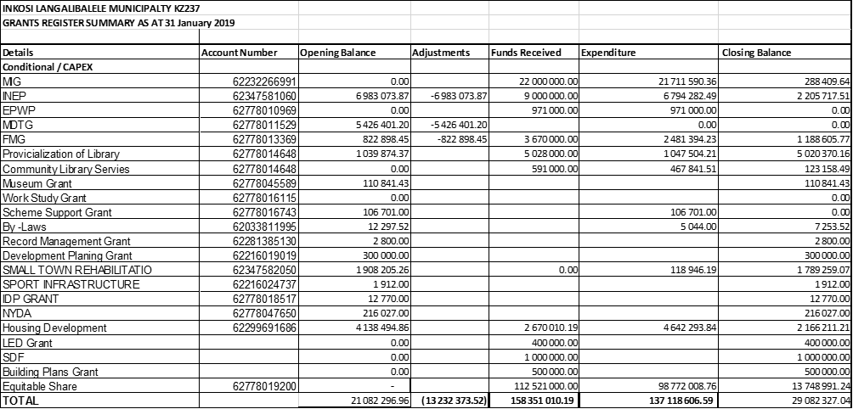

## **Adjustments to allocations and grants made by the municipality**

There were no allocations and grants made by Inkosi Langalibalele Municipality to any other municipality. There were, however, adjustments made to the municipality’s allocations as it has been presented above.

## **Adjustments to capital expenditure**

Below is a table that highlights all the adjustments to the capital budget and its funding.



The capital budget has been adjusted from R53.6 mil on the original budget to R59.9 mil. The adjustments are caused by grants received during the financial year for Massification Project and Housing Project.

## **Adjustments to Councilors Allowances and Employee benefits**



The adjustment were mainly for the reconciliation to Table B4 on Employee Related Cost and Councillors Allowances.





## **Municipal manager’s quality certificate**

I, **Mr. PS MKHIZE**, the Municipal Manager of Inkosi Langalibalele Municipality, hereby certify that the 2018/19 adjustments budget and supporting documentation have been prepared in accordance with the Municipal Finance Management Act and the regulations made under the Act, and that the 2018/19 adjustments budget and the supporting documentation are consistent with the Integrated Development Plan of the municipality.

Name: **Patrick Sibusiso Mkhize**

Municipal Manager of Inkosi Langalibalele Municipality, KZN237

Signature:_________________________

Date: _____________________________