F. ELECTRICITY SERVICES

- PAYMENT OF ACCOUNTS

All accounts shall be paid not later than the due day on the statement of account for the month following that in which the service was rendered

In the event of a consumer’s account remaining unpaid after the final date of payment, the customer shall be charged the “Late Payment Fee” and the consumer’s installation shall be disconnected from the supply mains. Should the customer pay the amount owing after the final date of payment but before the disconnection of supply, the “Late Payment Fee” will still be charged.

The charge owing to default of the consumer shall be called “Late Payment Fee” and shall be 10% of the amount not paid for 30 to 60 Days.

- ELECTRICITY TARIFFS

Charges for electricity consumers shall be as follows:

Scale 1: DOMESTIC DWELLINGS

Including the following, after application has been made in writing to the Director, Finance for this tariff to apply:

  - Religious Organizations
  - Charitable Organizations
  - Sporting Bodies that do not hold liquor licenses

For communal lighting in blocks of flats and medium density housing developments where all the dwelling units are owned under sectional title, and where the entire building is used exclusively for residential purposes, provided that proof is furnished that all of the dwelling units in the block are held under sectional title. Sporting Bodies who are leasing Council property for the purpose of running a sports club

Indigent Customers- Prepaid and Credit Meter Customers

Inclining Block Tariff

Block | Interval | Cost | VAT | Total
1 | 0 to 50 kWh | EBSST tariff: Free
2 | 51 to 350 kWh | R 1.2980 | 0.1947 | R 1.4927
3 | 351 to 600 kWh | R 1.5296 | 0.2294 | R 1.7591
4 | 601 to 1000 kWh | R 2.0610 | 0.3092 | R 2.3702
5 | 1001 and above | R 2.2021 | 0.3303 | R 2.5325

Normal Domestic Customers - Prepaid and Credit Meter Customers

Inclining Block Tariff

Block | Interval | Cost | VAT | Total
1 | 0 to 50 kWh | R 1.0021 | 0.1503 | R 1.1524
2 | 51 to 350 kWh | R 1.2590 | 0.1889 | R 1.4479
3 | 351 to 600 kWh | R 1.5779 | 0.2367 | R 1.8146
4 | 601 to 1000 kWh | R 1.6102 | 0.2415 | R 1.8517
5 | 1001 and above | R 1.8270 | 0.2741 | R 2.1011

Scale 2: COMMERCIAL AND GENERAL TARIFF

For supplies where the metering circuit breaker does not exceed 150amps 3 phase (100kVA), including all shops, offices, boarding houses, hotels, private hospitals, cinemas, garages, tea-rooms, and for all purposes not identified in any other scale.

    - COMMERCIAL RATE 1:

Applicable for Commercial consumer using an average consumption per month for the previous year of less than 1000 units
 |  | Cost | VAT | Total
Basic Charge per month | R 573.83 |  | R 86.07 | R 659.90
Energy rate per month | R 2.00 |  | R 0.30 | R 2.30

    - COMMERCIAL RATE 2:

Applicable for Commercial consumer using an average consumption per month for the previous year of more than 1000 units
 |  | Cost |  | VAT |  | Total
Basic Charge per month | R 1 413.79 |  | R 212.07 |  | R 1 625.86
Energy rate per month | R 1.55 |  | R 0.23 |  | R 1.78

    - Subject to a minimum charge equal to the basic charge on commercial Rate per month or part thereof where the supply is available but no electricity has been consumed.

    - Prepayment Metering is available for Commercial Rate 1 & 2 Customers at a conversion cost per meter of:
 |  | Cost | VAT | Total
Conversion to Prepayment (per Meter) | R 1 500.00 |  | R 225.00 | R 1 725.00

Scale 3: DEPARTMENTAL ACCOUNTS
Same as Commercial Accounts

Scale 4: ILLUMINATED SIGNS ON STREET POLES

- An inclusive charge per month or part thereof on each standard sign of not more than 50 watt loading, connected to the Council’s street light circuits, on which the Council does not undertake the maintenance or repairs
 | Cost | VAT | Total
Illuminated signs not more than 50 Watt loading | R 16.50 | R 2.48 | R 18.98

- An inclusive charge per month or part thereof on each standard sign of not more than 150 watt loading, connected to the Council’s street light circuits, on which the Council does not undertake the maintenance or repairs
 | Cost |  | VAT | Total
Private connections – Limited to 150 Watts |  | R 49.50 | R 7.43 | R 56.93

Scale 5: PRIVATE CONNECTIONS TO STREET LIGHTS

- An inclusive charge per month or part thereof, for each street light, of not more than 150 watt loading, connected to the Council’s street light circuits, on which the Council undertakes the maintenance and repairs.
 | Cost |  | VAT | Total
Private connections – Limited to 150 Watts |  | R 49.50 | R 7.43 | R 56.93

- An inclusive charge per month or part thereof, for each street light, of not more than 250 watt loading, connected to the Council’s street light circuits, on which the Council undertakes the maintenance and repairs
 | Cost |  | VAT | Total
Private connections – Limited to 250 Watts |  | R 103.95 | R 15.59 | R 119.54

Scale 6: INDUSTRIAL SUPPLY

- Low voltage supply (400 volts)

For supplies where the metering circuit breaker exceeds 150 amps 3 phase (100 kVA).

Where the demand normally exceeds 100 kVA, the Council may require that power be taken at 6600V or at 11000V, provided that should low voltage power be available, the Council may agree under certain conditions, to provide power at the lower voltage.

The charge for low voltage metered bulk supply shall be as follows:

- Demand Charge (kVA):
The charge per month per kVA of maximum demand sustained for one half hour by the consumer shall be the kVA charge

- Consumption Charge (kWh):
The charge per kWh per month shall be the kWh charge

- Basic Charge
 | Cost | VAT | Total
Max Demand Charge exceeds 100 kVA | R 305.04 | R 45.76 | R 350.80
Consumption Charge per kWh | R 0.94 | R 0.14 | R 1.08
Basic Charge/Month | R 1 414.86 | R 212.23 | R 1 627.08

- Medium voltage supply (6600 or 11000 volts)

The charge for medium voltage metered bulk supply shall be as follows:

- Demand Charge (kVA):
The charge per month per kVA of maximum demand sustained for one half hour by the consumer shall be the kVA charge

- Consumption Charge (kWh):
The charge per kWh per month shall be the kWh charge

- Basic Charge

 | Cost | VAT | Total
Max demand charge exceeds 100 kVA | R 280.22 | R 42.03 | R 322.25
Consumption Charge per kWh | R 0.92 | R 0.14 | R 1.06
Basic Charge/Month | R 2 345.76 | R 351.86 | R 2 697.63

Scale 6: INDUSTRIAL SUPPLY

Shall be subject to the following conditions:

“Normally” for the purposes of these tariffs, shall be deemed to mean the average monthly maximum demand in kVA recorded during the previous Municipal financial year, as determined by the Director, Electrical Engineering in consultation with the consumer.

        - The consumer shall declare by the end of May each year, what the expected highest maximum demand in kVA shall be for the ensuing Municipal financial year.

- The declared maximum demand shall not be less than the highest maximum demand recorded in the Municipal financial year.

- If the consumer fails to declare the expected highest maximum demand, the Director, Electrical Engineering reserves the right to assess the declared maximum demand on behalf of the consumer.

- If the declared or highest recorded maximum demand is higher than notified maximum demand the relevant charge for increase of supply will be applicable. If there is no record of notified maximum demand, recorded maximum demand in year 2013/2014 will be considered as notified maximum demand.

- The amount payable in any one month in respect of the maximum demand shall not be less than 70% of the aforesaid declared maximum demand.

- Council reserves the right to waive these clauses where such action is deemed to be merited.

- Declared Maximum demand for a new customer or customer upgrading supply will be
70 % of requested size of connection in kVA for a full 12 months where after an adjustment as per the above clauses will be made.

Scale 7: TIME-OF-USE TARIFF

Time-of-use tariffs are appropriate for consumers who are able to manage their energy consumption and maximum demand according to ESKOM’S specified time schedule. This tariff is available to all bulk consumers (with AMD over 100 KVA) subject to the following conditions:

- Consumer to request in writing their intention to change to TOU tariff. Applicable fee shall be R 15 000.00 + R 2 250.00 = R 17 250.00.
- Council will install metering equipment and monitor Consumer profile for minimum period of 6 months. If during such period average consumer consumption during off peak time is less than 45% of total consumption , consumer shall not be eligible for this tariff
- Application for change of tariffs to be submitted before 31 March for the tariff implementation started from 01 July
- Once implemented tariff will be applicable for duration of 12 months. Subsequent change of tariff will follow the same process

Charges as per following schedule:

The charges levied under TIME-OF-USE TARIFF shall be subject to the following conditions:

- The consumer shall declare by the end of May each year, what the expected highest maximum demand in kVA shall be for the ensuing Municipal financial year.

- The declared maximum demand shall not be less than the highest maximum demand recorded in the Municipal financial year.

- If the consumer fails to declare the expected highest maximum demand, the Director, Electrical Engineering reserves the right to assess the declared maximum demand on behalf of the consumer.

- If the declared or highest recorded maximum demand is higher than notified maximum demand the relevant charge for increase of supply will be applicable. If there is no record of notified maximum demand, recorded maximum demand in year 2013/2014 will be considered as notified maximum demand.

- The amount payable in any one month in respect of the maximum demand shall not be less than 70% of the aforesaid declared maximum demand.

- Council reserves the right to waive these clauses where such action is deemed to be merited.

- Declared Maximum demand for a new customer or customer upgrading supply will be 70 % of requested size of connection for a full 12 months where after an adjustment as per the above clauses will be made.

- Low Load Factor Time of Use Tariff is available for customer whose average load factor recorded in previous financial year is less than 40% irrespective of voltage supplied to the customer. Other Time of Use tariffs will be made available if customer improves the load factor above 40%.

Charges as per following schedule:

Time of Use consumer: Low Load Factor

 |  | Cost | VAT | Total
Basic Charge |  | R 1 572.77 | R 235.92 | R 1 808.69
Demand Charge (R/kVA) |  | R 162.47 | R 24.37 | R 186.84

 |  |  | Cost | VAT | Total
Energy Charge (R/kWh) | SUMMER | Peak | R 1.62 | R 0.24 | R 1.86
 |  | Standard | R 1.15 | R 0.17 | R 1.33
 |  | Off-Peak | R 0.77 | R 0.12 | R 0.89

 |  |  | Cost | VAT | Total
Energy Charge (R/kWh) | WINTER | Peak | R 5.51 | R 0.83 | R 6.34
 |  | Standard | R 1.76 | R 0.26 | R 2.03
 |  | Off-Peak | R 1.02 | R 0.15 | R 1.17

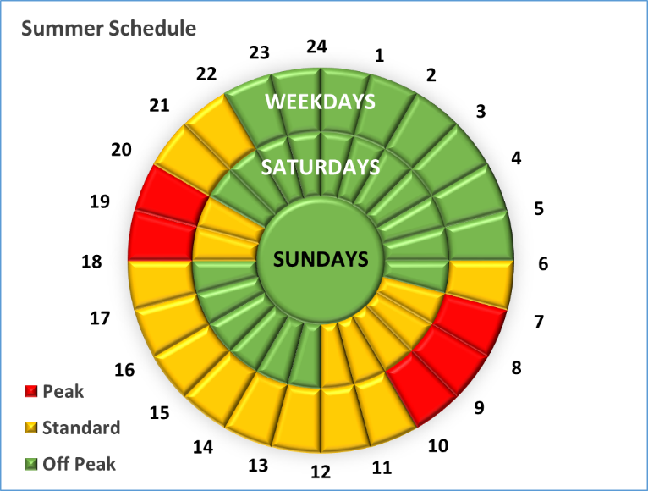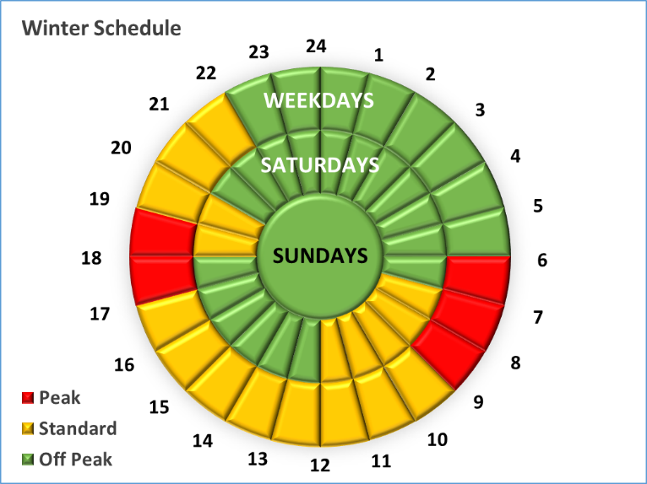

Time of Use consumer: Low Voltage Customers

 |  |  | Cost | VAT | Total
Basic Charge |  |  | R 1 507.25 | R 226.09 | R 1 733.33
Demand Charge (R/kVA) |  |  | R 144.76 | R 21.71 | R 166.48

 |  |  | Cost | VAT | Total
Energy Charge (R/kWh) | SUMMER | Peak | R 1.89 | R 0.28 | R 2.18
 |  | Standard | R 1.08 | R 0.16 | R 1.24
 |  | Off-Peak | R 0.61 | R 0.09 | R 0.70

 |  |  | Cost | VAT | Total
Energy Charge (R/kWh) | WINTER | Peak | R 5.10 | R 0.76 | R 5.86
 |  | Standard | R 1.67 | R 0.25 | R 1.92
 |  | Off-Peak | R 0.94 | R 0.14 | R 1.08

Time of Use consumer: Medium Voltage Customers
Up to and including 3 000 kVA

 |  |  |  | Cost | VAT | Total
Basic Charge |  |  |  | R 2 162.83 | R 324.42 | R 2 487.25
Demand Charge (R/kVA) |  |  |  | R 100.73 | R 15.11 | R 115.84

 |  |  | Cost | VAT | Total
Energy Charge (R/kWh) | SUMMER | Peak | R 1.76 | R 0.26 | R 2.02
 |  | Standard | R 1.16 | R 0.17 | R 1.33
 |  | Off-Peak | R 0.60 | R 0.09 | R 0.69

 |  |  | Cost | VAT | Total
Energy Charge (R/kWh) | WINTER | Peak | R 5.04 | R 0.76 | R 5.80
 |  | Standard | R 1.62 | R 0.24 | R 1.86
 |  | Off-Peak | R 0.91 | R 0.14 | R 1.05

Time of Use consumer: Medium Voltage Customers
Above 3 001 kVA

 |  |  | Cost | VAT | Total
Basic Charge |  |  | R 2 515.76 | R 377.36 | R 2 893.13
Demand Charge (R/kva) |  |  | R 90.32 | R 13.55 | R 103.87

 |  |  | Cost | VAT | Total
Energy Charge (R/kWh) | SUMMER | Peak | R 1.64 | R 0.25 | R 1.89
 |  | Standard | R 1.01 | R 0.15 | R 1.17
 |  | Off-Peak | R 0.57 | R 0.09 | R 0.66

 |  |  | Cost | VAT | Total
Energy Charge (R/kWh) | WINTER | Peak | R 5.39 | R 0.81 | R 6.20
 |  | Standard | R 1.55 | R 0.23 | R 1.78
 |  | Off-Peak | R 0.92 | R 0.14 | R 1.06

TIME OF USE TIME SCHEDULES

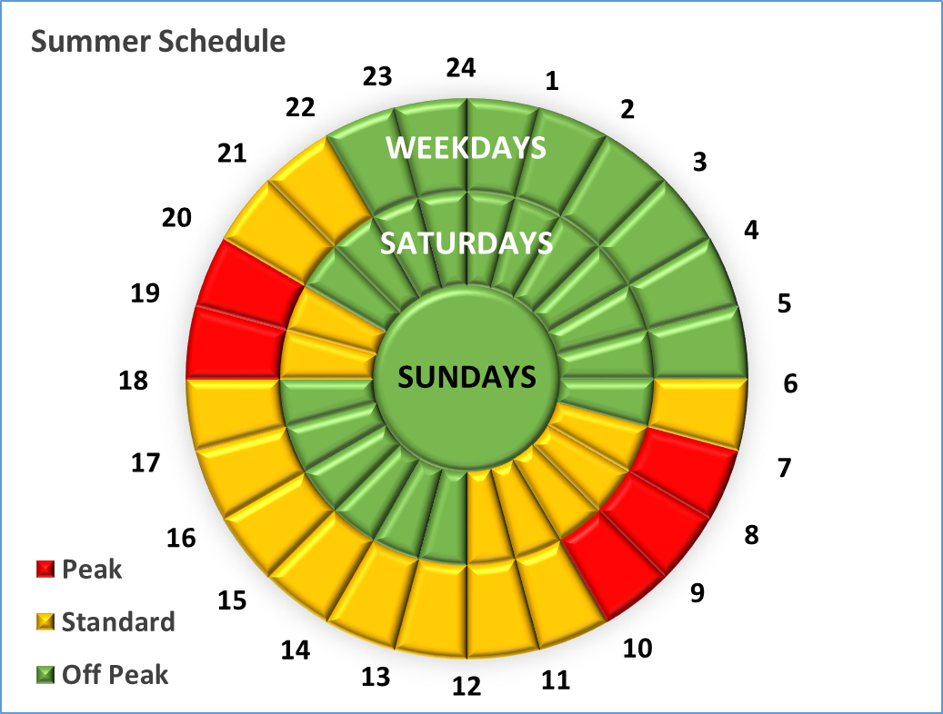

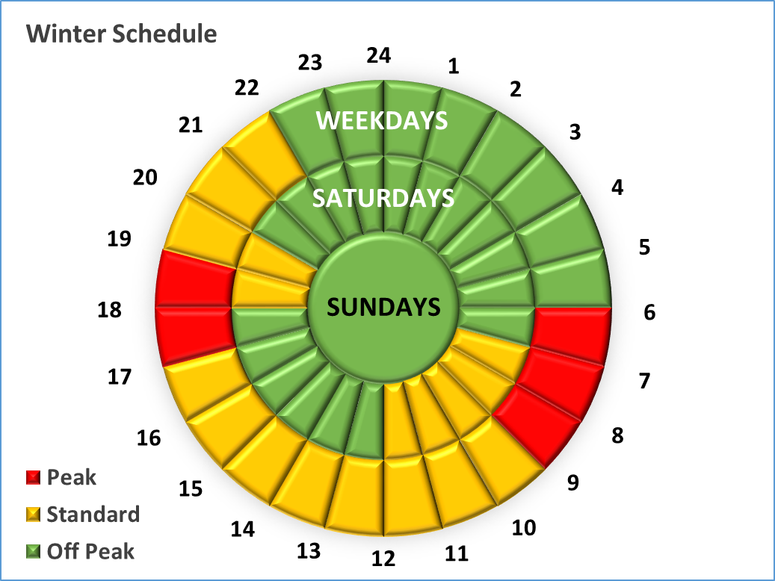

3. ELECTRICITY INSTALLATIONS

Except where other competent arrangements shall have been agreed upon, and provided further that at the discretion of the Council, payment of any work so performed may be demanded in advance or upon completion of the work, subject to a satisfactory guarantee being filed if required by the Council.

The tariff of charges shall be as follows:

        - New or altered connections to the supply mains

The charges for obtaining a service connection to the nearest supply mains or for altering an existing service connection shall be as follows:

- Domestic service connection
 | Cost | VAT | Total
(i) Single phase,60 amp | R 5 813.06 | R 871.96 | R 6 685.02

 | Cost | VAT | Total
(ii) Single phase,60 amp with Readyboard | R 6 605.79 | R 990.87 | R 7 596.65

- Domestic service connection, three phase, 60amp

 | Cost | VAT | Total
Domestic service connection, three phase, 60amps | R 14 538.22 | R 2 180.73 |  | R 16 718.96

- Domestic service connection, single phase, 80 amp, for the moving of an existing connection from within the property to an appropriate boundary meter box

 | Cost | VAT | Total
Domestic service connection, single phase 80 amp move to boundary | R 2 202.09 | R 330.31 | R 2 532.41

- Domestic service connection, three phase, 60 amp, for the moving of an existing connection from within the property to an appropriate boundary meter box

 | Cost | VAT | Total
Domestic service connection, three phase 60 amp move to boundary | R 5 952.20 | R 892.83 | R 6 845.03

- Additional Metering

Additional Metering to existing Domestic Service Connections can be done at a basic cost of
R 11 307.00 + R 1 696.05 = R 13 003.05 plus the additional costs to supply and install the additional metering, (meters, meter box, circuit breakers). The cost at current rate for single phase supply will be deducted from the costing.

The additional metering can be installed only if the following conditions are adhered to:

- That the existing Electricity supply be upgraded to a maximum of 60 Amps, 3 Phase Supply
- That the application conforms to the Town Planning Scheme
- That the customer be advised that separate accounts needs to be billed for each additional meter
- That should the applicant require 2 meters in total on the site, that a 3rd meter be installed which will be a conventional meter, where the basic charge will be levied to the owner. This is due to the fact that Umtshezi Municipality only supplies 1 phase and 3 phase electrical connections, and as a means to protect the Umtshezi income, the 3rd phase must be accounted for.

- Commercial and General connections:

The supply shall be made available on a cost listed below, which shall include the supplying transformer portion, meter and control circuit breaker at the metering point, on a pro-rata user component basis, based on the present day replacement costs applicable on date of application.

Should an increase in an existing supply be required, the difference in bulk services contribution between the existing and required supply will be levied.

The cost of obtaining a:
 | Cost | VAT | Total
a) 230 V Single phase Supply (limited to 80 A) | R 14 748.28 | R 2 212.24 | R 16 960.52
b) 400 V 3 phase 80 A Supply | R 29 033.04 | R 4 354.96 | R 33 387.99
c) 400 V 3 phase 100 A Supply | R 48 315.64 | R 7 247.35 | R 55 562.98
d) 400 V 3 phase 150 A Supply | R 77 095.66 | R 11 564.35 | R 88 660.00
e) 400 V 3 phase 200 A Supply | R 117 340.71 | R 17 601.11 | R 134 941.81
f) 400 V 3 phase 250 A Supply | R 191 884.98 | R 28 782.75 | R 220 667.73

Any other connection cost shall be calculated on a pro-rata user component basis, based on the present day replacement costs from their point of supply up to the and including supplying transformer/minisubstation.. Over and above that Council plus 10% cost will be added.

The owner shall be responsible for the sizing of the controlling circuit breaker. Should an increase in an existing supply be required, the difference in bulk services contribution between the existing and the required supply will be levied.

- Industrial and other service connections where the supply voltage exceeds 400 volts:

The supply shall be made available on a cost to Council plus 10% basis, calculated from and including the supplying transformer to the metering point, on a pro-rata user component basis, based on the present day replacement costs applicable on date of application.

Where the electrical infrastructure providing the supply is dedicated to a single owner, the cost is to include all labour, transport and equipment required as well as pro-rata cost of equipment shared.

Should an increase in an existing supply be required, the difference in bulk services contribution between the existing and required supply will be levied.

- All other connections and alterations, the cost to Council plus 10%, subject to a minimum charge of:

All other connections and alterations. the cost to Council plus 10%, | Cost | VAT | Total
Subject to a minimum charge of: | R 2 204.27 | R 330.64 | R 2 534.91

        - Alterations or repairs to Council owned properties

The charge for alterations or repairs to Council owned property, caused by the tenant, shall be the material cost to Council plus 10% plus actual hours spent subject to a minimum charge of:

 | Cost | VAT | Total
Alterations or Repairs to Council Owned Property | R 2 204.27 | R 330.64 | R 2 534.91

    - Electricity Meters

- A consumer with a standard Single phase connection or a standard 3 Phase connection with 3 single phase meters or a single 3 phase meter may request to replace his/her credit meter with a prepayment meter and the Director, Electrical Engineering will, at his/her discretion, decide which type of prepaid meters would be used as a replacement. The cost is solely for supply and installation of prepaid meter. Any work within property of the consumer to be done by registered contractor and on account of the consumer:

 | Cost | VAT | Total
Conversion to Prepayment - Single Phase | R 1 500.00 | R 225.00 | R 1 725.00

- A consumer with a standard Three phase connection of 100 Amps limited to 150 Amps may request to replace his/her credit meter with a prepayment meter and the Director, Electrical Engineering will, at his/her discretion, decide which type of prepaid meters would be used as a replacement. The cost is solely for supply and installation of prepaid meter. Any work within property of the consumer to be done by registered contractor and on account of the consumer:
 | Cost | VAT | Total
Conversion to Prepayment - Three Phase limited to 150 Amps | R 15 000.00 | R 2 250.00 | R 17 250.00

    - Connections (switching on of a supply)

4.1 Connection after the Supply has been disconnected for non payment as per “1, Late Payment”, shall be the amount levied in the following month’s bill as:

Cost VAT Total

- Reconnection Fee R 500.00 R 75.00 R 575.00
- Customer Connecting themselves (Unauthorised) R 10 000.00 R 1 500.00 R 11 500.00
(No Customer is permitted to Reconnect themselves, such action will be deemed “Unauthorised and Charged according to (4.1 b)

4.2 Where supply is switched on at request of customer-charge shall be | Cost | VAT | Total
a) During office hours | R 601.21 | R 90.18 | R 691.40
b) After office hours and Saturdays | R 782.39 | R 117.36 | R 899.75
c) Sundays and Public Holidays | R 1 045.38 | R 156.81 | R 1 202.18

    - Disconnections (switching off of a supply)

- No charge shall be levied for the switching off of a supply at the consumer’s request during normal working hours. If the work is requested after hours charges will be as follows:

Disconnections (switching of supply) - after hours | Cost | VAT | Total
a) After office hours and Saturdays | R 782.39 | R 117.36 | R 899.75
b) Sundays and Public Holidays | R 1 045.38 | R 156.81 | R 1 202.18

- Disconnection due to tampering: Disconnection due to tampering:

- First offence (Immediate Disconnection):
Disconnection due to tampering | Cost | VAT | Total
First Offence | R 15 000.00 | R 2 250.00 | R 17 250.00

In addition to the charge levied for tampering, monetary losses will be levied as follows:
The monetary losses calculated/estimated for consumption will be based on the maximum amount of electricity consumed during previous months of actual consumption prior to tampering (noticeable variance/decrease in consumption), should the actual consumption not be detected, an average consumption of 1500 kWh will be averaged per month for that customer who has been caught tampering, the maximum period which the monetary losses will be calculated. All calculations will include VAT and must provide proof of payment of the full amount owing prior to reconnection.

The Accounting Officer can at his or her discretion provide a written agreement for the payments to be done if the customer requires the electricity to be reconnected but cannot afford the full amount owing. A copy of such agreement must be submitted to the electricity department for reconnection.

- Second offence (Immediate Disconnection):

The charge below including the fee calculated/estimated for consumption will be levied for re-connection as:

Disconnection due to tampering | Cost | VAT | Total
Second Offence | R 25 000.00 | R 3 750.00 | R 28 750.00

In addition to the charge levied for tampering, monetary losses will be levied as follows:
The monetary losses calculated/estimated for consumption will be based on the maximum amount of electricity consumed during previous months of actual consumption prior to tampering (noticeable variance/decrease in consumption), should the actual consumption not be detected, an average consumption of 1500 kWh will be averaged per month for that customer who has been caught tampering, the maximum period which the monetary losses will be calculated. All calculations will include VAT and must provide proof of payment of the full amount owing prior to reconnection.

The Accounting Officer can at his or her discretion provide a written agreement for the payments to be done if the customer requires the electricity to be reconnected but cannot afford the full amount owing. A copy of such agreement must be submitted to the electricity department for reconnection.

- Third offence (Removal of Supply and all Equipment- Criminal Case to be opened at the South African Police Services):

The charge below including the fee calculated/estimated for consumption will be levied:

Disconnection due to tampering | Cost | VAT | Total
Third Offence | R 45 000.00 | R 6 750.00 | R 51 750.00

In addition to the charge levied for tampering, monetary losses will be levied as follows:
The monetary losses calculated/estimated for consumption will be based on the maximum amount of electricity consumed during previous months of actual consumption prior to tampering (noticeable variance/decrease in consumption), should the actual consumption not be detected, an average consumption of 1500 kWh will be averaged per month for that customer who has been caught tampering, the maximum period which the monetary losses will be calculated. All calculations will include VAT and must provide proof of payment of the full amount owing prior to reconnection.

The Accounting Officer can at his or her discretion provide a written agreement for the payments to be done if the customer requires the electricity to be reconnected but cannot afford the full amount owing. A copy of such agreement must be submitted to the electricity department for reconnection.

    - Call Outs

If a Council employee is called out with reference to a failure of the power supply to a consumer’s premises, when such failure is found to be due to any cause other than a fault in the Council’s supply main, the charge for such call out shall be:

Call Outs | Cost | VAT | Total
a) During office hours | R 601.21 | R 90.18 | R 691.40
b) After office hours and Saturdays | R 782.39 | R 117.36 | R 899.75
c) Sundays and Public Holidays | R 1 045.38 | R 156.81 | R 1 202.18

(7) Testing of Electricity Meters

Should the consumer doubt the correctness of the electricity meter, it may be officially tested by the Independent Lab at a fixed charge. If under test, such meter is found to be in error against the consumer, by more than the amount allowed for in the Electricity Supply Bylaws, the charge shall be refunded, including fixed charged of:

 | Cost | VAT | Total
Testing of meters | R 3 642.25 | R 546.34 | R 4 188.59

- Special charge for long service mains

In addition to the charges in the tariffs, the Council may recover other charges from any consumer or group of consumer whose supply requires special mains or special capital expenditure.

- Differentiations

Supply of electricity outside the Municipal area shall be by agreement, subject to NATIONAL ELECTRICITY REGULATOR approval.

- Temporary connections

No temporary supply will be made for customers; full connection fee will be applicable

- Removal and re-installation
 | Cost | VAT | Total
Removal of meter (minimum applicable charge) | R 2 204.27 | R 330.64 | R 2 534.91
Re-installation of meter (double the minimum applicable charge) | R 4 408.54 | R 661.28 | R 5 069.82

- Sport field Lights:
 | Cost | VAT | Total
Lambert Park Rugby Field (per hour) | R 54.00 | R 8.10 | R 62.10
Lambert Park -Bottom Cricket Field (Per Hour) | R 36.00 | R 5.40 | R 41.40
Lambert Park -Top Cricket Field (Per Hour) | R 27.65 | R 4.15 | R 31.80
Wembezi Soccer Field (Per Hour) | R 36.00 | R 5.40 | R 41.40
Lambert Park - Sports Court (Per Hour) | R 18.00 | R 2.70 | R 20.70

The cost of the electricity consumed shall be at the normal charges as laid down in Section 2 ELECTRICITY TARIFFS with an additional amount of R 2.00/kWh included for repairs and maintenance.

*********************

